Entity classes
The responsibility of an entity class is to manage data within the e-Business system. A specific type of entity class covers code sets which are modelled as enumerations. These code sets may be the existing code lists found in the UN/EDIFACT directory, and may be reused.

An entity class is a template for multiple objects with similar features. Business objects, containing one or more entity classes embody all the features of a particular set of object instances. When a model is designed in an Object Oriented environment, actual objects are not defined, but rather classes of objects are defined. An instance of a class is a synonym for an actual object. If class is the general (generic) representation of an object, an instance is its concrete representation. For example, a class could be “person” and the instance would be “John Smith.”
Business objects that are involved in a scenario become apparent in the development of the requirements specification. There is no automatic process for identifying business objects, but good candidates are “things” that are described by word (nouns) phrases, that have characteristics (or attributes) that take on values, and have responsibilities or (behaviors). Examples are persons, places, concepts or situations, independent of how the phrase is used in a particular sentence. There is particular interest in identifying business objects that implement many of the basic facts and rules needed for almost any business application. These are called common business objects (CBOs) and include business objects that most commercial applications have to deal with such as a business partner (customer), address, calendar, payment terms, currency, etc. CBOs are documented with a description of what they do. CBO attributes are documented by a description of what they contain, their type, and an indication of a set of values (if applicable). CBO methods are documented with a description of their logic Figure 20 illustrates an example of the address CBO from the SanFrancisco Project. Annex 8 provides additional information on the SanFrancisco Project address example.

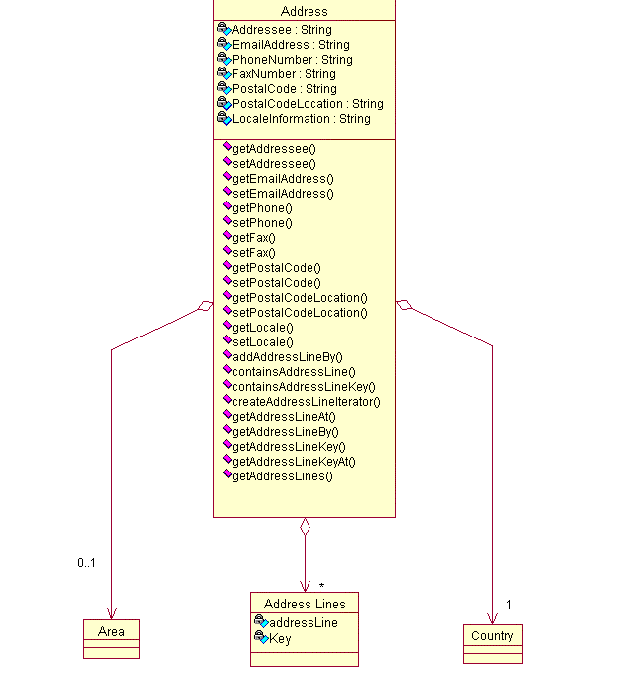
Figure 20 Address CBO from the SanFrancisco Project

Annex 8 Describing addresses
Addresses are basic to most business systems. We need to record location information and how to contact our customers, suppliers, and employees. By recording this information, we are able to send letters, invoices, and purchase orders, and to contact them by phone, fax, or e-mail. One way to model this is shown in the figure below. Here we have an Address with the basic contact information, addressee's name, email address, and phone numbers. It also owns a group of address lines to give us a flexible way to record all the different kinds of addresses we may need.
Basic address diagram
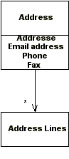
Using addresses in SanFrancisco
The SanFrancisco class that records this information is called Address. In SanFrancisco the same kind of address object is used both for the company's addresses and for the addresses of the company's business partners. Address contains the basic contact information, a collection of free form address lines and references to a country, and optionally a user-defined "area." (You can think of area as an application-defined equivalent to a region.) The following diagram shows the structure of a SanFrancisco address.
SanFrancisco address implementation model
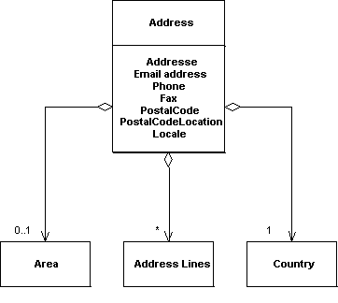
Working with address information
The following table shows the names and types of the various attributes of an address. Most are Strings. The exceptions are Country and Area which are references to persistent objects. SanFrancisco does not impose any required format on the Strings, although LocaleInformation should conform to the standard for Java locales ("en_US", for example).
Address attributes table
Attribute Name | Type | Can Update? | Purpose
Addressee | String | Y | The person this location is associated with
PostalCode | String | Y | The Zip Code / PostalCode for this location
PostalCode  Location | String | Y | The city for this location
PhoneNumber | String | Y | The phone number for this location
FaxNumber | String | Y | The fax number for this location
EMailAddress | String | Y | The email address for the addressee
Locale  Information | String | Y | The locale code for this location
Country | Country | Y | A reference to the country for this location
Area | Area | Y | A reference to a user-defined area (sales, shipping, etc.)
At first glance you might think that the use of a single PhoneNumber is a limitation, but you will see that, in places where addresses are used, an open-ended collection is maintained. Therefore, you can have a separate address object for each phone number you need to maintain for a company or business partner. This could also be handled by using the generic address line support to add address lines that represent additional phone numbers.
Working with address lines
In addition to the String attributes, a SanFrancisco address has a collection of address lines. Each address line is a String. Each address line has a key, which is defined by the user or application. If all you want to do is store an image of an address label, you might key your address lines with sequential numbers; if you want more meaningful access to the address information, use keys like "street address", "city", "state", and so on.
Class Address
public void addAddressLineBy(String addressLine, String key)
public boolean containsAddressLine(String addressline)
public boolean containsAddressLineKey(String key)
public Iterator createAddressLineIterator()
public String getAddressLineAt(Iterator position)
public String getAddressLineBy(String key)
public String getAddressLineKey(String addressLine)
public String getAddressLineKeyAt(Iterator position)
public DMap getAddressLines()
The next example shows how to construct a display address from an Address object.
Example -- Display address
public void displayAddress() throws SFException {
// display a typically formatted U.S. address
Address theAddress = CompanyContext.getActiveCompany().getPrimaryAddress();
System.out.println(theAddress.getAddressee());
System.out.println(theAddress.getAddressLineBy("addr1"));
String addr2 = theAddress.getAddressLineBy("addr2");
if (addr2 != null) {
System.out.println (addr2);
}
System.out.println(theAddress.getAddressLineBy("city")
+ ", "
+ theAddress.getAddressLineBy("state")
+ " "
+ theAddress.getPostalCode());
}
Finding addresses
Unlike many persistent Entities in SanFrancisco, addresses are not maintained by controllers. Instead, addresses are explicitly associated with the business object whose address it is. A company object will own its addresses and a business partner will own its address(es) and each provides methods to access and maintain addresses.
For more information about configuring a new address, see Configuring an address. For more information about extending the address object to provide additional data or functionality, see Extending an address.

