BPSS and Notation

Introduction
This document is a proposal for graphical notation for ebXML business collaboration. The proposal includes at the same time a UML based notation and an extended notation.

A common set of notation is a major requirement for the adoption of ebXML BPSS specification. Indeed, such a specification provides the linkage between business requirements and the enabling technologies. Mostly business people will define collaboration. They will exchange information and viewpoints in terms of diagrams and pictures, not in terms of XML files. At the same time, specifications have to be precise enough to be rendered in a way that runtime engines can understand them to configure themselves.
Consequently, the notation has to be well balanced between these two objectives.

Business Transaction

The problem
A BusinessTransaction is the conjunction of two elements:
- A specification of document flows between two roles
- A specification of the context of the interaction in terms of:
  - Time constraints
  - Signals for acknowledgment and non repudiation
  - Possible constraints on Business Document content.
One of the major characteristics of a business transaction is that it results in either a Success or a Failure. This result can only be determined by the combination of both the transaction interaction context and the document flowing between the roles.

A common representation of a BusinessTransaction is an Activity Diagram with two end-states, success and failure, to represent the two possible results of the transaction. The computation of the end-result is usually described in the guard transition between the requesting activity and the end-states. This notation is focused on the computation of the end result of the BusinessTransaction:
Strength: This notation highlights the inherent success or failure of a transaction which is a major characteristic of ebXML and the UMM.
Weakness: The effective end-result computation is determined by information defined outside the transaction itself, like the timeToPerform attribute of transaction activities inside of a Binary Collaboration. Furthermore, the usage of guards for BusinessTransaction is not available in the BPSS specification.

The computation of the end-result is a key point for BusinessTransaction and certainly governs the associated notation. Therefore, the following paragraph attempts to define what the computation model is in order to propose which BusinessTransaction elements should be highlighted in the notation.

The guard conditions are not part of BPSS Transaction specification

The Transaction Computation model
The following diagram describes how a transaction end-result can be computed from the requester perspective, based on the elements available in the BPSS collaboration document and the transaction patterns for signals and acknowledgment:
- Attributes on requesting and responding activities.
- Business Documents and ConditionExpressions.
- isPositive attribute response on Document Envelope
This computation model outlines that today’s BPSS requires the definition of logical document flows to enable the computation of the end-result in case of multiple possible responses. Using guards to express the condition of success or failure is difficult because:
- Guards do not exist in the current specification of BPSS BusinessTransaction.
- ConditionExpression on BusinessDocuments cannot be used either. They are conditions defining a match between a physical document and a logical document. Nothing specifies whether they express a success or a failure.
The bad thing of all this is that it may seem difficult to define success or failure without guards. However, the logical flow solution is powerful enough. Furthermore, it helps a lot in the binding of Collaboration definition to internal implementation. It would be difficult to branch into internal business activities if the branching conditions where hidden into the guards.

Transaction example
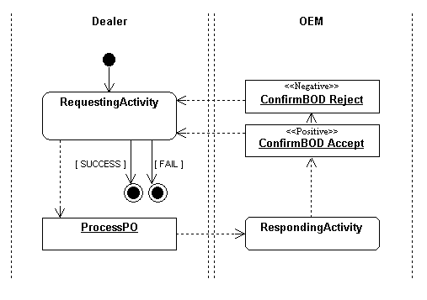

<BusinessDocument
name="ProcessPO"
specificationLocation="www.mydtd.com/OAGi/ProcessPO.dtd"
/>
<BusinessDocument
name="ConfirmBOD Accept"
specificationLocation="www.mydtd.com/OAGi/ConfirmBOD.dtd"
>
<ConditionExpression expressionLanguage=“Xpath” expression="status=0x99" />
</BusinessDocument>
<BusinessDocument
name="ConfirmBOD Reject"
specificationLocation="www.mydtd.com/OAGi/ConfirmBOD.dtd"
>
<ConditionExpression expressionLanguage=“Xpath” expression="status=0x00" />
</BusinessDocument>

<BusinessTransaction name="PO">
<RequestingBusinessActivity
name="Dealer"
isNonRepudiationRequired="true"
timeToAcknowledgeReceipt="P2D"
timeToAcknowledgeAcceptance="P3D"
>
<DocumentEnvelope businessDocument="ProcessPO" />
</RequestingBusinessActivity>

<RespondingBusinessActivity
name="OEM"
isNonRepudiationRequired="true"
timeToAcknowledgeReceipt="P5D"
>
<DocumentEnvelope isPositiveResponse="true" businessDocument="ConfirmBOD Accept" />
<DocumentEnvelope isPositiveResponse="false" businessDocument="ConfirmBOD Reject"/>
</RespondingBusinessActivity>
</BusinessTransaction>

Proposed solutions

UML Notation for BusinessTransaction
As outlined in the computation model, the highlight is made on Document flow. End-states can be represented but no guard should be used for the end-result computation. A stereotype is added to differentiate positive response from negative response.

Extended notation for Transaction
As document flow is now the highlighted element in the notation, the need for a separation between role and activity is no more needed. The extended notation simplifies the diagram by merging roles and activities.
- Activities are represented as boxes
- Request flows are represented with a ‘?’ symbol.
- Positive response flows are represented with a ‘=’ symbol
- Negative response flow are represented with a ‘!=’ symbol

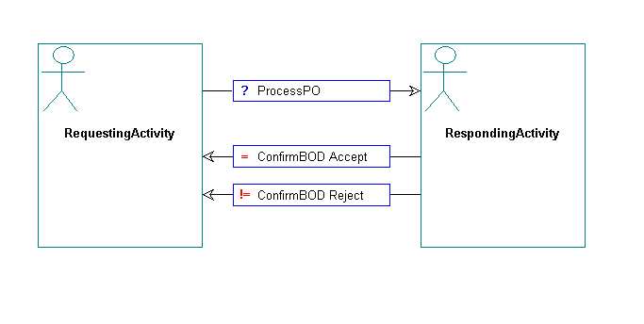

Binary Collaboration

The problem
Binary collaborations contain two modeling aspects:
- A control flow of transaction activities that specifies the rules for transitions between activities
- A participation flow that specifies which role is the initiator of each activity.

A first proposal is to have two separate diagrams to represent each of these aspects. The responsibility flow is described in a Sequence Diagram and the control flow in an Activity Diagram. The drawback is that we need to read the two diagrams to have an understanding of the whole collaboration.

Proposed solutions
The main idea is to have a common diagram for both the control flow and the participation flow. The control flow already has a well-defined notation.

UML Notation for Binary Collaboration
Swim lanes are available in Activity Diagram. However, the main purpose of swim lanes is to depict responsibility not participation: each swim lane object is responsible of the activities occurring inside its region.
The solution is to say that the transaction’s activities are owned by the initiating role. Activities are placed in the swim lane of the initiating role. Therefore, ownership of activities determines initiation.

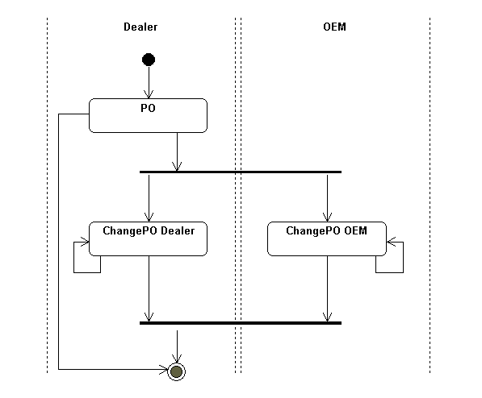

Extended Notation for Binary Collaboration
The extended notation takes into account that activities are not owned by roles inside a Binary-Collaboration. Therefore, the swim lane notation is not used. The notation shows at the same time the control flow and the participation flows.

