ebXML Tokyo POC
Proof-Of-Concept
Working Draft, October 11, 2000
This version:

0000.doc

Authors
- Krishna Sankar [ksankar@cisco.com]
- Mark Hale [hale@ajubasolutions.com]
- Philippe DeSmedt [PDeSmedt@viquity.com]
- Patil, Sanjay [Spatil@netfish.com]
Contributors
- Askary, Sid [saskary@netfish.com]
- Sigmund Handelman/Watson/IBM [swhandel@us.ibm.com]
- Hirotaka Hara [hara@flab.fujitsu.co.jp]
- Jacques Durand [jacques@savvion.com]
- Melanie Kudela [MKudela@uc-council.org]
- Nicholas Kassem[nick.kassem@eng.sun.com]

Abstract
This document acts as the controlling document for the Proof-of-concept initiative during the ebXML conference in Tokyo Nov. 6,2000 – Nov 9, 2000.
This document contains the business processes, the messages, the DTDs for the messages, the components and objects used inside those messages and examples.
It is the intention of this document to be as complete as possible so that a team of developers can choose the functionalities, implement them without any ambiguity, and achieve interoperability.
To achieve this, there will be references and links to other ebXML specifications, DTDs etc. It is the intention of the POC to implement key concepts of ebXML, which have ebXML specifications.
One of the major goals of this document is to provide traceability of the different messages, objects etc to the respective ebXML specifications. The aim of the POC is to showcase implementations of ebXML specifications.
Supporting Industry Verticals

This proof of concept will show implementations of business processes for Retail and Automotive Industries. These implementations are supported by the leading constituent bodies in these verticals: the Global Commerce Initiative (GCI) and Automotive Industry Action Group (AIAG), respectively. Their support of the effort is detailed below.
Global Commerce Initiative (GCI)

The Global Commerce Initiative involves UCC/EAN and represents the retail industry vertical market. These members along with their POC counterparts will be referred to as the “Retail Team” in the balance of this document.
The Retail Team has worked on provided use cases that are international or global. The business process reflects product item alignment and order exchange. The processes have the added benefit of producing a model that allows for the transport-level ebXML specifications to be tested inside of the scope of the POC.
The Retail team has provided DTDs, Schemas, and instances for use in the demonstration.
Automotive Industry Action Group (AIAG)

The team of ebXML members and AIAG members will be referred to as the “Automotive Team” in the balance of this document. The members the Automotive Team have also met at ebXML and X12 meetings.
The prime outputs of the Automotive Team have been a process model of the Automotive Supply Chain and a set of Core Blocks and Core Components that can be used to create business documents. These business documents can be used to instantiate business exchanges.
This work will be manifested in a Materials Management track in which the Automotive Team has provided DTDs, Schemas, and instances for use in the demonstration.
Referenced Documents
- [ebXML-TRP] Messaging Service Specification ebXML Transport, Routing & Packaging, Version 0.21c, 26 September 2000

- [ebXML-R&R] ebXML Registry And Repository Registry Services Proposal 2, Working Draft 10/02/2000 Version 0.8

- tpaXML Specification by IBM submitted to ebXML

Notational Conventions
The key words "MUST", "MUST NOT", "REQUIRED", "SHALL", "SHALL NOT", "SHOULD", "SHOULD NOT", "RECOMMENDED", "MAY", and "OPTIONAL" in this document are to be interpreted as described in Key Words for Use in RFC’s to Indicate Requirement Levels (RFC 2119).
Status of this Document
This document represents work in progress upon which no reliance should be made.
Document Version History
- Version 0.001: Initial version (not released)
- Version 0.002: Corrections based on internal review (not released)
- Version 0.003: More corretions
- Version 0.004: Initial Draft slated for voting by the members
- Version 0.005: Draft document sent for first level voting

Files
The DTDs and other related files can be downloaded from the URL <TBD>

Table of Contents
1 Introduction 7
1.1 Purpose 7
1.2 General Plan 8
1.3 Roles and Responsibilities 9
2 Scenarios and Flow 10
2.1 Demonstration Flow 10
2.2 Introduction 10
2.2.1 Stage 1 : BP Modeling and core components 11
2.2.2 Stage 2 : Building Partner Relationship configurations 12
2.2.3 Stage 3 : Business Transactions 12
2.3 Track 1 – Trading Partner Agreement (TPA) formation 13
2.3.1.1 Business Document DTD and Examples : 14
2.4 Track 2 – Retail use case 14
2.4.1 Step 1 : Item Alignment 15
2.4.1.1 Message Details & Examples: 16
2.4.2 Step 3 : Exchange Purchase Order 17
2.4.2.1 Message Details & Examples : 17
2.5 Track 2 – Automotive use case 19
2.5.1.1 Sequence Diagram : 19
2.5.1.2 Message Details and examples: 20
3 Participant Roles 21
4 Topology 23
5 Technical Details, Business messages & Examples 24
5.1.1 ebXML Message Structure 24
5.1.2 Packaging 25
5.1.3 Header 26
5.1.4 Payload 26
5.1.5 Transport 26
5.1.6 Trading Partner Profiles 27
Appendix A : Trading Partner Profile and TPA DTD (tpa_1_0_6.dtd) 28
Appendix B : Trading Partner Profile and TPA examples 32
Appendix B1 : PPv1.0.dtd 38
Appendix B2 : pp.xml 41
Appendix B3 : pav1.0.dtd 43
Appendix B4 : pa.xml 46
Appendix C : ItemV0.107200.dtd 54
Appendix D : ItemCreate.xml 62
Appendix E : ItemCreateAck.xml 69
Appendix F : ItemAlign.xml 70
Appendix G : ItemAlignAck.xml 71
Appendix H : OrderV0.1072400.dtd 72
Appendix I : OrderCreate.xml 74
Appendix J : OrderCreateAck.xml 75
Appendix K : OrderAcceptance.xml 76
Appendix L : OrderAcceptanceAck.xml 77
Appendix M : SimplePO_Attributes for V0.1072400.pdf 78
Appendix N : ASNV0.1.dtd 79
Appendix O : ASN.xml 82
Appendix P : ASNAck.xml 85
Appendix Q : ReceiptV0.1.dtd 86
Appendix R : Receipt.xml 89
Appendix S : ReceiptAck.xml 91
Appendix J : SimplePO_Attributes for V0.1072400.pdf. 92
Appendix Z : Caveats and Issues 96
Table of Figures
Figure 1 - top level electronic business stages 11
Figure 2 14
Figure 3 16
Figure 4 17
Figure 5 19
Figure 6 20

Table of Tables
Table 1: Terminology Mapping Table Error! Bookmark not defined.

Introduction

Purpose

We are sure there will be many changes to this section. In the end, this section should reflect the business messages (technological and marketing) we want to send out.

The purpose of the Proof of Concept is to :
- Build an interoperable, ebXML TRP infrastructure including reliable messaging and security
- Show ebXML support and interoperability for multiple industry verticals
- Exchange of business documents/messages according to ebXML TRP
- Show interoperable framework which is standards independent
  - As pointed out in a GCI document, with an open standard - interoperability will no longer be the issue. B2B requires infrastructure for message routing, delivery, directory, security, non-repudiation, retries, exception and above all the capability to link trading partners of all sizes from large to small and medium enterprises with cost effective solutions.
- Explore the viability of enabling dynamic trading networks
  - Discovery of partners in a repository
  - Trading partners forming trading agreements
  - Publishing and execution of business service interfaces
- Showcase the capabilities and integration of the ebXML RegRep
- Illustrate how the ebXML business process meta-model facility can be implemented in practice.
  - The workings of the business process and core component teams and their industry partners will be reflected in this scoped demonstration.
  - Showcase the modeling/Assembly of business processes for new and legacy practices in alignment with the ebXML metamodel

General Plan

The POC demo consists of a trading network, which implements the following general scenarios.
Supplier & Registry | Register Profile with RR
Buyer & Registry | Register/Retrieve Profiles
Buyer & Registry | Get information about seller
Buyer & Seller | TPA negotiation
Buyer & Seller | Exchange business documents as per the automotive vertical use case and/or the retail vertical use case

There will be three sequential Tracks :
- Trading Partner Agreement (TPA) formation – consists of interacting with the ebXML registry/repository in order to get trading partner profiles and then interacting with partners to arrive at a Trading Partner agreement.
- Retail Vertical Scenario – consists of two use cases, Item Alignment and Order exchange; exchanging retail vertical payload over the transport based on current ebXML TRP specs, using the ebXML regrep and retail vertical business process as iterated by GCI.
- Automotive Vertical Scenario – consists of exchanging ASN (Advanced Shipping Notice); exchanging automotive vertical payload over the transport based on current ebXML TRP specs, using the ebXML regrep and automotive business process as defined by AIAG.
As there are many participants, some will participate in Track 1, some in Track 2 and some in Track 3. All tacks will use common TRP, regrep interfaces and hubs thus illustrating the interoperability of ebXML.
Note (temporary) : In some sense, the Tokyo demo = SJ Demo + regrep + Automotive Payload/BP + Retail BP + BP/cc meta-model.

Roles and Responsibilities
The simulated network consists of trading partners providing services. The services provide fall under one or more of the following roles.
Note : Not all roles will be demonstrated at the Tokyo POC.
Buyer/Customer | A party who normally initiates a transaction with a seller
Seller/ Supplier | A party who has goods to sell – normally responds to a business message from a buyer
Hub/Routing Provider | An intermediate entity that routes documents between source and target, optionally providing value added services as part of the process  Note : Requesters can communicate to responders via the hub or directly. That flexibility allows the demonstration environment to simulate point-to-point, hub and spoke and federated models of communication.
Registry Infrastructure Provider | An entity which provides a registry / repository to store profiles, tpas etc. This entity provides the six or so interfaces as defined by the regrep specification
Registry/Broker Services provider | A party, which provides vale added services, like discovery mechanisms, tpa merging facility etc over the regreg. It is envisioned that the Registry/Broker Services provider can provide interoperable interfaces with other standards like eCO, UDDI et al. Also the broker can provide aggregation over multiple registries
BP/cc Provider | Model and store BP/cc et al in the ebXML regrep
Registry User | A party who can use the regrep for storing Profiles, retrieving profiles, business processes, tpas etc.

Scenarios and Flow

Demonstration Flow

The demonstration will be an introduction followed by three sequential tracks. Each track introduces a new aspect of ebXML but all the tracks use the same ebXML framework incl TRP, Registry/Repository and other concepts.
All the three scenarios exchange business documents (as payloads from different verticals) over the interoperable ebXML TRP. One of the major advantages of ebXML is this payload neutral interoperable message layer. The message layer also includes security and reliability [ebXML-TRP].

Introduction

Most probably, this section will be presented by Klaus with some slides. I have some pointers to the topics we need to cover in the introduction. The major topics would be the ebXML activities - BP/CC and it’s positioning, general steps involved et al

The three essential stages of an electronic business are :
- Business Process Modeling and leveraging core components
- Building Partner relationship configurations either using ebXML Registry/Repository or using other communication methods
- Engaging in Business Transactions by exchanging business documents over interoperable ebXML TRP.
Each stage consists of multiple steps and activities. Figure 1 schematically shows the general top-level activities.
A business process meta-model and its constituent core components are being developed in their respective working groups. The model, components, and resulting business documents are implicit to any implementation of an ebXML conversation. The importance of a meta-model is to provide a consistent methodology for deriving business processes throughout the ebXML verticals. The hierarchy structures business process activities from categorization to functional design and implementation. As this occurs, core components are bound to the business messages in their context. The methodology leading to this formation will be highlighted in presentation form as an introduction to the proof of concept.
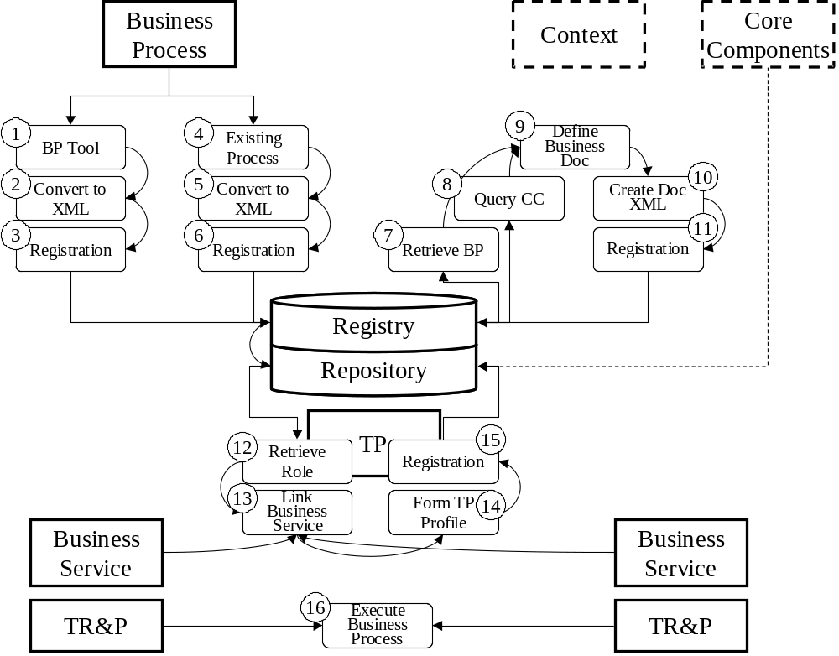
Figure 1 - top level electronic business stages

Stage 1 : BP Modeling and core components

The BP Modeling/CC consists of creation of a new business processes and storage in the registry/repository or conversion of an existing business process for storage in the registry/repository. The activities required to achieve this step are :
- Creation of a new business processes and storage in the registry/repository
1. Define process in UML tool
2. Translate business process to XML
3. Register business process in repository as XML

b) Conversion of an existing business process for storage in the registry/repository

4. Model business process in existing tool
5. Translate business process to XML
6. Register business process in repository as XML

Stage 2 : Building Partner Relationship configurations

This stage consists of the steps to register and discover business processes in the repository by trading partners incl formation of profiles, their retrieval, and identification of business service interfaces. The activities required to achieve this stage are :
- Retrieve business process from repository for use in defining business documents
- Query repository for available core components for use in defining business documents
- Define business documents using business process contexts and core components
- Create business documents as XML schemas (or DTDs)
- Register business documents as XML in repository
- Retrieve one role from a business process for use in defining TPP profile, repeat for other role
- Link profile to respective business service interfaces
- Form profile in XML format for registration
- Register TPP profiles as XML for use in configuring business service interfaces
Track 1 of the POC will demonstrate this stage of ebusiness

Stage 3 : Business Transactions

This is where the business process models are executed in accordance with a conversation as defined in the business process model, using their respective TPP profiles as start up configuration parameters.
Tracks 2 & 3 of the POC will demonstrate this stage of ebusiness. Track 2 demonstrates the retail vertical and track 3 the automotive vertical

Track 1 – Trading Partner Agreement (TPA) formation

There are two ways of configuring systems for interaction – either pre-configuration of static files or dynamic discovery and TP exchange interacting with the ebXML registry/repository.
The POC demonstrates both methods. In the case of static TPA formation, it is assumed that the TPA was arrived at by out-of-band methods.
It is worth noting that ebXML and this POC illustrate/include the scenarios with and without interaction with a registry.
It is true that working with a registry entitles one with richer functionality; it is also true that every business might not have the resources or might not want to interact with a registry. Therefore, a registry is not a mandatory component.
In the case of dynamic discovery and TP exchange, the partners get information from an ebXML Registry/Repository as defined in the ebXML specification [ebXML-R&R]. The top-level sequence diagram for this interaction is shown in Figure 1.
For the Tokyo POC demo, the Profiles will be pre-loaded into the registry using a conversation not explicitly shown in the demonstration. The Tokyo POC will show the conversation as depicted in Figure 1. Registry services are used to discover a partner and request the appropriate profile as shown in Steps 1-4. A baseline implementation will be a union for merging the profiles as done in Step 5. Buyers can use more sophisticated agreement schemes, but it is not required for compliance. Finally, in Steps 6-9 the TPA is agreed upon and is maintained by Buyer and Seller.
Note on TPA discovery and TPA negotiation:
For Tokyo POC, we will show dynamic discovery of content (e.g. PP), based on browse and drill down queries between Regsitry clinet and registry based on RR Services v0.8 spec. We will not show dynamic negotiation of TPA between buyer and seller.

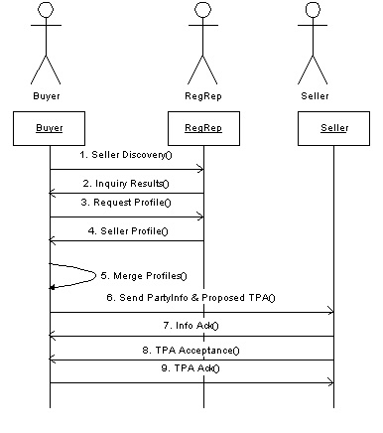
Figure 2

Business Document DTD and Examples :

Appendix A | TPA_1_0_6 DTD
Appendix B | Business Document Example
Appendix B1 | PP.xml (Partner profile)
Appendix B2 | TPA.xml

Track 2 – Retail use case

The retail industry chain contains two commercial conversations as shown be their collaborations below. The collaborations are Item Alignment and Order Exchange. The BusinessOperationsMap Industry is Retail, the BusinessArea is Supplier, the ProcessArea is Order Management, the BusinessProcess is Purchasing, and the business collaborations are Align Items and Order Items. Notice that the Order Exchange collaboration is dependent on a successful completion of Item Alignment. During ordering, Items are referred to by unique identifiers corresponding to their aligned descriptions.

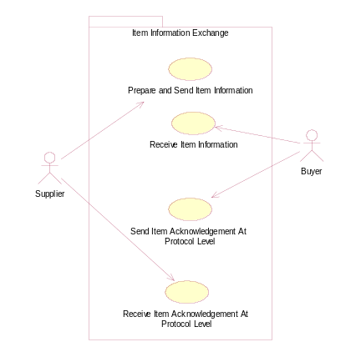 | 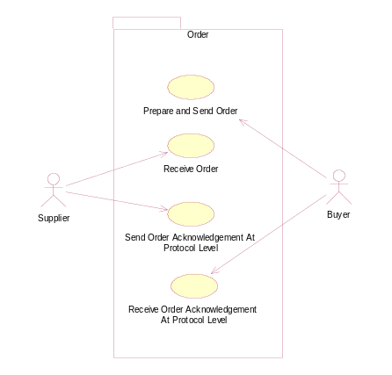

This scenario can be demonstrated with or without the use of ebXML registry. If the scenario is without the registry, then the configuration files and TP are static – manually created by an out-of-band process like e-mail or telephone conversation.
If the participant is implementing this scenario with a registry, then that organization will have to show Track 1 (for building the relationship) and then Track 2 (engaging a business transaction). As we had mentioned earlier, ebXML and POC accommodates both ways.

Step 1 : Item Alignment

This is the item synchronization functionality as defined by EAN/UCC, which enables item information exchange and synchronization between GCI trading partners. The “owner / manufacturer” of the Items communicates item information to the “customer/buyer “ of the authorized/approved items over the internet either directly or through intermediaries such as Exchanges. The receipt of this item information is positively acknowledged at a communication protocol level. The top level sequence diagram is shown in Figure 2.
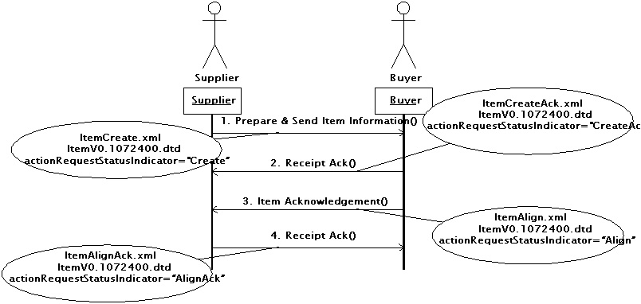
Figure 3
This scenario demonstrates the exchange of Item Alignment payload as per GCI standards over ebXML TRP using implicit BP/CC.

Message Details & Examples:

Appendix C | ItemV0.107200.dtd
Appendix D | ItemCreate.xml
Appendix E | ItemCreateAck.xml
Appendix F | ItemAlign.xml
Appendix G | ItemAlignAck.xml

Step 3 : Exchange Purchase Order

After the buyer has the item information, the next logical step is to order those items. In this scenario, the “customer/ buyer” communicates a simple Purchase Order for the above communicated items to the “owner / manufacturer” for specific quantities and delivery of them at specific address and delivery date. The receipt of this Simple Purchase Order needs to be positively acknowledged at a communication protocol level. The top level sequence diagram is shown in Figure 3.
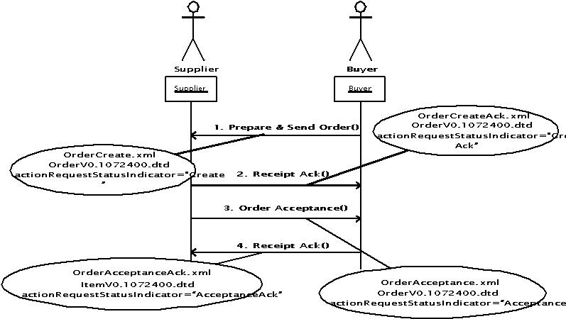
Figure 4
This scenario demonstrates the exchange of Purchase Order payload as per GCI standards over ebXML TRP using implicit BP/CC.

Message Details & Examples :

Appendix H | OrderV0.1072400.dtd
Appendix I | OrderCreate.xml
Appendix J | OrderCreateAck.xml
Appendix K | OrderAcceptance.xml
Appendix L | OrderAcceptanceAck.xml
Appendix M | SimplePO_Attributes for V0.1072400.pdf.  The Global Data Dictionary which should be used as reference material to support the class model and the XML files.

Track 2 – Automotive use case
The automotive supply chain contains two commercial transactions as shown in the use case below. They are Notify of Shipment and Notify of Receipt. For more detailed information see [ebXML-prop3] The BusinessOperationsMap Industry is Automotive, the BusinessArea is Manufacturing, the ProcessArea is Material Management, the BusinessProcess is Replenish Materials and the BusinessCollaboration is Ship Materials.

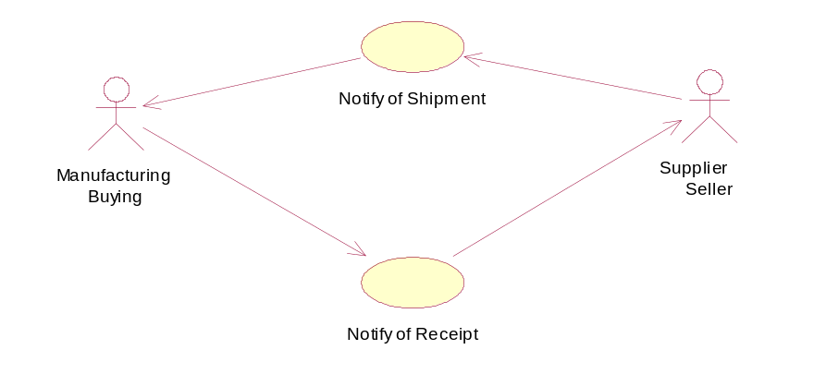
Figure 5
The structure of each transaction is as follows.
  - Notify of Shipment : In this scenario (part of automotive supply chain vertical) the seller/supplier informs the buyer that that materials have been shipped. The Business Document exchanged is “Advance Shipment Notification”
  - Notify of Receipt : In this scenario, the buyer informs the supplier on the status of a recent material receipt. The Business Document exchanged is “Receiving Advice”.

If the participant is implementing this scenario with a registry, then that organization will have to show Track 1 (for building the relationship) and then Track 3 (engaging a business transaction). As we had mentioned earlier, ebXML and POC accommodates both ways.

Sequence Diagram :

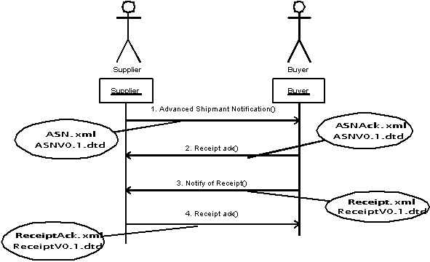
Figure 6

Message Details and examples:

Appendix N | ASNV0.1.dtd
Appendix O | ASN.xml
Appendix P | ASNAck.xml
Appendix Q | ReceiptV0.1.dtd
Appendix R | Receipt.xml
Appendix S | ReceiptAck.xml

Participant Roles
The following table details the roles that individual participants will play within the demo environment.
The two tables are a preliminary first cut. If there are any contentions, we can refine this as we move along.
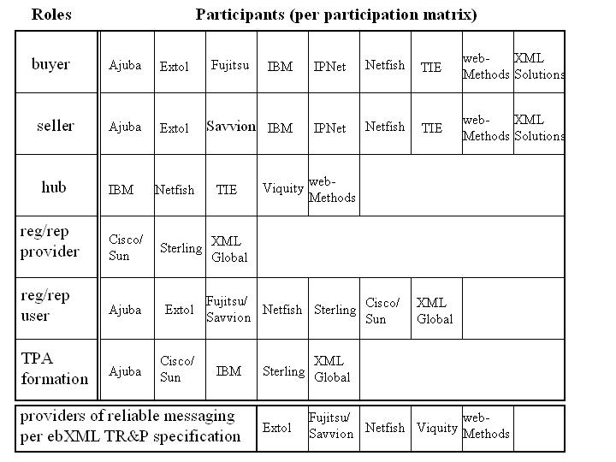
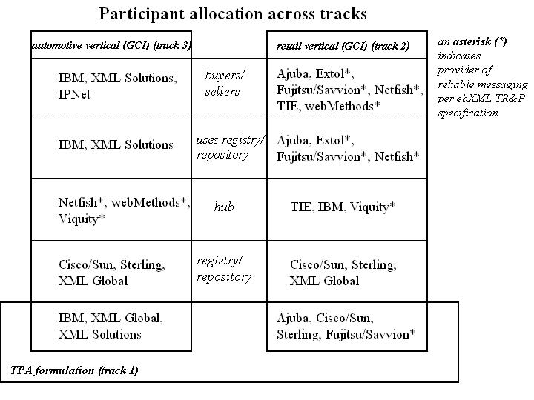

Topology
This section focuses on identifying the pairings (groupings) of participants in the various stages of the demonstration, the automotive / retail scenarios shown, and on the aspects of the ebXML messaging capabilities that will be shown [security, reliable messaging].

<<TBD at f2f>>

Technical Details, Business messages & Examples
<< I am keeping the old document sections here. We need a TRP example here. >>

ebXML Message Structure
An ebXML Message consists of:
- an outer Communication Protocol Envelope, such as HTTP or SMTP,
- an inner communication “protocol independent” ebXML Message Envelope, specified using MIME multipart/related, that contains the two main parts of the Message:
- an ebXML Header Container that is used to envelope one ebXML Header Document, and
- an optional, single ebXML Payload Container that MUST be used to envelope the real payload (transferred data) of the Message

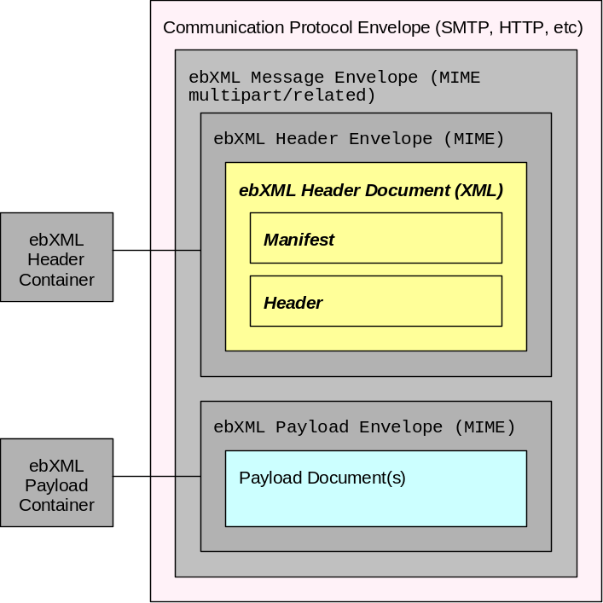
Figure 7 ebXML Message Structure
Note: The Courier font is used to represent MIME components. Items shown in bold italics represent XML items.

An ebXML Header Envelope and an ebXML Payload Envelop are constructed of standard, MIME components.

An ebXML Header (or Payload) Document is the content of the standard MIME part and is:
- an XML document in an ebXML Header, or
- an XML or some other document for the ebXML Payload

Packaging

The most recent version of the ebXML TR&P Packaging specification [ebXML-TRP] should be followed for demonstration communications. Values in bold italic blue are generated dynamically by the participant according to the pattern shown. Values in bold are fixed for a particular message, but may change for different messages. Values in normal text are fixed and common to all messages. An example is shown below:
<<http example >>
Content-Type: multipart/related;
type=”application/vnd.eb+xml”;
charset="iso-8859-1";
version=0.1;
boundary=unique-string-within-message
Content-Length: int-length

--unique-string-within-message
Content-ID: uid@originator-domain
Content-Length: int-length [units based on content-transfer-encoding]
Content-Type: application/vnd.eb+xml

<?xml version="1.0" encoding="UTF-8"?>
<ebXMLHeader>
....
</ebXMLHeader>
--unique-string-within-message
Content-ID: uid@originator-domain
Content-Length: int-length [units based on content-transfer-encoding]
Content-Type: application/xml

<RN-Action-Message> or <RN-Signal-Message>

--unique-string-within-message--

Header
The most recent version of the ebXML TR&P Header specification [ebXML-TRP] should be followed for demonstration communications. The following sections show the header values for each of the four messages within the Create Purchase Order scenario. Values in bold italic blue are generated dynamically by the participant according to the pattern shown. Values in bold are fixed for a particular message, but may change for different messages. Values in normal text are fixed and common to all messages.

Payload

The payloads for the messages to be exchanged should conform to the appropriate industry vertical payloads.

Transport
The ebXML TR&P specification is transport independent. Therefore, the demonstration environment will allow communication via multiple protocols. Allowing multiple protocols (a) follows the spirit of the ebXML TRP specification; (b) enables broader participation from the member base; and (c) provides a more compelling demonstration. It must be noted that the most common protocol to be used at this time is HTTP. Participants deviating from that protocol must ensure that other participants are able to communicate via the selected protocol in order to participate in the demonstration scenario. Current “Hub” participants can process only the HTTP protocol.
It is suggested that, for the HTTP protocol, a minimal header should be utilized within the transport envelope. The example HTTP header within the specification contains multiple non-required fields. The following header is proposed for use in the demonstration environment with the extraneous information proposed for removal struck-through:

POST destination-server-URI HTTP/1.1
Accept: multipart/related
Accept-Language: en-us
Accept-Encoding: gzip, deflate
User-Agent: Group 8760 InsideAgent
Host: destination-server-domain:destination-server-port
Connection: Keep-Alive
Content-Type: multipart/related;
type=”application/vnd.eb+xml”;
charset="iso-8859-1";
version=0.1;
boundary=unique-string-within-message
Content-Length: int-length

--unique-string-within-message

Trading Partner Profiles
Each participating vendor must declare certain critical connectivity information in order to help ensure interoperability and ease of demonstration assembly.
<< This sectiuon would contain the Partner Profiles of the six or seven partners who will use the registry and interact with it. These profiles will be preloaded into the registry by an out-of-band method which is not part of the POC.

Appendix A : Trading Partner Profile and TPA DTD (tpa_1_0_6.dtd)

<!--**********************************************************************-->
<!-- (C)Copyright IBM Corporation 2000; all rights reserved -->
<!-- TPA DTD -->
<!-- File name: TPA.dtd -->
<!--**********************************************************************-->
<!--**********************************************************************-->
<!ELEMENT TPA (TPAInfo , DeliveryChannelSet , Transport+ , DocExchange+ , BusinessProtocol , Comment* )>
<!ATTLIST TPA xmlns CDATA #IMPLIED >
<!--The xmlns attribute identifies the XML Schema document when a TPA is -->
<!--parsed by an XML Schema parser. It is ignored by a DTD parser. -->
<!--**********************************************************************-->
<!-- General information -->
<!--**********************************************************************-->
<!ELEMENT TPAInfo (TPAName , TPAType? , Role? , Participants , Arbitrator? , Duration? , InvocationLimit? , ConcurrentConversations? , ConversationLife? )>
<!ELEMENT TPAName (#PCDATA )>
<!ELEMENT TPAType (Protocol , Version , Type )>
<!ELEMENT Protocol (#PCDATA )>
<!ELEMENT Version (#PCDATA )>
<!ELEMENT Type (#PCDATA )>
<!--**********************************************************************-->
<!-- Specification of Roles and Participants -->
<!--**********************************************************************-->
<!ELEMENT Role (RoleDefn+ )>
<!ELEMENT RoleDefn (RoleName , RolePlayer )>
<!ELEMENT RoleName (#PCDATA )>
<!ELEMENT RolePlayer (#PCDATA )>
<!ELEMENT Participants (Member+ )>
<!ELEMENT Member (PartyName , CompanyTelephone , Address+ , Contact+ )>
<!ATTLIST Member MemberId CDATA #REQUIRED
IdCodeType CDATA #REQUIRED >
<!ELEMENT PartyName (#PCDATA )>
<!ATTLIST PartyName Partyname ID #REQUIRED >
<!ELEMENT CompanyTelephone (#PCDATA )>
<!ELEMENT Address (AddressType , AddressLine+ , City , State , Zip , Country )>
<!ELEMENT AddressType (#PCDATA )>
<!ELEMENT AddressLine (#PCDATA )>
<!ELEMENT City (#PCDATA )>
<!ELEMENT State (#PCDATA )>
<!ELEMENT Zip (#PCDATA )>
<!ELEMENT Country (#PCDATA )>
<!ELEMENT Contact (LastName , FirstName , MiddleName , Title , ContactTelephone+ , EMail+ , Fax? )>
<!ATTLIST Contact Type (primary | secondary ) 'primary' >
<!ELEMENT LastName (#PCDATA )>
<!ELEMENT FirstName (#PCDATA )>
<!ELEMENT MiddleName (#PCDATA )>
<!ELEMENT Title (#PCDATA )>
<!ELEMENT ContactTelephone (#PCDATA )>
<!ATTLIST ContactTelephone Type (primary | secondary ) 'primary' >
<!ELEMENT EMail (#PCDATA )>
<!ATTLIST EMail Type (primary | secondary ) 'primary' >
<!ELEMENT Fax (#PCDATA )>
<!ELEMENT Arbitrator (#PCDATA )>
<!ATTLIST Arbitrator MemberId CDATA #REQUIRED
IdCodeType CDATA #REQUIRED >
<!ELEMENT Duration (Start? , End? )>
<!ELEMENT Start (Date , Time )>
<!ELEMENT End (Date , Time )>
<!ELEMENT Date (#PCDATA )>
<!ELEMENT Time (#PCDATA )>
<!ELEMENT InvocationLimit (#PCDATA )>
<!ELEMENT ConcurrentConversations (#PCDATA )>
<!ELEMENT ConversationLife (#PCDATA )>
<!--**********************************************************************-->
<!-- Specification of Delivery Channels -->
<!--**********************************************************************-->
<!ELEMENT DeliveryChannelSet (DeliveryChannel+ )>
<!ELEMENT DeliveryChannel (Version? )>
<!ATTLIST DeliveryChannel ChannelId ID #REQUIRED
TransportId IDREF #REQUIRED
DocExchangeId IDREF #REQUIRED >
<!--**********************************************************************-->
<!-- Specification of Transport Protocol -->
<!--**********************************************************************-->
<!ELEMENT Transport (Communication , TransportSecurity? )>
<!ATTLIST Transport TransportId ID #REQUIRED >
<!ELEMENT Communication (HTTP | SMTP | VANEDI | FTP )>
<!ELEMENT HTTP (Version? , HTTPNode+ , TransportEncoding? , TransportTimeout? , NetworkDelay? )>
<!ELEMENT SMTP (Version? , SMTPNode+ , TransportEncoding? , TransportTimeout? , NetworkDelay? )>
<!ELEMENT VANEDI (Version? , VANEDINode+ , TransportEncoding? , TransportTimeout? , NetworkDelay? )>
<!ELEMENT FTP (Version? , FTPNode+ , TransportEncoding? , TransportTimeout? , NetworkDelay? )>
<!ELEMENT HTTPNode (OrgName , HTTPAddress )>
<!ELEMENT SMTPNode (OrgName , SMTPAddress )>
<!ELEMENT VANEDINode (OrgName , VANEDIAddress )>
<!ELEMENT FTPNode (OrgName , FTPAddress , TransferType , PassiveMode , ControlPort )>
<!ELEMENT OrgName EMPTY>
<!ATTLIST OrgName Partyname IDREF #REQUIRED >
<!ELEMENT HTTPAddress (LogonURL? , RequestURL? , ResponseURL? )>
<!ELEMENT LogonURL (#PCDATA )>
<!ELEMENT RequestURL (#PCDATA )>
<!ELEMENT ResponseURL (#PCDATA )>
<!ELEMENT VANEDIAddress (InBox , OutBox )>
<!ELEMENT InBox (#PCDATA )>
<!ELEMENT OutBox (#PCDATA )>
<!ELEMENT SMTPAddress (#PCDATA )>
<!ELEMENT FTPAddress (InDirectory , OutDirectory )>
<!ELEMENT InDirectory (#PCDATA )>
<!ELEMENT OutDirectory (#PCDATA )>
<!ELEMENT TransferType (#PCDATA )>
<!ELEMENT PassiveMode (#PCDATA )>
<!ELEMENT ControlPort (#PCDATA )>
<!ELEMENT TransportEncoding (#PCDATA )>
<!ELEMENT TransportTimeout (Timeout , Retries , RetryInterval )>
<!ELEMENT Timeout (#PCDATA )>
<!ELEMENT Retries (#PCDATA )>
<!ELEMENT RetryInterval (#PCDATA )>
<!ELEMENT NetworkDelay (#PCDATA )>
<!--**********************************************************************-->
<!-- Specification of Transport Security Protocol -->
<!--**********************************************************************-->
<!ELEMENT TransportSecurity (Encryption? , Authentication? )>
<!ELEMENT Encryption (Protocol , Version? , Certificate )>
<!ELEMENT Authentication (PasswordAuthentication? , CertificateAuthentication? )>
<!ELEMENT PasswordAuthentication (Protocol , Version? , LogonInfo? )>
<!ELEMENT LogonInfo (LogonParty+ )>
<!ELEMENT LogonParty (OrgName , UserId , Password )>
<!ELEMENT UserId (#PCDATA )>
<!ELEMENT Password (#PCDATA )>
<!ELEMENT CertificateAuthentication (Protocol , Version? , Certificate )>
<!ELEMENT Certificate (CertType , KeyLength , Party+ )>
<!ELEMENT CertType (#PCDATA )>
<!ELEMENT KeyLength (#PCDATA )>
<!ELEMENT Party (OrgName , OrgCertSource? , IssuerOrgName , IssuerCertSource )>
<!ELEMENT OrgCertSource (#PCDATA )>
<!ELEMENT IssuerOrgName (#PCDATA )>
<!ELEMENT IssuerCertSource (#PCDATA )>
<!--**********************************************************************-->
<!-- Specification of DocExchange Protocol -->
<!--**********************************************************************-->
<!ELEMENT DocExchange (MessageEncoding? , MessageIdempotency , MessageRetries? , MessageSecurity? )>
<!ATTLIST DocExchange DocExchangeId ID #REQUIRED >
<!ELEMENT MessageEncoding (#PCDATA )>
<!ELEMENT MessageIdempotency (#PCDATA )>
<!ELEMENT MessageRetries (Retries , RetryInterval )>
<!--**********************************************************************-->
<!-- Specification of Message Security Protocol -->
<!--**********************************************************************-->
<!ELEMENT MessageSecurity (NonRepudiation? , DigitalEnvelope? )>
<!ELEMENT NonRepudiation (Protocol , Version? , HashFunction , EncryptionAlgorithm , SignatureAlgorithm , Certificate )>
<!ELEMENT HashFunction (#PCDATA )>
<!ELEMENT EncryptionAlgorithm (#PCDATA )>
<!ELEMENT SignatureAlgorithm (#PCDATA )>
<!ELEMENT DigitalEnvelope (Protocol? , Version? , EncryptionAlgorithm , Certificate? )>
<!--**********************************************************************-->
<!-- Specification of Business Protocol -->
<!--**********************************************************************-->
<!ELEMENT BusinessProtocol (MessageSet , BusinessInterface )>
<!ELEMENT MessageSet (#PCDATA )>
<!ELEMENT BusinessInterface (ServiceInterface+ )>
<!ELEMENT ServiceInterface (OrgName , TaskName? , ActionMenu , ServerServiceTime? , StartEnabled? , TerminateConversation? , ServiceSecurity? )>
<!ATTLIST ServiceInterface InterfaceId CDATA #REQUIRED >
<!ELEMENT TaskName (#PCDATA )>
<!ELEMENT ActionMenu (Action+ )>
<!ELEMENT Action (Request , Response? , ExceptionResponse? , ResponseServiceTime? , Sequencing? , ActionSecurity? )>
<!ATTLIST Action ActionId CDATA #REQUIRED
Type (basic | concurrent ) 'basic'
Invocation (syncOnly | asyncOnly ) 'asyncOnly' >
<!--**********************************************************************-->
<!-- Each Request is identified by a request name. -->
<!--**********************************************************************-->
<!ELEMENT Request (RequestName , RequestMessage , Channel? )>
<!ELEMENT RequestName (#PCDATA )>
<!ELEMENT RequestMessage (#PCDATA )>
<!--**********************************************************************-->
<!-- Specify optional binding to delivery channel -->
<!--**********************************************************************-->
<!ELEMENT Channel EMPTY>
<!ATTLIST Channel ChannelId IDREF #REQUIRED >
<!--**********************************************************************-->
<!-- Response is a reply from the server following a prior -->
<!-- request invocation. There can be zero, one or multiple responses for -->
<!-- a given request, depending on the application. -->
<!--**********************************************************************-->
<!ELEMENT Response (ResponseName+ )>
<!ELEMENT ResponseName (#PCDATA )>
<!ATTLIST ResponseName Required (yes | no ) 'yes' >
<!ELEMENT ExceptionResponse (ExceptionResponseName+ )>
<!ELEMENT ExceptionResponseName (#PCDATA )>
<!ELEMENT ResponseServiceTime (ServiceTime , Presume? )>
<!ELEMENT ServiceTime (#PCDATA )>
<!ELEMENT Presume (#PCDATA )>
<!--**********************************************************************-->
<!-- Specify none or more sequencing rules to be applied to this action -->
<!--**********************************************************************-->
<!ELEMENT Sequencing (Enable? , Disable? )>
<!ELEMENT Enable (RequestName+ )>
<!ELEMENT Disable (RequestName+ )>
<!--**********************************************************************-->
<!-- Specify ActionSecurity yes for this action to overide the message -->
<!-- security default defined in ServiceSecurity. -->
<!-- No Need to specify this tag if default is no -->
<!--**********************************************************************-->
<!ELEMENT ActionSecurity (#PCDATA )>
<!--**********************************************************************-->
<!-- Service time-out if specified is the default time-out for actions -->
<!-- that do not have time-out defined. -->
<!--**********************************************************************-->
<!ELEMENT ServerServiceTime (ServiceTime , Presume? )>
<!--**********************************************************************-->
<!ELEMENT StartEnabled (RequestName+ )>
<!ELEMENT TerminateConversation (RequestName+ )>
<!--**********************************************************************-->
<!-- Specify default message security for all actions in the server. -->
<!-- Value is yes. No Need to specify this tag if message security not -->
<!-- wanted since default is no. -->
<!--**********************************************************************-->
<!ELEMENT ServiceSecurity (#PCDATA )>
<!--**********************************************************************-->
<!ELEMENT Comment (#PCDATA )>

Appendix B : Trading Partner Profile and TPA examples

<?xml version = "1.0"?>
<!--DOCTYPE TPA SYSTEM "tpa_1_0_6.dtd"-->

<!--Note: above URL will actually point to a URL in the repository for the schema for TPAML-->
<TPA>
<TPAInfo>
<TPAName>Sample TPA between Registry client and Registry Service</TPAName>
<TPAType>
<Protocol>ebXML</Protocol>
<Version>0.1</Version>
<Type>RegistryServices</Type>
</TPAType>
<Role>
<RoleDefn>
<RoleName>RegistryClient</RoleName>
<RolePlayer/>
</RoleDefn>
<RoleDefn>
<RoleName>RegistryService</RoleName>
<RolePlayer/>
</RoleDefn>
</Role>
<Participants>
<Member IdCodeType = "DUNS" MemberId = "333333333">
<PartyName Partyname = "CiscoRegistryClient">CiscoRegistryClient</PartyName>
<CompanyTelephone/>
<Address>
<AddressType>location</AddressType>
<AddressLine>
</AddressLine>
<City>
</City>
<State>
</State>
<Zip>
</Zip>
<Country>
</Country>
</Address>
<Contact Type = "primary">
<LastName>Sankar</LastName>
<FirstName>Krishna</FirstName>
<MiddleName>
</MiddleName>
<Title>
</Title>
<ContactTelephone Type = "primary">123-456-7890</ContactTelephone>
<EMail Type = "primary">ksankar@cisco.com</EMail>
</Contact>
</Member>
<Member IdCodeType = "DUNS" MemberId = "000000000">
<PartyName Partyname = "SunRegistryService">SunRegistryService</PartyName>
<CompanyTelephone>
</CompanyTelephone>
<Address>
<AddressType>location</AddressType>
<AddressLine>
</AddressLine>
<City>
</City>
<State>
</State>
<Zip>
</Zip>
<Country>USA</Country>
</Address>
<Contact Type = "primary">
<LastName>Najmi</LastName>
<FirstName>Farrukh</FirstName>
<MiddleName>Salahudin</MiddleName>
<Title>
</Title>
<ContactTelephone Type = "primary">781-442-0703</ContactTelephone>
<EMail Type = "primary">najmi@east.sun.com</EMail>
</Contact>
</Member>
</Participants>
<Duration>
<Start>
<Date>20000725</Date>
<Time>000000.000Z</Time>
</Start>
<End>
<Date>20001231</Date>
<Time>000000.000Z</Time>
</End>
</Duration>
</TPAInfo>
<DeliveryChannelSet>
<DeliveryChannel ChannelId = "id_registry_http_transport_channel" TransportId = "id_registry_http_transport" DocExchangeId = "id_doc_exchange"/>
<DeliveryChannel ChannelId = "id_registryclient_http_transport_channel" TransportId = "id_registryclient_http_transport" DocExchangeId = "id_doc_exchange"/>
</DeliveryChannelSet>
<Transport TransportId = "id_registry_http_transport">
<Communication>
<HTTP>
<Version>1.1</Version>
<HTTPNode>
<OrgName Partyname = "SunRegistryService"/>
<HTTPAddress>
<RequestURL>http://10.0.0.0:/servlet/RegistryService</RequestURL>
</HTTPAddress>
</HTTPNode>
<TransportEncoding>ebXML</TransportEncoding>
</HTTP>
</Communication>
</Transport>
<Transport TransportId = "id_registryclient_http_transport">
<Communication>
<HTTP>
<Version>1.1</Version>
<HTTPNode>
<OrgName Partyname = "CiscoRegistryClient"/>
<HTTPAddress>
<RequestURL>http://10.0.0.112:8000/servlet/RegistryClient</RequestURL>
</HTTPAddress>
</HTTPNode>
<TransportEncoding>ebXML</TransportEncoding>
</HTTP>
</Communication>
</Transport>
<DocExchange DocExchangeId = "id_doc_exchange">
<MessageIdempotency>required</MessageIdempotency>
</DocExchange>
<BusinessProtocol>
<MessageSet>ebXML Registry Service</MessageSet>
<BusinessInterface>

<!--Begin Interfaces implemented by RegistryService-->
<ServiceInterface InterfaceId = "Registry">
<OrgName Partyname = "SunRegistryService"/>
<TaskName>Registry</TaskName>
<ActionMenu>
<Action Type = "basic" Invocation = "asyncOnly" ActionId = "registerParty">
<Request>
<RequestName>RegisterPartyRequest</RequestName>
<RequestMessage>RegisterPartyRequest</RequestMessage>
<Channel ChannelId = "id_registry_http_transport_channel"/>
</Request>
<Response>
<ResponseName Required = "yes">RequestAcceptedResponse</ResponseName>
</Response>
<ExceptionResponse>
<ExceptionResponseName>EbXMLError</ExceptionResponseName>
</ExceptionResponse>

</Action>
</ActionMenu>
</ServiceInterface>
<ServiceInterface InterfaceId = "ObjectManager">
<OrgName Partyname = "SunRegistryService"/>
<TaskName>ObjectManager</TaskName>
<ActionMenu>
<Action Type = "basic" Invocation = "asyncOnly" ActionId = "submitObjects">
<Request>
<RequestName>SubmitObjectsRequest</RequestName>
<RequestMessage>SubmitObjectsRequest</RequestMessage>
<Channel ChannelId = "id_registry_http_transport_channel"/>
</Request>
<Response>
<ResponseName Required = "yes">RequestAcceptedResponse</ResponseName>
</Response>
<ExceptionResponse>
<ExceptionResponseName>EbXMLError</ExceptionResponseName>
</ExceptionResponse>

</Action>

<Action Type = "basic" Invocation = "asyncOnly" ActionId = "approveObjects">
<Request>
<RequestName>ApproveObjectsRequest</RequestName>
<RequestMessage>ApproveObjectsRequest</RequestMessage>
<Channel ChannelId = "id_registry_http_transport_channel"/>
</Request>
<Response>
<ResponseName Required = "yes">RequestAcceptedResponse</ResponseName>
</Response>
<ExceptionResponse>
<ExceptionResponseName>EbXMLError</ExceptionResponseName>
</ExceptionResponse>

</Action>

<Action Type = "basic" Invocation = "asyncOnly" ActionId = "deprecateObjects">
<Request>
<RequestName>DeprecateObjectsRequest</RequestName>
<RequestMessage>DeprecateObjectsRequest</RequestMessage>
<Channel ChannelId = "id_registry_http_transport_channel"/>
</Request>
<Response>
<ResponseName Required = "yes">RequestAcceptedResponse</ResponseName>
</Response>
<ExceptionResponse>
<ExceptionResponseName>EbXMLError</ExceptionResponseName>
</ExceptionResponse>

</Action>

<Action Type = "basic" Invocation = "asyncOnly" ActionId = "removeObjects">
<Request>
<RequestName>RemoveObjectsRequest</RequestName>
<RequestMessage>RemoveObjectsRequest</RequestMessage>
<Channel ChannelId = "id_registry_http_transport_channel"/>
</Request>
<Response>
<ResponseName Required = "yes">RequestAcceptedResponse</ResponseName>
</Response>
<ExceptionResponse>
<ExceptionResponseName>EbXMLError</ExceptionResponseName>
</ExceptionResponse>

</Action>

</ActionMenu>
</ServiceInterface>

<ServiceInterface InterfaceId = "ObjectQueryManager">
<!-- Note only asynch version of interface actions are needed for Tokyo POC-->
<OrgName Partyname = "SunRegistryService"/>
<TaskName>ObjectQueryManager</TaskName>
<ActionMenu>
<Action Type = "basic" Invocation = "asyncOnly" ActionId = "getRootClassificationNodesAsynch">
<Request>
<RequestName>GetRootClassificationNodesRequest</RequestName>
<RequestMessage>GetRootClassificationNodesRequest</RequestMessage>
<Channel ChannelId = "id_registry_http_transport_channel"/>
</Request>
<Response>
<ResponseName Required = "yes">GetRootClassificationNodesResponse</ResponseName>
</Response>
<!--Note there is no ExceptionResponse since reponse can convey errors as well-->

</Action>

<Action Type = "basic" Invocation = "asyncOnly" ActionId = "getClassificationTreeAsynch">
<Request>
<RequestName>GetClassificationTreeRequest</RequestName>
<RequestMessage>GetClassificationTreeRequest</RequestMessage>
<Channel ChannelId = "id_registry_http_transport_channel"/>
</Request>
<Response>
<ResponseName Required = "yes">GetClassificationTreeResponse</ResponseName>
</Response>
<!--Note there is no ExceptionResponse since reponse can convey errors as well-->

</Action>

<Action Type = "basic" Invocation = "asyncOnly" ActionId = "getClassifiedObjectsAsynch">
<Request>
<RequestName>GetClassifiedObjectsRequest</RequestName>
<RequestMessage>GetClassifiedObjectsRequest</RequestMessage>
<Channel ChannelId = "id_registry_http_transport_channel"/>
</Request>
<Response>
<ResponseName Required = "yes">GetClassifiedObjectsResponse</ResponseName>
</Response>
<!--Note there is no ExceptionResponse since reponse can convey errors as well-->

</Action>

</ActionMenu>
</ServiceInterface>

<!--End Interfaces implemented by RegistryService-->

<!--Begin Interfaces implemented by RegistryClient-->
<ServiceInterface InterfaceId = "RegistryClient">
<OrgName Partyname = "CiscoRegistryClient"/>
<TaskName>RegistryClient</TaskName>
<ActionMenu>
<Action Type = "basic" Invocation = "asyncOnly" ActionId = "registerPartyAccepted">
<Request>
<RequestName>RequestAcceptedResponse</RequestName>
<RequestMessage> RequestAcceptedResponse </RequestMessage>
<Channel ChannelId = "id_registryclient_http_transport_channel"/>
</Request>
</Action>
<Action Type = "basic" Invocation = "asyncOnly" ActionId = "registerPartyError">
<Request>
<RequestName>EbXMLError</RequestName>
<RequestMessage>EbXMLError</RequestMessage>
<Channel ChannelId = "id_registryclient_http_transport_channel"/>
</Request>
</Action>
</ActionMenu>
</ServiceInterface>

<ServiceInterface InterfaceId = "ObjectManagerClient">
<OrgName Partyname = "CiscoRegistryClient"/>
<TaskName>ObjectManagerClient</TaskName>
<ActionMenu>
<Action Type = "basic" Invocation = "asyncOnly" ActionId = "submitObjectsAccepted">
<Request>
<RequestName>RequestAcceptedResponse</RequestName>
<RequestMessage> RequestAcceptedResponse </RequestMessage>
<Channel ChannelId = "id_registryclient_http_transport_channel"/>
</Request>
</Action>
<Action Type = "basic" Invocation = "asyncOnly" ActionId = "submitObjectsError">
<Request>
<RequestName>EbXMLError</RequestName>
<RequestMessage>EbXMLError</RequestMessage>
<Channel ChannelId = "id_registryclient_http_transport_channel"/>
</Request>
</Action>
<Action Type = "basic" Invocation = "asyncOnly" ActionId = "approveObjectsAccepted">
<Request>
<RequestName>RequestAcceptedResponse</RequestName>
<RequestMessage> RequestAcceptedResponse </RequestMessage>
<Channel ChannelId = "id_registryclient_http_transport_channel"/>
</Request>
</Action>
<Action Type = "basic" Invocation = "asyncOnly" ActionId = "approveObjectsError">
<Request>
<RequestName>EbXMLError</RequestName>
<RequestMessage>EbXMLError</RequestMessage>
<Channel ChannelId = "id_registryclient_http_transport_channel"/>
</Request>
</Action>
<Action Type = "basic" Invocation = "asyncOnly" ActionId = "deprecateObjectsAccepted">
<Request>
<RequestName>RequestAcceptedResponse</RequestName>
<RequestMessage> RequestAcceptedResponse </RequestMessage>
<Channel ChannelId = "id_registryclient_http_transport_channel"/>
</Request>
</Action>
<Action Type = "basic" Invocation = "asyncOnly" ActionId = "deprecateObjectsError">
<Request>
<RequestName>EbXMLError</RequestName>
<RequestMessage>EbXMLError</RequestMessage>
<Channel ChannelId = "id_registryclient_http_transport_channel"/>
</Request>
</Action>
<Action Type = "basic" Invocation = "asyncOnly" ActionId = "removeObjectsAccepted">
<Request>
<RequestName>RequestAcceptedResponse</RequestName>
<RequestMessage> RequestAcceptedResponse </RequestMessage>
<Channel ChannelId = "id_registryclient_http_transport_channel"/>
</Request>
</Action>
<Action Type = "basic" Invocation = "asyncOnly" ActionId = "removeObjectsError">
<Request>
<RequestName>EbXMLError</RequestName>
<RequestMessage>EbXMLError</RequestMessage>
<Channel ChannelId = "id_registryclient_http_transport_channel"/>
</Request>
</Action>
</ActionMenu>
</ServiceInterface>

<ServiceInterface InterfaceId = "ObjectQueryManagerClient">
<OrgName Partyname = "CiscoRegistryClient"/>
<TaskName>ObjectQueryManagerClient</TaskName>
<ActionMenu>
<Action Type = "basic" Invocation = "asyncOnly" ActionId = "getRootClassificationNodesAsynchResponse">
<Request>
<RequestName>GetRootClassificationNodesResponse</RequestName>
<RequestMessage>GetRootClassificationNodesResponse</RequestMessage>
<Channel ChannelId = "id_registryclient_http_transport_channel"/>
</Request>
</Action>
<Action Type = "basic" Invocation = "asyncOnly" ActionId = "getClassificationTreeAsynchResponse">
<Request>
<RequestName>GetClassificationTreeResponse</RequestName>
<RequestMessage>GetClassificationTreeResponse</RequestMessage>
<Channel ChannelId = "id_registryclient_http_transport_channel"/>
</Request>
</Action>
<Action Type = "basic" Invocation = "asyncOnly" ActionId = "getClassifiedObjectsAsynchResponse">
<Request>
<RequestName>GetClassifiedObjectsResponse</RequestName>
<RequestMessage>GetClassifiedObjectsResponse</RequestMessage>
<Channel ChannelId = "id_registryclient_http_transport_channel"/>
</Request>
</Action>
</ActionMenu>
</ServiceInterface>

<!--End Interfaces implemented by RegistryClient-->
</BusinessInterface>

</BusinessProtocol>
<Comment>This document is an example of the sample TPA between a RegistryClient and the ebXML RegistryService v0.8</Comment>
</TPA>

Appendix B1 : PPv1.0.dtd
<!ELEMENT TPAInfo (TPAName , TPAType , Role , Participants , Duration )>

<!ELEMENT TPAName (#PCDATA )>

<!ELEMENT TPAType (Protocol , Version , Type )>

<!ELEMENT Protocol (#PCDATA )>

<!ELEMENT Version (#PCDATA )>

<!ELEMENT Type (#PCDATA )>

<!ELEMENT Role (RoleDefn+ )>

<!ELEMENT RoleDefn (RoleName , RolePlayer )>

<!ELEMENT RoleName (#PCDATA )>

<!ELEMENT RolePlayer (#PCDATA )>
<!ELEMENT Member (PartyName , CompanyTelephone , Address , Contact )>
<!ATTLIST Member MemberId CDATA #REQUIRED
IdCodeType (DUNS ) #REQUIRED >
<!ELEMENT PartyName (#PCDATA )>
<!ATTLIST PartyName Partyname CDATA #REQUIRED >
<!ELEMENT CompanyTelephone (#PCDATA )>

<!ELEMENT Address (AddressType , AddressLine , City , State , Zip , Country )>

<!ELEMENT AddressType (#PCDATA )>

<!ELEMENT AddressLine (#PCDATA )>

<!ELEMENT City (#PCDATA )>

<!ELEMENT State (#PCDATA )>

<!ELEMENT Zip (#PCDATA )>

<!ELEMENT Country (#PCDATA )>

<!ELEMENT Contact (LastName , FirstName , MiddleName , Title , ContactTelephone , EMail )>
<!ATTLIST Contact Type (primary ) #REQUIRED >
<!ELEMENT LastName (#PCDATA )>

<!ELEMENT FirstName (#PCDATA )>

<!ELEMENT MiddleName (#PCDATA )>

<!ELEMENT Title (#PCDATA )>

<!ELEMENT ContactTelephone (#PCDATA )>
<!ATTLIST ContactTelephone Type (primary ) #REQUIRED >
<!ELEMENT EMail (#PCDATA )>
<!ATTLIST EMail Type (primary ) #REQUIRED >
<!ELEMENT Duration (Start , End )>

<!ELEMENT Start (Date , Time )>

<!ELEMENT Date (#PCDATA )>

<!ELEMENT Time (#PCDATA )>

<!ELEMENT End (Date , Time )>

<!ELEMENT DeliveryChannelSet (DeliveryChannel+ )>

<!ELEMENT DeliveryChannel EMPTY>
<!ATTLIST DeliveryChannel DocExchangeId (id_doc_exchange ) #REQUIRED
ChannelId CDATA #REQUIRED
TransportId CDATA #REQUIRED >
<!ELEMENT Transport (Communication )>
<!ATTLIST Transport TransportId CDATA #REQUIRED >
<!ELEMENT Communication (HTTP )>

<!ELEMENT HTTP (Version , HTTPNode , TransportEncoding )>

<!ELEMENT HTTPNode (OrgName , HTTPAddress )>

<!ELEMENT OrgName (#PCDATA )>
<!ATTLIST OrgName Partyname (SunRegistryService | CiscoRegistryClient ) #REQUIRED >
<!ELEMENT HTTPAddress (RequestURL )>

<!ELEMENT RequestURL (#PCDATA )>

<!ELEMENT TransportEncoding (#PCDATA )>

<!ELEMENT DocExchange (MessageIdempotency )>
<!ATTLIST DocExchange DocExchangeId CDATA #REQUIRED >
<!ELEMENT MessageIdempotency (#PCDATA )>

<!ELEMENT BusinessProtocol (MessageSet , BusinessInterface )>

<!ELEMENT MessageSet (#PCDATA )>

<!ELEMENT BusinessInterface (ServiceInterface+ )>

<!ELEMENT ServiceInterface (OrgName , TaskName , ActionMenu )>
<!ATTLIST ServiceInterface InterfaceId CDATA #REQUIRED >
<!ELEMENT TaskName (#PCDATA )>

<!ELEMENT ActionMenu (Action+ )>

<!ELEMENT Action (Request , Response* , ExceptionResponse* )>
<!ATTLIST Action ActionId ID #REQUIRED
Type (basic ) #REQUIRED
Invocation (asyncOnly ) #REQUIRED >
<!ELEMENT Request (RequestName , RequestMessage , Channel )>

<!ELEMENT RequestName (#PCDATA )>

<!ELEMENT RequestMessage (#PCDATA )>

<!ELEMENT Channel EMPTY>
<!ATTLIST Channel ChannelId (id_registry_http_transport_channel | id_registryclient_http_transport_channel ) #REQUIRED >
<!ELEMENT Response (ResponseName )>

<!ELEMENT ResponseName (#PCDATA )>
<!ATTLIST ResponseName Required (yes ) #REQUIRED >
<!ELEMENT ExceptionResponse (ExceptionResponseName )>

<!ELEMENT ExceptionResponseName (#PCDATA )>

<!ELEMENT Comment (#PCDATA )>

<!ELEMENT PP (Member , Profile+ )>

<!ELEMENT Profile (Role , BusinessInterface , DocExchange , Transport+ , BusinessProcess )>

<!ELEMENT BusinessProcess (ConversationID )>

<!ELEMENT ConversationID (#PCDATA )>

Appendix B2 : pp.xml
<?xml version ="1.0"?>
<!DOCTYPE PP SYSTEM "file:///C:/Documents and Settings/hale/Favorites/Links/XML Resources/XML Organizations/Bodies/ebXML/Tokyo POC/Payload Information/Track 1 v1.0/PPv1.0.dtd">
<!--Generated by XML Authority.-->
<PP><!-- (Member , Profile+ )-->
<Member MemberId = "888888888" IdCodeType = "DUNS"><!-- (PartyName , CompanyTelephone , Address , Contact )-->
<PartyName Partyname = "Ajuba Solutions">Ajuba Solutions</PartyName>
<CompanyTelephone>650-210-0100</CompanyTelephone>
<Address><!-- (AddressType , AddressLine , City , State , Zip , Country )-->
<AddressType>Location</AddressType>
<AddressLine>2593 Coast Avenue</AddressLine>
<City>Mountain View</City>
<State>CA</State>
<Zip>94043</Zip>
<Country>USA</Country>
</Address>
<Contact Type = "primary"><!-- (LastName , FirstName , MiddleName , Title , ContactTelephone , EMail )-->
<LastName>Hale</LastName>
<FirstName>Mark</FirstName>
<MiddleName>Andrew</MiddleName>
<Title>Standards Architect</Title>
<ContactTelephone Type = "primary">650-210-0100 x4155</ContactTelephone>
<EMail Type = "primary">mark.hale@ajubasolutions.com</EMail>
</Contact>
</Member>
<Profile><!-- (Role , BusinessInterface , DocExchange , Transport+ , BusinessProcess )-->
<Role><!-- (RoleDefn+ )-->
<RoleDefn><!-- (RoleName , RolePlayer )-->
<RoleName>Buyer</RoleName>
<RolePlayer>Retail</RolePlayer>
</RoleDefn>
</Role>
<BusinessInterface><!-- (ServiceInterface+ )-->
<ServiceInterface InterfaceId = "Item Alignment"><!-- (OrgName , TaskName , ActionMenu )-->
<OrgName Partyname = "SunRegistryService">only text</OrgName>
<TaskName>only text</TaskName>
<ActionMenu><!-- (Action+ )-->
<Action ActionId = "id" Type = "basic" Invocation = "asyncOnly "><!-- (Request , Response* , ExceptionResponse* )-->
<Request><!-- (RequestName , RequestMessage , Channel )-->
<RequestName>only text</RequestName>
<RequestMessage>only text</RequestMessage>
<Channel ChannelId = "id_registry_http_transport_channel"/>
</Request>
<Response><!-- (ResponseName )-->
<ResponseName Required = "yes">only text</ResponseName>
</Response>
<ExceptionResponse><!-- (ExceptionResponseName )-->
<ExceptionResponseName>only text</ExceptionResponseName>
</ExceptionResponse>
</Action>
</ActionMenu>
</ServiceInterface>
</BusinessInterface>
<DocExchange DocExchangeId = "string"><!-- (MessageIdempotency )-->
<MessageIdempotency>only text</MessageIdempotency>
</DocExchange>
<Transport TransportId = "string"><!-- (Communication )-->
<Communication><!-- (HTTP )-->
<HTTP><!-- (Version , HTTPNode , TransportEncoding )-->
<Version>only text</Version>
<HTTPNode><!-- (OrgName , HTTPAddress )-->
<OrgName Partyname = "SunRegistryService">only text</OrgName>
<HTTPAddress><!-- (RequestURL )-->
<RequestURL>only text</RequestURL>
</HTTPAddress>
</HTTPNode>
<TransportEncoding>only text</TransportEncoding>
</HTTP>
</Communication>
</Transport>
<BusinessProcess><!-- (ConversationID )-->
<ConversationID>Item Alignment</ConversationID>
</BusinessProcess>
</Profile>
</PP>

Appendix B3 : pav1.0.dtd
<!ELEMENT TPA (TPAInfo , DeliveryChannelSet , Transport+ , DocExchange , BusinessProtocol , Comment )>

<!ELEMENT TPAInfo (TPAName , TPAType , Role , Participants , Duration )>

<!ELEMENT TPAName (#PCDATA )>

<!ELEMENT TPAType (Protocol , Version , Type )>

<!ELEMENT Protocol (#PCDATA )>

<!ELEMENT Version (#PCDATA )>

<!ELEMENT Type (#PCDATA )>

<!ELEMENT Role (RoleDefn+ )>

<!ELEMENT RoleDefn (RoleName , RolePlayer )>

<!ELEMENT RoleName (#PCDATA )>

<!ELEMENT RolePlayer (#PCDATA )>

<!ELEMENT Participants (Member+ )>

<!ELEMENT Member (PartyName , CompanyTelephone , Address , Contact )>
<!ATTLIST Member MemberId CDATA #REQUIRED
IdCodeType (DUNS ) #REQUIRED >
<!ELEMENT PartyName (#PCDATA )>
<!ATTLIST PartyName Partyname CDATA #REQUIRED >
<!ELEMENT CompanyTelephone (#PCDATA )>

<!ELEMENT Address (AddressType , AddressLine , City , State , Zip , Country )>

<!ELEMENT AddressType (#PCDATA )>

<!ELEMENT AddressLine (#PCDATA )>

<!ELEMENT City (#PCDATA )>

<!ELEMENT State (#PCDATA )>

<!ELEMENT Zip (#PCDATA )>

<!ELEMENT Country (#PCDATA )>

<!ELEMENT Contact (LastName , FirstName , MiddleName , Title , ContactTelephone , EMail )>
<!ATTLIST Contact Type (primary ) #REQUIRED >
<!ELEMENT LastName (#PCDATA )>

<!ELEMENT FirstName (#PCDATA )>

<!ELEMENT MiddleName (#PCDATA )>

<!ELEMENT Title (#PCDATA )>

<!ELEMENT ContactTelephone (#PCDATA )>
<!ATTLIST ContactTelephone Type (primary ) #REQUIRED >
<!ELEMENT EMail (#PCDATA )>
<!ATTLIST EMail Type (primary ) #REQUIRED >
<!ELEMENT Duration (Start , End )>

<!ELEMENT Start (Date , Time )>

<!ELEMENT Date (#PCDATA )>

<!ELEMENT Time (#PCDATA )>

<!ELEMENT End (Date , Time )>

<!ELEMENT DeliveryChannelSet (DeliveryChannel+ )>

<!ELEMENT DeliveryChannel EMPTY>
<!ATTLIST DeliveryChannel DocExchangeId (id_doc_exchange ) #REQUIRED
ChannelId CDATA #REQUIRED
TransportId CDATA #REQUIRED >
<!ELEMENT Transport (Communication )>
<!ATTLIST Transport TransportId CDATA #REQUIRED >
<!ELEMENT Communication (HTTP )>

<!ELEMENT HTTP (Version , HTTPNode , TransportEncoding )>

<!ELEMENT HTTPNode (OrgName , HTTPAddress )>

<!ELEMENT OrgName (#PCDATA )>
<!ATTLIST OrgName Partyname (SunRegistryService | CiscoRegistryClient ) #REQUIRED >
<!ELEMENT HTTPAddress (RequestURL )>

<!ELEMENT RequestURL (#PCDATA )>

<!ELEMENT TransportEncoding (#PCDATA )>

<!ELEMENT DocExchange (MessageIdempotency )>
<!ATTLIST DocExchange DocExchangeId CDATA #REQUIRED >
<!ELEMENT MessageIdempotency (#PCDATA )>

<!ELEMENT BusinessProtocol (MessageSet , BusinessInterface )>

<!ELEMENT MessageSet (#PCDATA )>

<!ELEMENT BusinessInterface (ServiceInterface+ )>

<!ELEMENT ServiceInterface (OrgName , TaskName , ActionMenu )>
<!ATTLIST ServiceInterface InterfaceId CDATA #REQUIRED >
<!ELEMENT TaskName (#PCDATA )>

<!ELEMENT ActionMenu (Action+ )>

<!ELEMENT Action (Request , Response*, ExceptionResponse*)>
<!ATTLIST Action ActionId ID #REQUIRED
Type (basic ) #REQUIRED
Invocation (asyncOnly ) #REQUIRED >
<!ELEMENT Request (RequestName , RequestMessage , Channel )>

<!ELEMENT RequestName (#PCDATA )>

<!ELEMENT RequestMessage (#PCDATA )>

<!ELEMENT Channel EMPTY>
<!ATTLIST Channel ChannelId (id_registry_http_transport_channel | id_registryclient_http_transport_channel ) #REQUIRED >
<!ELEMENT Response (ResponseName )>

<!ELEMENT ResponseName (#PCDATA )>
<!ATTLIST ResponseName Required (yes ) #REQUIRED >
<!ELEMENT ExceptionResponse (ExceptionResponseName )>

<!ELEMENT ExceptionResponseName (#PCDATA )>

<!ELEMENT Comment (#PCDATA )>

Appendix B4 : pa.xml
<?xml version = "1.0"?>
<!DOCTYPE TPA SYSTEM "PAv1.0.dtd">

<!--Note: above URL will actually point to a URL in the repository for the schema for TPAML-->
<TPA>
<TPAInfo>
<TPAName>Sample TPA between Registry client and Registry Service</TPAName>
<TPAType>
<Protocol>ebXML</Protocol>
<Version>0.1</Version>
<Type>RegistryServices</Type>
</TPAType>
<Role>
<RoleDefn>
<RoleName>RegistryClient</RoleName>
<RolePlayer/>
</RoleDefn>
<RoleDefn>
<RoleName>RegistryService</RoleName>
<RolePlayer/>
</RoleDefn>
</Role>
<Participants>
<Member IdCodeType = "DUNS" MemberId = "333333333">
<PartyName Partyname = "CiscoRegistryClient">CiscoRegistryClient</PartyName>
<CompanyTelephone/>
<Address>
<AddressType>location</AddressType>
<AddressLine>
</AddressLine>
<City>
</City>
<State>
</State>
<Zip>
</Zip>
<Country>
</Country>
</Address>
<Contact Type = "primary">
<LastName>Sankar</LastName>
<FirstName>Krishna</FirstName>
<MiddleName>
</MiddleName>
<Title>
</Title>
<ContactTelephone Type = "primary">123-456-7890</ContactTelephone>
<EMail Type = "primary">ksankar@cisco.com</EMail>
</Contact>
</Member>
<Member IdCodeType = "DUNS" MemberId = "000000000">
<PartyName Partyname = "SunRegistryService">SunRegistryService</PartyName>
<CompanyTelephone>
</CompanyTelephone>
<Address>
<AddressType>location</AddressType>
<AddressLine>
</AddressLine>
<City>
</City>
<State>
</State>
<Zip>
</Zip>
<Country>USA</Country>
</Address>
<Contact Type = "primary">
<LastName>Najmi</LastName>
<FirstName>Farrukh</FirstName>
<MiddleName>Salahudin</MiddleName>
<Title>
</Title>
<ContactTelephone Type = "primary">781-442-0703</ContactTelephone>
<EMail Type = "primary">najmi@east.sun.com</EMail>
</Contact>
</Member>
</Participants>
<Duration>
<Start>
<Date>20000725</Date>
<Time>000000.000Z</Time>
</Start>
<End>
<Date>20001231</Date>
<Time>000000.000Z</Time>
</End>
</Duration>
</TPAInfo>
<DeliveryChannelSet>
<DeliveryChannel ChannelId = "id_registry_http_transport_channel" TransportId = "id_registry_http_transport" DocExchangeId = "id_doc_exchange"/>
<DeliveryChannel ChannelId = "id_registryclient_http_transport_channel" TransportId = "id_registryclient_http_transport" DocExchangeId = "id_doc_exchange"/>
</DeliveryChannelSet>
<Transport TransportId = "id_registry_http_transport">
<Communication>
<HTTP>
<Version>1.1</Version>
<HTTPNode>
<OrgName Partyname = "SunRegistryService"/>
<HTTPAddress>
<RequestURL>http://10.0.0.0:/servlet/RegistryService</RequestURL>
</HTTPAddress>
</HTTPNode>
<TransportEncoding>ebXML</TransportEncoding>
</HTTP>
</Communication>
</Transport>
<Transport TransportId = "id_registryclient_http_transport">
<Communication>
<HTTP>
<Version>1.1</Version>
<HTTPNode>
<OrgName Partyname = "CiscoRegistryClient"/>
<HTTPAddress>
<RequestURL>http://10.0.0.112:8000/servlet/RegistryClient</RequestURL>
</HTTPAddress>
</HTTPNode>
<TransportEncoding>ebXML</TransportEncoding>
</HTTP>
</Communication>
</Transport>
<DocExchange DocExchangeId = "id_doc_exchange">
<MessageIdempotency>required</MessageIdempotency>
</DocExchange>
<BusinessProtocol>
<MessageSet>ebXML Registry Service</MessageSet>
<BusinessInterface>

<!--Begin Interfaces implemented by RegistryService-->
<ServiceInterface InterfaceId = "Registry">
<OrgName Partyname = "SunRegistryService"/>
<TaskName>Registry</TaskName>
<ActionMenu>
<Action Type = "basic" Invocation = "asyncOnly" ActionId = "registerParty">
<Request>
<RequestName>RegisterPartyRequest</RequestName>
<RequestMessage>RegisterPartyRequest</RequestMessage>
<Channel ChannelId = "id_registry_http_transport_channel"/>
</Request>
<Response>
<ResponseName Required = "yes">RequestAcceptedResponse</ResponseName>
</Response>
<ExceptionResponse>
<ExceptionResponseName>EbXMLError</ExceptionResponseName>
</ExceptionResponse>

</Action>
</ActionMenu>
</ServiceInterface>
<ServiceInterface InterfaceId = "ObjectManager">
<OrgName Partyname = "SunRegistryService"/>
<TaskName>ObjectManager</TaskName>
<ActionMenu>
<Action Type = "basic" Invocation = "asyncOnly" ActionId = "submitObjects">
<Request>
<RequestName>SubmitObjectsRequest</RequestName>
<RequestMessage>SubmitObjectsRequest</RequestMessage>
<Channel ChannelId = "id_registry_http_transport_channel"/>
</Request>
<Response>
<ResponseName Required = "yes">RequestAcceptedResponse</ResponseName>
</Response>
<ExceptionResponse>
<ExceptionResponseName>EbXMLError</ExceptionResponseName>
</ExceptionResponse>

</Action>

<Action Type = "basic" Invocation = "asyncOnly" ActionId = "approveObjects">
<Request>
<RequestName>ApproveObjectsRequest</RequestName>
<RequestMessage>ApproveObjectsRequest</RequestMessage>
<Channel ChannelId = "id_registry_http_transport_channel"/>
</Request>
<Response>
<ResponseName Required = "yes">RequestAcceptedResponse</ResponseName>
</Response>
<ExceptionResponse>
<ExceptionResponseName>EbXMLError</ExceptionResponseName>
</ExceptionResponse>

</Action>

<Action Type = "basic" Invocation = "asyncOnly" ActionId = "deprecateObjects">
<Request>
<RequestName>DeprecateObjectsRequest</RequestName>
<RequestMessage>DeprecateObjectsRequest</RequestMessage>
<Channel ChannelId = "id_registry_http_transport_channel"/>
</Request>
<Response>
<ResponseName Required = "yes">RequestAcceptedResponse</ResponseName>
</Response>
<ExceptionResponse>
<ExceptionResponseName>EbXMLError</ExceptionResponseName>
</ExceptionResponse>

</Action>

<Action Type = "basic" Invocation = "asyncOnly" ActionId = "removeObjects">
<Request>
<RequestName>RemoveObjectsRequest</RequestName>
<RequestMessage>RemoveObjectsRequest</RequestMessage>
<Channel ChannelId = "id_registry_http_transport_channel"/>
</Request>
<Response>
<ResponseName Required = "yes">RequestAcceptedResponse</ResponseName>
</Response>
<ExceptionResponse>
<ExceptionResponseName>EbXMLError</ExceptionResponseName>
</ExceptionResponse>

</Action>

</ActionMenu>
</ServiceInterface>

<ServiceInterface InterfaceId = "ObjectQueryManager">
<!-- Note only asynch version of interface actions are needed for Tokyo POC-->
<OrgName Partyname = "SunRegistryService"/>
<TaskName>ObjectQueryManager</TaskName>
<ActionMenu>
<Action Type = "basic" Invocation = "asyncOnly" ActionId = "getRootClassificationNodesAsynch">
<Request>
<RequestName>GetRootClassificationNodesRequest</RequestName>
<RequestMessage>GetRootClassificationNodesRequest</RequestMessage>
<Channel ChannelId = "id_registry_http_transport_channel"/>
</Request>
<Response>
<ResponseName Required = "yes">GetRootClassificationNodesResponse</ResponseName>
</Response>
<!--Note there is no ExceptionResponse since reponse can convey errors as well-->

</Action>

<Action Type = "basic" Invocation = "asyncOnly" ActionId = "getClassificationTreeAsynch">
<Request>
<RequestName>GetClassificationTreeRequest</RequestName>
<RequestMessage>GetClassificationTreeRequest</RequestMessage>
<Channel ChannelId = "id_registry_http_transport_channel"/>
</Request>
<Response>
<ResponseName Required = "yes">GetClassificationTreeResponse</ResponseName>
</Response>
<!--Note there is no ExceptionResponse since reponse can convey errors as well-->

</Action>

<Action Type = "basic" Invocation = "asyncOnly" ActionId = "getClassifiedObjectsAsynch">
<Request>
<RequestName>GetClassifiedObjectsRequest</RequestName>
<RequestMessage>GetClassifiedObjectsRequest</RequestMessage>
<Channel ChannelId = "id_registry_http_transport_channel"/>
</Request>
<Response>
<ResponseName Required = "yes">GetClassifiedObjectsResponse</ResponseName>
</Response>
<!--Note there is no ExceptionResponse since reponse can convey errors as well-->

</Action>

</ActionMenu>
</ServiceInterface>

<!--End Interfaces implemented by RegistryService-->

<!--Begin Interfaces implemented by RegistryClient-->
<ServiceInterface InterfaceId = "RegistryClient">
<OrgName Partyname = "CiscoRegistryClient"/>
<TaskName>RegistryClient</TaskName>
<ActionMenu>
<Action Type = "basic" Invocation = "asyncOnly" ActionId = "registerPartyAccepted">
<Request>
<RequestName>RequestAcceptedResponse</RequestName>
<RequestMessage> RequestAcceptedResponse </RequestMessage>
<Channel ChannelId = "id_registryclient_http_transport_channel"/>
</Request>
</Action>
<Action Type = "basic" Invocation = "asyncOnly" ActionId = "registerPartyError">
<Request>
<RequestName>EbXMLError</RequestName>
<RequestMessage>EbXMLError</RequestMessage>
<Channel ChannelId = "id_registryclient_http_transport_channel"/>
</Request>
</Action>
</ActionMenu>
</ServiceInterface>

<ServiceInterface InterfaceId = "ObjectManagerClient">
<OrgName Partyname = "CiscoRegistryClient"/>
<TaskName>ObjectManagerClient</TaskName>
<ActionMenu>
<Action Type = "basic" Invocation = "asyncOnly" ActionId = "submitObjectsAccepted">
<Request>
<RequestName>RequestAcceptedResponse</RequestName>
<RequestMessage> RequestAcceptedResponse </RequestMessage>
<Channel ChannelId = "id_registryclient_http_transport_channel"/>
</Request>
</Action>
<Action Type = "basic" Invocation = "asyncOnly" ActionId = "submitObjectsError">
<Request>
<RequestName>EbXMLError</RequestName>
<RequestMessage>EbXMLError</RequestMessage>
<Channel ChannelId = "id_registryclient_http_transport_channel"/>
</Request>
</Action>
<Action Type = "basic" Invocation = "asyncOnly" ActionId = "approveObjectsAccepted">
<Request>
<RequestName>RequestAcceptedResponse</RequestName>
<RequestMessage> RequestAcceptedResponse </RequestMessage>
<Channel ChannelId = "id_registryclient_http_transport_channel"/>
</Request>
</Action>
<Action Type = "basic" Invocation = "asyncOnly" ActionId = "approveObjectsError">
<Request>
<RequestName>EbXMLError</RequestName>
<RequestMessage>EbXMLError</RequestMessage>
<Channel ChannelId = "id_registryclient_http_transport_channel"/>
</Request>
</Action>
<Action Type = "basic" Invocation = "asyncOnly" ActionId = "deprecateObjectsAccepted">
<Request>
<RequestName>RequestAcceptedResponse</RequestName>
<RequestMessage> RequestAcceptedResponse </RequestMessage>
<Channel ChannelId = "id_registryclient_http_transport_channel"/>
</Request>
</Action>
<Action Type = "basic" Invocation = "asyncOnly" ActionId = "deprecateObjectsError">
<Request>
<RequestName>EbXMLError</RequestName>
<RequestMessage>EbXMLError</RequestMessage>
<Channel ChannelId = "id_registryclient_http_transport_channel"/>
</Request>
</Action>
<Action Type = "basic" Invocation = "asyncOnly" ActionId = "removeObjectsAccepted">
<Request>
<RequestName>RequestAcceptedResponse</RequestName>
<RequestMessage> RequestAcceptedResponse </RequestMessage>
<Channel ChannelId = "id_registryclient_http_transport_channel"/>
</Request>
</Action>
<Action Type = "basic" Invocation = "asyncOnly" ActionId = "removeObjectsError">
<Request>
<RequestName>EbXMLError</RequestName>
<RequestMessage>EbXMLError</RequestMessage>
<Channel ChannelId = "id_registryclient_http_transport_channel"/>
</Request>
</Action>
</ActionMenu>
</ServiceInterface>

<ServiceInterface InterfaceId = "ObjectQueryManagerClient">
<OrgName Partyname = "CiscoRegistryClient"/>
<TaskName>ObjectQueryManagerClient</TaskName>
<ActionMenu>
<Action Type = "basic" Invocation = "asyncOnly" ActionId = "getRootClassificationNodesAsynchResponse">
<Request>
<RequestName>GetRootClassificationNodesResponse</RequestName>
<RequestMessage>GetRootClassificationNodesResponse</RequestMessage>
<Channel ChannelId = "id_registryclient_http_transport_channel"/>
</Request>
</Action>
<Action Type = "basic" Invocation = "asyncOnly" ActionId = "getClassificationTreeAsynchResponse">
<Request>
<RequestName>GetClassificationTreeResponse</RequestName>
<RequestMessage>GetClassificationTreeResponse</RequestMessage>
<Channel ChannelId = "id_registryclient_http_transport_channel"/>
</Request>
</Action>
<Action Type = "basic" Invocation = "asyncOnly" ActionId = "getClassifiedObjectsAsynchResponse">
<Request>
<RequestName>GetClassifiedObjectsResponse</RequestName>
<RequestMessage>GetClassifiedObjectsResponse</RequestMessage>
<Channel ChannelId = "id_registryclient_http_transport_channel"/>
</Request>
</Action>
</ActionMenu>
</ServiceInterface>

<!--End Interfaces implemented by RegistryClient-->
</BusinessInterface>

</BusinessProtocol>
<Comment>This document is an example of the sample TPA between a RegistryClient and the ebXML RegistryService v0.8</Comment>
</TPA>

Appendix C : ItemV0.107200.dtd

<?xml version="1.0" encoding="UTF-8"?>
<!--DTD generated by XML Spy v3.0 (http://www.xmlspy.com)-->
<!ELEMENT Color (description)>
<!ATTLIST Color
codeValue CDATA #REQUIRED
listAgency CDATA #REQUIRED
>
<!ELEMENT DateInstant (#PCDATA)>
<!ATTLIST DateInstant
dateAndTime CDATA #REQUIRED
timeZone CDATA #IMPLIED
>
<!ELEMENT DateRange (#PCDATA)>
<!ATTLIST DateRange
fromDate CDATA #IMPLIED
toDate CDATA #IMPLIED
>
<!ELEMENT GlobalLocationNumber (#PCDATA)>
<!ELEMENT GlobalTradeItemNumber (#PCDATA)>
<!ELEMENT InformationProviderAlignmentIdentification (#PCDATA)>
<!ELEMENT Item (startAvailability, releaseDateAndTimeForViewing, effectiveChange?, lastChange?, endAvailability?, firstSale?, partiesReceivingNonPublicData*, manufacturer?, informationProvider, nonPublicIndicator, groups*, itemId, additionalItemId*, replacedByItemId?, itemContainment, tradeItemMeasures, handlingInformation?, hazardousInformation?, materialSafetyDataSheet, itemDescription?, tradeItemCharacteristics, colorCharacteristics?, sizeCharacteristics?, strengthCharacteristics?, packagingMaterialCharacteristics?, packagingMarkingCharacteristics, unitIndicator, tradeItemQuantities, replacementItem?)>
<!ELEMENT ItemAlignment (document, Item+)>
<!ATTLIST ItemAlignment
actionRequestStatusIndicator (Create|CreateAck) #REQUIRED
>
<!ELEMENT ManufacturerAlignmentIdentification (#PCDATA)>
<!ELEMENT PartiesReceivingNonPublicDataAlignmentIdentification (#PCDATA)>
<!ELEMENT PartyIdentification ((GlobalLocationNumber) | (alternatePartyID))*>
<!ELEMENT SimpleDate (#PCDATA)>
<!ATTLIST SimpleDate
date CDATA #IMPLIED
>
<!ELEMENT Size (description)>
<!ATTLIST Size
codeValue CDATA #REQUIRED
listAgency CDATA #REQUIRED
>
<!ELEMENT additionalAttributeDescription (#PCDATA)>
<!ATTLIST additionalAttributeDescription
description CDATA #REQUIRED
language CDATA #REQUIRED
>
<!ELEMENT additionalItemId (#PCDATA)>
<!ATTLIST additionalItemId
id CDATA #REQUIRED
format (CouponNumber | LotteryGameNumber | LotteryPackBookNumber | NABCAProductCode | SupplierNumber) #REQUIRED
>
<!ELEMENT alternatePartyID (#PCDATA)>
<!ATTLIST alternatePartyID
id CDATA #REQUIRED
format (DUNS_PLUS_4 | SCAC | UNLOCODE | DUNS | SellerAssigned | BuyerAssigned) #REQUIRED
>
<!ELEMENT alternateProductID (#PCDATA)>
<!ATTLIST alternateProductID
id CDATA #REQUIRED
format (CouponNumber | LotteryGameNumber | LotteryPackBookNumber | NABCAProductCode | SupplierNumber) #REQUIRED
>
<!ELEMENT colorCharacteristics (Color)>
<!ELEMENT containedItemId ((GlobalTradeItemNumber)|(alternateProductID))>
<!ELEMENT creationDate (#PCDATA)>
<!ATTLIST creationDate
date CDATA #IMPLIED
>
<!ELEMENT dangerousGoodsItemNumberLetter (#PCDATA)>
<!ELEMENT dangerousGoodsSubstanceIdentificationNumber (#PCDATA)>
<!ELEMENT dangerousGoodsTechnicalName (#PCDATA)>
<!ATTLIST dangerousGoodsTechnicalName
description CDATA #REQUIRED
language CDATA #REQUIRED
>
<!ELEMENT depth (#PCDATA)>
<!ATTLIST depth
value CDATA #REQUIRED
unitOfMeasure CDATA #REQUIRED
>
<!ELEMENT description (#PCDATA)>
<!ATTLIST description
description CDATA #REQUIRED
language CDATA #REQUIRED
>
<!ELEMENT descriptionShort (#PCDATA)>
<!ATTLIST descriptionShort
description CDATA #REQUIRED
language CDATA #REQUIRED
>
<!ELEMENT diameter (#PCDATA)>
<!ATTLIST diameter
value CDATA #REQUIRED
unitOfMeasure CDATA #REQUIRED
>
<!ELEMENT document (creationDate)>
<!ATTLIST document
id CDATA #REQUIRED
status (COPY | ORIGINAL) #REQUIRED
type CDATA #REQUIRED
language CDATA #REQUIRED
>
<!ELEMENT drainedWeight (#PCDATA)>
<!ATTLIST drainedWeight
value CDATA #REQUIRED
unitOfMeasure CDATA #REQUIRED
>
<!ELEMENT effectiveChange ((SimpleDate)| (DateInstant)| (DateRange))>
<!ELEMENT endAvailability ((SimpleDate)|(DateInstant)|(DateRange))>
<!ELEMENT fatContent (#PCDATA)>
<!ATTLIST fatContent
value CDATA #REQUIRED
unitOfMeasure CDATA #REQUIRED
>
<!ELEMENT fatContentBasisOfMeasurement (#PCDATA)>
<!ATTLIST fatContentBasisOfMeasurement
value CDATA #REQUIRED
unitOfMeasure CDATA #REQUIRED
>
<!ELEMENT firstSale ((SimpleDate)|(DateInstant)|(DateRange))>
<!ELEMENT grossWeight (#PCDATA)>
<!ATTLIST grossWeight
value CDATA #REQUIRED
unitOfMeasure CDATA #REQUIRED
>
<!ELEMENT groupIdDescription (#PCDATA)>
<!ATTLIST groupIdDescription
description CDATA #REQUIRED
language CDATA #REQUIRED
>
<!ELEMENT groupIdMaintenanceAgency (#PCDATA)>
<!ATTLIST groupIdMaintenanceAgency
description CDATA #REQUIRED
language CDATA #REQUIRED
>
<!ELEMENT groups (tradeItemGroupDescription)>
<!ATTLIST groups
tradeItemGroupCode CDATA #REQUIRED
tradeItemGroupCodeAgency CDATA #REQUIRED
tradeItemGroupType CDATA #REQUIRED
>
<!ELEMENT handlingInformation (storageHandlingTemperature, stackingWeight, handlingInstructions+)>
<!ATTLIST handlingInformation
palletDataPalletTypeOrCode CDATA #REQUIRED
palletDataPalletHandlingOneWayReusable CDATA #REQUIRED
stackingFactor CDATA #REQUIRED
>
<!ELEMENT handlingInstructions (#PCDATA)>
<!ATTLIST handlingInstructions
description CDATA #REQUIRED
language CDATA #REQUIRED
>
<!ELEMENT hazardousInformation (dangerousGoodsTechnicalName, dangerousGoodsSubstanceIdentificationNumber, dangerousGoodsItemNumberLetter)>
<!ATTLIST hazardousInformation
hazardCode CDATA #REQUIRED
hazardousTypeClassificationSystem (ADR | RID | UN) #REQUIRED
flashPointTemperature CDATA #REQUIRED
flashPointTemperatureUnitOfMeasure CDATA #REQUIRED
>
<!ELEMENT height (#PCDATA)>
<!ATTLIST height
value CDATA #REQUIRED
unitOfMeasure CDATA #REQUIRED
>
<!ELEMENT informationProvider (PartyIdentification, InformationProviderAlignmentIdentification)>
<!ELEMENT itemContainment (containedItemId, quantityContained)>
<!ELEMENT itemDescription (itemName, description, descriptionShort?, additionalAttributeDescription?, tradeItemBrandName?, groupIdDescription?, groupIdMaintenanceAgency?)>
<!ATTLIST itemDescription
groupId CDATA #IMPLIED
>
<!ELEMENT itemId ((GlobalTradeItemNumber)|(alternateProductID))>
<!ELEMENT itemName (#PCDATA)>
<!ELEMENT lastChange ((SimpleDate)|(DateInstant)|(DateRange))>
<!ELEMENT manufacturer (PartyIdentification, ManufacturerAlignmentIdentification)>
<!ELEMENT materialSafetyDataSheet (#PCDATA)>
<!ELEMENT netContent (#PCDATA)>
<!ATTLIST netContent
value CDATA #REQUIRED
unitOfMeasure CDATA #REQUIRED
>
<!ELEMENT nonPublicIndicator (#PCDATA)>
<!ELEMENT orderQuantityMaximum (#PCDATA)>
<!ATTLIST orderQuantityMaximum
value CDATA #REQUIRED
unitOfMeasure CDATA #REQUIRED
>
<!ELEMENT orderQuantityMinimum (#PCDATA)>
<!ATTLIST orderQuantityMinimum
value CDATA #REQUIRED
unitOfMeasure CDATA #REQUIRED
>
<!ELEMENT orderQuantityMultiple (#PCDATA)>
<!ATTLIST orderQuantityMultiple
value CDATA #REQUIRED
unitOfMeasure CDATA #REQUIRED
>
<!ELEMENT packagingMarkingCharacteristics (#PCDATA)>
<!ATTLIST packagingMarkingCharacteristics
markedWithIngredients CDATA #REQUIRED
packagingMarkedAsRecyclable CDATA #REQUIRED
packagingMarkedAsReturnable CDATA #REQUIRED
productMarkedAsRecyclable CDATA #REQUIRED
>
<!ELEMENT packagingMaterial (description)>
<!ATTLIST packagingMaterial
codeValue CDATA #REQUIRED
listAgency CDATA #REQUIRED
>
<!ELEMENT packagingMaterialCharacteristics (packagingMaterial+, packagingMaterialDescriptionLanguage+)>
<!ATTLIST packagingMaterialCharacteristics
packagingMaterialComposition CDATA #REQUIRED
packagingMaterialType CDATA #REQUIRED
packagingType CDATA #REQUIRED
>
<!ELEMENT packagingMaterialDescriptionLanguage (#PCDATA)>
<!ATTLIST packagingMaterialDescriptionLanguage
description CDATA #REQUIRED
language CDATA #REQUIRED
>
<!ELEMENT packingWeight (#PCDATA)>
<!ATTLIST packingWeight
value CDATA #REQUIRED
unitOfMeasure CDATA #REQUIRED
>
<!ELEMENT partiesReceivingNonPublicData (PartyIdentification, PartiesReceivingNonPublicDataAlignmentIdentification)>
<!ELEMENT pegHorizontal (#PCDATA)>
<!ATTLIST pegHorizontal
value CDATA #REQUIRED
unitOfMeasure CDATA #REQUIRED
>
<!ELEMENT pegVertical (#PCDATA)>
<!ATTLIST pegVertical
value CDATA #REQUIRED
unitOfMeasure CDATA #REQUIRED
>
<!ELEMENT quantityContained (#PCDATA)>
<!ATTLIST quantityContained
value CDATA #REQUIRED
unitOfMeasure CDATA #REQUIRED
>
<!ELEMENT releaseDateAndTimeForViewing ((SimpleDate)|(DateInstant)|(DateRange))>
<!ELEMENT replacedByGtin ((GlobalTradeItemNumber)|(alternateProductID))>
<!ELEMENT replacedByItemId ((GlobalTradeItemNumber)|(alternateProductID))>
<!ELEMENT replacementItem (replacedByGtin)>
<!ELEMENT sizeCharacteristics (Size)>
<!ELEMENT stackingWeight (#PCDATA)>
<!ATTLIST stackingWeight
maximum CDATA #REQUIRED
unitOfMeasure CDATA #REQUIRED
>
<!ELEMENT startAvailability ((SimpleDate)|(DateInstant)|(DateRange))>
<!ELEMENT storageHandlingTemperature (#PCDATA)>
<!ATTLIST storageHandlingTemperature
Minimum CDATA #REQUIRED
Maximum CDATA #REQUIRED
unitOfMeasure CDATA #REQUIRED
>
<!ELEMENT strength (#PCDATA)>
<!ATTLIST strength
value CDATA #REQUIRED
unitOfMeasure CDATA #REQUIRED
>
<!ELEMENT strengthBasis (#PCDATA)>
<!ATTLIST strengthBasis
value CDATA #REQUIRED
unitOfMeasure CDATA #REQUIRED
>
<!ELEMENT strengthCharacteristics (strength, strengthBasis)>
<!ELEMENT tradeItemBrandName (#PCDATA)>
<!ATTLIST tradeItemBrandName
description CDATA #REQUIRED
language CDATA #REQUIRED
>
<!ELEMENT tradeItemCharacteristics (#PCDATA)>
<!ATTLIST tradeItemCharacteristics
geneticModificationIndicator CDATA #REQUIRED
freshnessDateProduct CDATA #REQUIRED
pricingOnTheProduct CDATA #REQUIRED
rightOfReturnForNonSoldTradeItems CDATA #REQUIRED
tradeItemBarCoded CDATA #REQUIRED
variableWeightTradeItem CDATA #REQUIRED
targetMarketCountryCode CDATA #REQUIRED
countryOfOrigin CDATA #REQUIRED
couponFamilyCode CDATA #IMPLIED
minimumProductLifeSpanFromTimeOfProduction CDATA #IMPLIED
form CDATA #IMPLIED
>
<!ELEMENT tradeItemGroupDescription (#PCDATA)>
<!ATTLIST tradeItemGroupDescription
description CDATA #REQUIRED
language CDATA #REQUIRED
>
<!ELEMENT tradeItemMeasures (netContent, grossWeight, packingWeight, depth?, diameter?, drainedWeight?, fatContent?, fatContentBasisOfMeasurement?, height?, pegHorizontal?, pegVertical?, width?)>
<!ATTLIST tradeItemMeasures
degreeOfOriginalWort CDATA #IMPLIED
numberOfCompleteLayersPerTradeItem CDATA #IMPLIED
numberOfLayersPerPallet CDATA #IMPLIED
numberOfTradeItemsContainedInACompleteLayer CDATA #IMPLIED
numberOfTradeItemsPerPallet CDATA #IMPLIED
numberOfTradeItemsPerPalletLayer CDATA #IMPLIED
pecentageAlcoholByVolume CDATA #IMPLIED
>
<!ELEMENT tradeItemQuantities (orderQuantityMaximum, orderQuantityMinimum, orderQuantityMultiple)>
<!ATTLIST tradeItemQuantities
orderSizingFactor CDATA #REQUIRED
minimumShip CDATA #REQUIRED
>
<!ELEMENT unitIndicator (#PCDATA)>
<!ATTLIST unitIndicator
baseUnitIndicator CDATA #REQUIRED
despatchUnitIndicator CDATA #REQUIRED
invoiceUnitIndicator CDATA #REQUIRED
orderingUnitIndicator CDATA #REQUIRED
>
<!ELEMENT width (#PCDATA)>
<!ATTLIST width
value CDATA #REQUIRED
unitOfMeasure CDATA #REQUIRED
>

Appendix D : ItemCreate.xml

<?xml version="1.0" encoding="UTF-8"?>
<!DOCTYPE ItemAlignment SYSTEM "ItemV0.1072400.dtd">
<ItemAlignment actionRequestStatusIndicator="Create">
<document id="123documentid" status="COPY" type="partytype" language="EN">
<creationDate date="2000-02-02"/>
</document>
<Item>
<startAvailability>
<SimpleDate date="2001-02-02"/>
</startAvailability>
<releaseDateAndTimeForViewing>
<DateInstant timeZone="EST" dateAndTime="2001-02-02T02:02:02"/>
</releaseDateAndTimeForViewing>
<effectiveChange>
<DateInstant timeZone="UT" dateAndTime="2001-02-02T01:01:01"/>
</effectiveChange>
<lastChange>
<DateInstant timeZone="UT" dateAndTime="2001-02-02T01:01:01"/>
</lastChange>
<endAvailability>
<SimpleDate date="2001-03-02"/>
</endAvailability>
<firstSale>
<DateRange fromDate="2001-02-01" toDate="2001-02-05"/>
</firstSale>
<partiesReceivingNonPublicData>
<PartyIdentification>
<alternatePartyID id="altId124" format="DUNS"/>
</PartyIdentification>
<PartiesReceivingNonPublicDataAlignmentIdentification>PartiesReceivingNonPublicData</PartiesReceivingNonPublicDataAlignmentIdentification>
</partiesReceivingNonPublicData>
<manufacturer>
<PartyIdentification>
<GlobalLocationNumber>4013962000116</GlobalLocationNumber>
</PartyIdentification>
<ManufacturerAlignmentIdentification>Manufacturer</ManufacturerAlignmentIdentification>
</manufacturer>
<informationProvider>
<PartyIdentification>
<GlobalLocationNumber>4013962000117</GlobalLocationNumber>
</PartyIdentification>
<InformationProviderAlignmentIdentification>informationProvider</InformationProviderAlignmentIdentification>
</informationProvider>
<nonPublicIndicator>0</nonPublicIndicator>
<groups tradeItemGroupCode="GR" tradeItemGroupCodeAgency="GRA" tradeItemGroupType="GT">
<tradeItemGroupDescription description="This is the trade group" language="En"/>
</groups>
<itemId>
<GlobalTradeItemNumber>00061414002007</GlobalTradeItemNumber>
</itemId>
<additionalItemId id="ID123" format="CouponNumber"/>
<replacedByItemId>
<GlobalTradeItemNumber>00061414002008</GlobalTradeItemNumber>
</replacedByItemId>
<itemContainment>
<containedItemId>
<GlobalTradeItemNumber>00061414002006</GlobalTradeItemNumber>
</containedItemId>
<quantityContained value="500" unitOfMeasure="items"/>
</itemContainment>
<tradeItemMeasures degreeOfOriginalWort="12" numberOfCompleteLayersPerTradeItem="1234" numberOfLayersPerPallet="12" numberOfTradeItemsContainedInACompleteLayer="12" numberOfTradeItemsPerPallet="12" numberOfTradeItemsPerPalletLayer="12" pecentageAlcoholByVolume="12">
<netContent value="12" unitOfMeasure="ft"/>
<grossWeight value="12" unitOfMeasure="oz"/>
<packingWeight value="12" unitOfMeasure="lb"/>
<depth value="12" unitOfMeasure="ft"/>
<diameter value="12" unitOfMeasure="cm"/>
<drainedWeight value="12" unitOfMeasure="oz"/>
<fatContent value="12" unitOfMeasure="oz"/>
<fatContentBasisOfMeasurement value="12" unitOfMeasure="oz"/>
<height value="12" unitOfMeasure="oz"/>
<pegHorizontal value="12" unitOfMeasure="oz"/>
<pegVertical value="12" unitOfMeasure="ft"/>
<width value="12" unitOfMeasure="ft"/>
</tradeItemMeasures>
<handlingInformation palletDataPalletHandlingOneWayReusable="reusable" palletDataPalletTypeOrCode="aaa" stackingFactor="123">
<storageHandlingTemperature Minimum="1234.34" Maximum="1234.34" unitOfMeasure="F"/>
<stackingWeight maximum="1234" unitOfMeasure="cm"/>
<handlingInstructions description="This is a description in one language." language="En"/>
<handlingInstructions description="This is a description in another language." language="Fr"/>
</handlingInformation>
<hazardousInformation hazardCode="Z" hazardousTypeClassificationSystem="ADR" flashPointTemperature="12.34" flashPointTemperatureUnitOfMeasure="Z">
<dangerousGoodsTechnicalName description="NameOfGoods" language="En"/>
<dangerousGoodsSubstanceIdentificationNumber>N123</dangerousGoodsSubstanceIdentificationNumber>
<dangerousGoodsItemNumberLetter>NAndL1</dangerousGoodsItemNumberLetter>
</hazardousInformation>
<materialSafetyDataSheet>0</materialSafetyDataSheet>
<itemDescription groupId="ID Of Group">
<itemName>Name Of Item</itemName>
<description description="Description Of Item" language="EN"/>
<descriptionShort description="Short Description" language="EN"/>
<tradeItemBrandName description="Brand Name" language="EN"/>
<groupIdDescription description="Description of Group ID" language="EN"/>
<groupIdMaintenanceAgency description="Description of Group ID" language="EN"/>
</itemDescription>
<tradeItemCharacteristics rightOfReturnForNonSoldTradeItems="1" geneticModificationIndicator="1" freshnessDateProduct="1" pricingOnTheProduct="0" countryOfOrigin="AU" tradeItemBarCoded="1" couponFamilyCode="1" form="1" minimumProductLifeSpanFromTimeOfProduction="1" variableWeightTradeItem="1" targetMarketCountryCode="1"/>
<colorCharacteristics>
<Color codeValue="CoC" listAgency="LA1">
<description description="Describe the color" language="EN"/>
</Color>
</colorCharacteristics>
<sizeCharacteristics>
<Size codeValue="SiC" listAgency="LA2">
<description description="Large size" language="EN"/>
</Size>
</sizeCharacteristics>
<strengthCharacteristics>
<strength value="10.00" unitOfMeasure="strength"/>
<strengthBasis value="9.0" unitOfMeasure="medium"/>
</strengthCharacteristics>
<packagingMaterialCharacteristics packagingMaterialComposition="description of Composition" packagingMaterialType="Ty1" packagingType="Ty2">
<packagingMaterial codeValue="PM1" listAgency="LA4">
<description description="Packaging" language="EN"/>
</packagingMaterial>
<packagingMaterialDescriptionLanguage description="Description of packaging Material" language="EN"/>
</packagingMaterialCharacteristics>
<packagingMarkingCharacteristics markedWithIngredients="1" packagingMarkedAsRecyclable="1" packagingMarkedAsReturnable="1" productMarkedAsRecyclable="1"/>
<unitIndicator baseUnitIndicator="1" despatchUnitIndicator="1" invoiceUnitIndicator="1" orderingUnitIndicator="1"/>
<tradeItemQuantities orderSizingFactor="12" minimumShip="12">
<orderQuantityMaximum value="12" unitOfMeasure="items"/>
<orderQuantityMinimum value="12" unitOfMeasure="pallets"/>
<orderQuantityMultiple value="12" unitOfMeasure="items"/>
</tradeItemQuantities>
<replacementItem>
<replacedByGtin>
<GlobalTradeItemNumber>00061414002009</GlobalTradeItemNumber>
</replacedByGtin>
</replacementItem>
</Item>
<Item>
<startAvailability>
<SimpleDate date="2000-02-02"/>
</startAvailability>
<releaseDateAndTimeForViewing>
<DateInstant timeZone="EST" dateAndTime="2000-02-02T02:02:02"/>
</releaseDateAndTimeForViewing>
<effectiveChange>
<DateInstant timeZone="UT" dateAndTime="2000-02-02T01:01:01"/>
</effectiveChange>
<lastChange>
<DateInstant timeZone="UT" dateAndTime="2000-02-02T01:01:01"/>
</lastChange>
<endAvailability>
<SimpleDate date="2000-03-02"/>
</endAvailability>
<firstSale>
<DateRange fromDate="2000-02-01" toDate="2000-02-05"/>
</firstSale>
<partiesReceivingNonPublicData>
<PartyIdentification>
<alternatePartyID id="altId123" format="DUNS_PLUS_4"/>
</PartyIdentification>
<PartiesReceivingNonPublicDataAlignmentIdentification>PartiesReceivingNonPublicData</PartiesReceivingNonPublicDataAlignmentIdentification>
</partiesReceivingNonPublicData>
<manufacturer>
<PartyIdentification>
<GlobalLocationNumber>4013962000006</GlobalLocationNumber>
</PartyIdentification>
<ManufacturerAlignmentIdentification>Manufacturer</ManufacturerAlignmentIdentification>
</manufacturer>
<informationProvider>
<PartyIdentification>
<GlobalLocationNumber>4013962000007</GlobalLocationNumber>
</PartyIdentification>
<InformationProviderAlignmentIdentification>informationProvider</InformationProviderAlignmentIdentification>
</informationProvider>
<nonPublicIndicator>0</nonPublicIndicator>
<groups tradeItemGroupCode="GR" tradeItemGroupCodeAgency="GRA" tradeItemGroupType="GT">
<tradeItemGroupDescription description="This is the trade group" language="En"/>
</groups>
<itemId>
<GlobalTradeItemNumber>00061414001997</GlobalTradeItemNumber>
</itemId>
<additionalItemId id="ID123" format="CouponNumber"/>
<replacedByItemId>
<GlobalTradeItemNumber>00061414001998</GlobalTradeItemNumber>
</replacedByItemId>
<itemContainment>
<containedItemId>
<GlobalTradeItemNumber>00061414001996</GlobalTradeItemNumber>
</containedItemId>
<quantityContained value="100" unitOfMeasure="items"/>
</itemContainment>
<tradeItemMeasures degreeOfOriginalWort="12" numberOfCompleteLayersPerTradeItem="1234" numberOfLayersPerPallet="12" numberOfTradeItemsContainedInACompleteLayer="12" numberOfTradeItemsPerPallet="12" numberOfTradeItemsPerPalletLayer="12" pecentageAlcoholByVolume="12">
<netContent value="12" unitOfMeasure="ft"/>
<grossWeight value="12" unitOfMeasure="oz"/>
<packingWeight value="12" unitOfMeasure="lb"/>
<depth value="12" unitOfMeasure="ft"/>
<diameter value="12" unitOfMeasure="cm"/>
<drainedWeight value="12" unitOfMeasure="oz"/>
<fatContent value="12" unitOfMeasure="oz"/>
<fatContentBasisOfMeasurement value="12" unitOfMeasure="oz"/>
<height value="12" unitOfMeasure="oz"/>
<pegHorizontal value="12" unitOfMeasure="oz"/>
<pegVertical value="12" unitOfMeasure="ft"/>
<width value="12" unitOfMeasure="ft"/>
</tradeItemMeasures>
<handlingInformation palletDataPalletHandlingOneWayReusable="reusable" palletDataPalletTypeOrCode="aaa" stackingFactor="123">
<storageHandlingTemperature Minimum="1234.34" Maximum="1234.34" unitOfMeasure="F"/>
<stackingWeight maximum="1234" unitOfMeasure="cm"/>
<handlingInstructions description="This is a description in one language." language="En"/>
<handlingInstructions description="This is a description in another language." language="Fr"/>
</handlingInformation>
<hazardousInformation hazardCode="Z" hazardousTypeClassificationSystem="ADR" flashPointTemperature="12.34" flashPointTemperatureUnitOfMeasure="Z">
<dangerousGoodsTechnicalName description="NameOfGoods" language="En"/>
<dangerousGoodsSubstanceIdentificationNumber>N123</dangerousGoodsSubstanceIdentificationNumber>
<dangerousGoodsItemNumberLetter>NAndL1</dangerousGoodsItemNumberLetter>
</hazardousInformation>
<materialSafetyDataSheet>0</materialSafetyDataSheet>
<itemDescription groupId="ID Of Group">
<itemName>Name Of Item</itemName>
<description description="Description Of Item" language="EN"/>
<descriptionShort description="Short Description" language="EN"/>
<tradeItemBrandName description="Brand Name" language="EN"/>
<groupIdDescription description="Description of Group ID" language="EN"/>
<groupIdMaintenanceAgency description="Description of Group ID" language="EN"/>
</itemDescription>
<tradeItemCharacteristics rightOfReturnForNonSoldTradeItems="1" geneticModificationIndicator="1" freshnessDateProduct="1" pricingOnTheProduct="0" countryOfOrigin="AU" tradeItemBarCoded="1" couponFamilyCode="1" form="1" minimumProductLifeSpanFromTimeOfProduction="1" variableWeightTradeItem="1" targetMarketCountryCode="1"/>
<colorCharacteristics>
<Color codeValue="CoC" listAgency="LA1">
<description description="Describe the color" language="EN"/>
</Color>
</colorCharacteristics>
<sizeCharacteristics>
<Size codeValue="SiC" listAgency="LA2">
<description description="Large size" language="EN"/>
</Size>
</sizeCharacteristics>
<packagingMaterialCharacteristics packagingMaterialComposition="description of Composition" packagingMaterialType="Ty1" packagingType="Ty2">
<packagingMaterial codeValue="PM1" listAgency="LA4">
<description description="Packaging" language="EN"/>
</packagingMaterial>
<packagingMaterialDescriptionLanguage description="Description of packaging Material" language="EN"/>
</packagingMaterialCharacteristics>
<packagingMarkingCharacteristics markedWithIngredients="1" packagingMarkedAsRecyclable="1" packagingMarkedAsReturnable="1" productMarkedAsRecyclable="1"/>
<unitIndicator baseUnitIndicator="1" despatchUnitIndicator="1" invoiceUnitIndicator="1" orderingUnitIndicator="1"/>
<tradeItemQuantities orderSizingFactor="12" minimumShip="12">
<orderQuantityMaximum value="12" unitOfMeasure="items"/>
<orderQuantityMinimum value="12" unitOfMeasure="pallets"/>
<orderQuantityMultiple value="12" unitOfMeasure="items"/>
</tradeItemQuantities>
<replacementItem>
<replacedByGtin>
<GlobalTradeItemNumber>00061414001999</GlobalTradeItemNumber>
</replacedByGtin>
</replacementItem>
</Item>
</ItemAlignment>

Appendix E : ItemCreateAck.xml

<?xml version="1.0" encoding="UTF-8"?>
<!DOCTYPE ItemAlignment SYSTEM "ItemV0.1072400.dtd">
<ItemAlignment actionRequestStatusIndicator="CreateAck">
<document id="123documentid" status="COPY" type="partytype" language="EN">
<creationDate date="2000-02-02"/>
</document>
<Item>
<itemId>
<GlobalTradeItemNumber>00061414002007</GlobalTradeItemNumber>
</itemId>
</Item>
<Item>
<itemId>
<GlobalTradeItemNumber>00061414001997</GlobalTradeItemNumber>
</itemId>
</Item>
</ItemAlignment>

Appendix F : ItemAlign.xml

<?xml version="1.0" encoding="UTF-8"?>
<!DOCTYPE ItemAlignment SYSTEM "ItemV0.1072400.dtd">
<ItemAlignment actionRequestStatusIndicator="Align">
<document id="123documentid" status="COPY" type="partytype" language="EN">
<creationDate date="2000-02-02"/>
</document>
<Item>
<itemId>
<GlobalTradeItemNumber>00061414002007</GlobalTradeItemNumber>
</itemId>
</Item>
<Item>
<itemId>
<GlobalTradeItemNumber>00061414001997</GlobalTradeItemNumber>
</itemId>
</Item>
</ItemAlignment>

Appendix G : ItemAlignAck.xml

<?xml version="1.0" encoding="UTF-8"?>
<!DOCTYPE ItemAlignment SYSTEM "ItemV0.1072400.dtd">
<ItemAlignment actionRequestStatusIndicator="AlignAck">
<document id="123documentid" status="COPY" type="partytype" language="EN">
<creationDate date="2000-02-02"/>
</document>
<Item>
<itemId>
<GlobalTradeItemNumber>00061414002007</GlobalTradeItemNumber>
</itemId>
</Item>
<Item>
<itemId>
<GlobalTradeItemNumber>00061414001997</GlobalTradeItemNumber>
</itemId>
</Item>
</ItemAlignment>

Appendix H : OrderV0.1072400.dtd

<?xml version="1.0" encoding="UTF-8"?>
<!--DTD generated by XML Spy v3.0 (http://www.xmlspy.com)-->
<!ELEMENT BuyerAlignmentIdentification (#PCDATA)>
<!ELEMENT DateInstant (#PCDATA)>
<!ATTLIST DateInstant
dateAndTime CDATA #REQUIRED
timeZone CDATA #IMPLIED
>
<!ELEMENT DateRange (#PCDATA)>
<!ATTLIST DateRange
fromDate CDATA #IMPLIED
toDate CDATA #IMPLIED
>
<!ELEMENT Document (creationDate)>
<!ATTLIST Document
id CDATA #REQUIRED
status (COPY | ORIGINAL) #REQUIRED
type CDATA #REQUIRED
language CDATA #REQUIRED
>
<!ELEMENT GlobalLocationNumber (#PCDATA)>
<!ELEMENT GlobalTradeItemNumber (#PCDATA)>
<!ELEMENT Order (Document, buyer, seller, shipTo, requestedMovementType, lineItem+)>
<!ATTLIST Order
actionRequestStatusIndicator (Create|CreateAck|Fulfill|FulfillAck) #REQUIRED
>
<!ELEMENT PartyIdentification ((GlobalLocationNumber) | (alternatePartyID))*>
<!ELEMENT SellerAlignmentIdentification (#PCDATA)>
<!ELEMENT ShipToAlignmentIdentification (#PCDATA)>
<!ELEMENT SimpleDate (#PCDATA)>
<!ATTLIST SimpleDate
date CDATA #IMPLIED
>
<!ELEMENT alternatePartyID (#PCDATA)>
<!ATTLIST alternatePartyID
id CDATA #REQUIRED
format (DUNS_PLUS_4 | SCAC | UNLOCODE | DUNS | SellerAssigned | BuyerAssigned) #IMPLIED
>
<!ELEMENT alternateProductID (#PCDATA)>
<!ATTLIST alternateProductID
id CDATA #REQUIRED
format (CouponNumber | LotteryGameNumber | LotteryPackBookNumber | NABCAProductCode | SupplierNumber) #IMPLIED
>
<!ELEMENT buyer (PartyIdentification, BuyerAlignmentIdentification)>
<!ELEMENT creationDate (#PCDATA)>
<!ATTLIST creationDate
date CDATA #IMPLIED
>
<!ELEMENT itemId ((GlobalTradeItemNumber), (alternateProductID))>
<!ELEMENT lineItem (itemId, requestedQuantity, price)>
<!ATTLIST lineItem
lineItemNumber CDATA #REQUIRED
>
<!ELEMENT movementDate (#PCDATA)>
<!ATTLIST movementDate
date CDATA #IMPLIED
>
<!ELEMENT price (#PCDATA)>
<!ATTLIST price
netPrice CDATA #REQUIRED
currencyOfNetPrice CDATA #REQUIRED
>
<!ELEMENT requestedMovementType (movementDate)>
<!ATTLIST requestedMovementType
movement (requestedDeliveryDate | requestedPickupDate) #REQUIRED
>
<!ELEMENT requestedQuantity (#PCDATA)>
<!ATTLIST requestedQuantity
value CDATA #REQUIRED
>
<!ELEMENT seller (PartyIdentification, SellerAlignmentIdentification)>
<!ELEMENT shipTo (PartyIdentification, ShipToAlignmentIdentification)>

Appendix I : OrderCreate.xml

<?xml version="1.0" encoding="UTF-8"?>
<!DOCTYPE Order SYSTEM "OrderV0.1072400.dtd">
<Order actionRequestStatusIndicator="Create">
<Document id="" status="COPY" type="" language="EN">
<creationDate date="2000-02-02"/>
</Document>
<buyer>
<PartyIdentification>
<GlobalLocationNumber>4325335000003</GlobalLocationNumber>
</PartyIdentification>
<BuyerAlignmentIdentification>Buyer</BuyerAlignmentIdentification>
</buyer>
<seller>
<PartyIdentification>
<GlobalLocationNumber/>
</PartyIdentification>
<SellerAlignmentIdentification/>
</seller>
<shipTo>
<PartyIdentification>
<GlobalLocationNumber/>
</PartyIdentification>
<ShipToAlignmentIdentification/>
</shipTo>
<requestedMovementType movement="requestedDeliveryDate">
<movementDate date="2000-03-03"/>
</requestedMovementType>
<lineItem lineItemNumber="1">
<itemId>
<GlobalTradeItemNumber/>
</itemId>
<requestedQuantity value="100"/>
<price netPrice="1000.00" currencyOfNetPrice=""/>
</lineItem>
</Order>

Appendix J : OrderCreateAck.xml

<?xml version="1.0" encoding="UTF-8"?>
<!DOCTYPE Order SYSTEM "OrderV0.1072400.dtd">
<Order actionRequestStatusIndicator="CreateAck">
<Document id="" status="COPY" type="" language="EN">
<creationDate date="2000-02-02"/>
</Document>
<buyer>
<PartyIdentification>
<GlobalLocationNumber>4325335000003</GlobalLocationNumber>
</PartyIdentification>
<BuyerAlignmentIdentification>Buyer</BuyerAlignmentIdentification>
</buyer>
<seller>
<PartyIdentification>
<GlobalLocationNumber/>
</PartyIdentification>
<SellerAlignmentIdentification/>
</seller>
<shipTo>
<PartyIdentification>
<GlobalLocationNumber/>
</PartyIdentification>
<ShipToAlignmentIdentification/>
</shipTo>
<requestedMovementType movement="requestedDeliveryDate">
<movementDate date="2000-03-03"/>
</requestedMovementType>
<lineItem lineItemNumber="1">
<itemId>
<GlobalTradeItemNumber/>
</itemId>
<requestedQuantity value="100"/>
<price netPrice="1000.00" currencyOfNetPrice=""/>
</lineItem>
</Order>

Appendix K : OrderAcceptance.xml

<?xml version="1.0" encoding="UTF-8"?>
<!DOCTYPE Order SYSTEM "OrderV0.1072400.dtd">
<Order actionRequestStatusIndicator="Acceptance">
<Document id="" status="COPY" type="" language="EN">
<creationDate date="2000-02-02"/>
</Document>
<buyer>
<PartyIdentification>
<GlobalLocationNumber>4325335000003</GlobalLocationNumber>
</PartyIdentification>
<BuyerAlignmentIdentification>Buyer</BuyerAlignmentIdentification>
</buyer>
<seller>
<PartyIdentification>
<GlobalLocationNumber/>
</PartyIdentification>
<SellerAlignmentIdentification/>
</seller>
<shipTo>
<PartyIdentification>
<GlobalLocationNumber/>
</PartyIdentification>
<ShipToAlignmentIdentification/>
</shipTo>
<requestedMovementType movement="requestedDeliveryDate">
<movementDate date="2000-03-03"/>
</requestedMovementType>
<lineItem lineItemNumber="1">
<itemId>
<GlobalTradeItemNumber/>
</itemId>
<requestedQuantity value="100"/>
<price netPrice="1000.00" currencyOfNetPrice=""/>
</lineItem>
</Order>

Appendix L : OrderAcceptanceAck.xml

<?xml version="1.0" encoding="UTF-8"?>
<!DOCTYPE Order SYSTEM "OrderV0.1072400.dtd">
<Order actionRequestStatusIndicator="AcceptanceAck">
<Document id="" status="COPY" type="" language="EN">
<creationDate date="2000-02-02"/>
</Document>
<buyer>
<PartyIdentification>
<GlobalLocationNumber>4325335000003</GlobalLocationNumber>
</PartyIdentification>
<BuyerAlignmentIdentification>Buyer</BuyerAlignmentIdentification>
</buyer>
<seller>
<PartyIdentification>
<GlobalLocationNumber/>
</PartyIdentification>
<SellerAlignmentIdentification/>
</seller>
<shipTo>
<PartyIdentification>
<GlobalLocationNumber/>
</PartyIdentification>
<ShipToAlignmentIdentification/>
</shipTo>
<requestedMovementType movement="requestedDeliveryDate">
<movementDate date="2000-03-03"/>
</requestedMovementType>
<lineItem lineItemNumber="1">
<itemId>
<GlobalTradeItemNumber/>
</itemId>
<requestedQuantity value="100"/>
<price netPrice="1000.00" currencyOfNetPrice=""/>
</lineItem>
</Order>

Appendix M : SimplePO_Attributes for V0.1072400.pdf

Appendix N : ASNV0.1.dtd

<!--This schema has been developed for ebXML Core Components Project Group from the work done at AIAG CC Work Day. This schema was written by Lisa Seaburg, lisa.seaburg@commerceone.com-->
<!-- CORE BLOCKS -->
<!ELEMENT DocumentLevel (DateTime , Type , Identification )>

<!ELEMENT Party (Name , OrganizationParty , Address , Contact , Reference )+>
<!ATTLIST Party Role NMTOKEN #REQUIRED >
<!ELEMENT Product (PartNumber , PartDescription , UnitOfMeasure , QualifyingProductID , Reference )>

<!ELEMENT Requirements (Quantity , DateTime , SubjectProduct )>

<!ELEMENT ShipmentReconciliation (PartNumber , Reference , Location , ShipperIDNumber , YTDCumQty , UnitOfMeasure , LastShipped )>

<!--Should format as YYYMMDDTHH:MM:SS-->
<!ELEMENT DateTime (#PCDATA )>
<!ATTLIST DateTime TimeZone NMTOKEN #REQUIRED
Role CDATA #IMPLIED
e-dtype NMTOKEN #FIXED 'string' >
<!--Should be only YYYMMDD -->
<!ELEMENT Date (#PCDATA )>
<!ATTLIST Date TimeZone NMTOKEN #REQUIRED
Role CDATA #IMPLIED
e-dtype NMTOKEN #FIXED 'string' >
<!ELEMENT Identification (ID , Type , Purpose , Reference , DateTime )>

<!ELEMENT OrganizationParty (Name )>
<!ATTLIST OrganizationParty Role CDATA #IMPLIED
PartyID CDATA #IMPLIED >
<!ELEMENT Address (StreetAddress1 , StreetAddress2 , City , State? , PostalCode? , Region? , Country )>

<!ELEMENT Contact (Name , Telephone , Fax , Email )*>

<!ELEMENT Name (#PCDATA )>
<!ATTLIST Name e-dtype NMTOKEN #FIXED 'string' >
<!ELEMENT Telephone (AreaCode , Exchange , PhoneNumber )>

<!ELEMENT Fax (#PCDATA )>
<!ATTLIST Fax e-dtype NMTOKEN #FIXED 'string' >
<!ELEMENT Email (#PCDATA )>
<!ATTLIST Email e-dtype NMTOKEN #FIXED 'string' >
<!ELEMENT Reference (RefFunction , RefName , RefValue )*>

<!ELEMENT RefFunction (#PCDATA )>
<!ATTLIST RefFunction e-dtype NMTOKEN #FIXED 'string' >
<!ELEMENT RefName (#PCDATA )>
<!ATTLIST RefName e-dtype NMTOKEN #FIXED 'string' >
<!ELEMENT RefValue (#PCDATA )>
<!ATTLIST RefValue e-dtype NMTOKEN #FIXED 'string' >
<!ELEMENT PartNumber (#PCDATA )>
<!ATTLIST PartNumber e-dtype NMTOKEN #FIXED 'string' >
<!ELEMENT Quantity (Qty , UnitOfMeasure )*>

<!-- ELEMENTS -->
<!ELEMENT Qty (#PCDATA )>
<!ATTLIST Qty e-dtype NMTOKEN #FIXED 'decimal' >
<!ELEMENT UnitOfMeasure (#PCDATA )>
<!ATTLIST UnitOfMeasure e-dtype NMTOKEN #FIXED 'string' >
<!ELEMENT PartDescription (Description )?>

<!ELEMENT SubjectProduct (#PCDATA )>
<!ATTLIST SubjectProduct e-dtype NMTOKEN #FIXED 'string' >
<!ELEMENT QualifyingProductID (#PCDATA )>
<!ATTLIST QualifyingProductID e-dtype NMTOKEN #FIXED 'string' >
<!ELEMENT ID (#PCDATA )>
<!ATTLIST ID e-dtype NMTOKEN #FIXED 'string' >
<!ELEMENT StreetAddress1 (#PCDATA )>
<!ATTLIST StreetAddress1 e-dtype NMTOKEN #FIXED 'string' >
<!ELEMENT StreetAddress2 (#PCDATA )>
<!ATTLIST StreetAddress2 e-dtype NMTOKEN #FIXED 'string' >
<!ELEMENT Type (#PCDATA )>
<!ATTLIST Type e-dtype NMTOKEN #FIXED 'string' >
<!ELEMENT City (#PCDATA )>
<!ATTLIST City e-dtype NMTOKEN #FIXED 'string' >
<!ELEMENT Purpose (#PCDATA )>
<!ATTLIST Purpose e-dtype NMTOKEN #FIXED 'string' >
<!ELEMENT State (#PCDATA )>
<!ATTLIST State e-dtype NMTOKEN #FIXED 'string' >
<!ELEMENT PostalCode (#PCDATA )>
<!ATTLIST PostalCode e-dtype NMTOKEN #FIXED 'int' >
<!ELEMENT Location (#PCDATA )>
<!ATTLIST Location e-dtype NMTOKEN #FIXED 'string' >
<!ELEMENT ShipperIDNumber (#PCDATA )>
<!ATTLIST ShipperIDNumber e-dtype NMTOKEN #FIXED 'string' >
<!ELEMENT YTDCumQty (#PCDATA )>
<!ATTLIST YTDCumQty e-dtype NMTOKEN #FIXED 'string' >
<!ELEMENT LastShipped (DateTime , Quantity )>

<!ELEMENT Region (#PCDATA )>
<!ATTLIST Region e-dtype NMTOKEN #FIXED 'string' >
<!ELEMENT AreaCode (#PCDATA )>
<!ATTLIST AreaCode e-dtype NMTOKEN #FIXED 'string' >
<!ELEMENT Description (#PCDATA )>
<!ATTLIST Description e-dtype NMTOKEN #FIXED 'string' >
<!ELEMENT Country (#PCDATA )>
<!ATTLIST Country e-dtype NMTOKEN #FIXED 'string' >
<!ELEMENT Exchange (#PCDATA )>
<!ATTLIST Exchange e-dtype NMTOKEN #FIXED 'int' >
<!ELEMENT PhoneNumber (#PCDATA )>
<!ATTLIST PhoneNumber e-dtype NMTOKEN #FIXED 'int' >
<!ELEMENT Packaging (Quantity , Reference , Type )>

<!ELEMENT Transport (CarrierID )>
<!ELEMENT CarrierID (#PCDATA )>
<!ATTLIST CarrierID e-dtype NMTOKEN #FIXED 'string' >
<!ELEMENT TransportDetail (CarrierID , TrailerNumber , EquipmentDesc , WeightOfPayload , VolumeOfPayload , NumberOfContainer , MaterialUsage , TransportCapacity , SealInfo )>
<!ELEMENT TrailerNumber (#PCDATA )>
<!ATTLIST TrailerNumber e-dtype NMTOKEN #FIXED 'string' >
<!ELEMENT EquipmentDesc (#PCDATA )>
<!ATTLIST EquipmentDesc e-dtype NMTOKEN #FIXED 'string' >
<!ELEMENT WeightOfPayload (#PCDATA )>
<!ATTLIST WeightOfPayload e-dtype NMTOKEN #FIXED 'string' >
<!ELEMENT VolumeOfPayload (#PCDATA )>
<!ATTLIST VolumeOfPayload e-dtype NMTOKEN #FIXED 'string' >
<!ELEMENT NumberOfContainer (#PCDATA )>
<!ATTLIST NumberOfContainer e-dtype NMTOKEN #FIXED 'string' >
<!ELEMENT MaterialUsage (#PCDATA )>
<!ATTLIST MaterialUsage e-dtype NMTOKEN #FIXED 'string' >
<!ELEMENT TransportCapacity (#PCDATA )>
<!ATTLIST TransportCapacity e-dtype NMTOKEN #FIXED 'string' >
<!ELEMENT SealInfo (SealNumber , SealDate , SealCondition )>
<!ELEMENT SealNumber (#PCDATA )>
<!ATTLIST SealNumber e-dtype NMTOKEN #FIXED 'string' >
<!ELEMENT SealDate (DateTime )>
<!ELEMENT SealCondition (#PCDATA )>
<!ATTLIST SealCondition e-dtype NMTOKEN #FIXED 'string' >

<!-- END CORE BLOCKS -->

<!ELEMENT AdvancedShipNotice (DocumentLevel , Party , Product , Packaging , Requirements , ShipmentReconciliation , TransportDetail )>

Appendix O : ASN.xml
<?xml version ="1.0"?>
<!DOCTYPE AdvancedShipNotice SYSTEM "ASNV0.1.dtd">
<AdvancedShipNotice><!-- (DocumentLevel , Party , Product , Packaging , Requirements , ShipmentReconciliation , TransportDetail )-->
<DocumentLevel><!-- (DateTime , Type , Identification )-->
<DateTime TimeZone = "EDT" Role = "">20001010,0920</DateTime>
<Type>Original</Type>
<Identification><!-- (ID , Type , Purpose , Reference , DateTime )-->
<ID>1234</ID>
<Type>Shipping</Type>
<Purpose>Advance Notice</Purpose>
<Reference><!-- (RefFunction , RefName , RefValue )*-->
<RefFunction>BLDA</RefFunction>
<RefName>Project A</RefName>
<RefValue>1234</RefValue>
</Reference>
<DateTime TimeZone = "EDT" Role = "">20000310,0914</DateTime>
</Identification>
</DocumentLevel>
<Party Role = "name"><!-- (Name , OrganizationParty , Address , Contact , Reference )+-->
<Name>CDE Manufacturing</Name>
<OrganizationParty Role = "Agent" PartyID = "123044"><!-- (Name )-->
<Name>DUNS</Name>
</OrganizationParty>
<Address><!-- (StreetAddress1 , StreetAddress2 , City , State? , PostalCode? , Region? , Country )-->
<StreetAddress1>1294</StreetAddress1>
<StreetAddress2>Local Street</StreetAddress2>
<City>New York</City>
<State>NY</State>
<PostalCode>10001</PostalCode>
<Region></Region>
<Country>USA</Country>
</Address>
<Contact><!-- (Name , Telephone , Fax , Email )*-->
<Name>A.B. Works</Name>
<Telephone><!-- (AreaCode , Exchange , PhoneNumber )-->
<AreaCode>1-212</AreaCode>
<Exchange>795</Exchange>
<PhoneNumber>0124</PhoneNumber>
</Telephone>
<Fax>1-212-795-9876</Fax>
<Email>clear@abworks.com</Email>
</Contact>
<Reference><!-- (RefFunction , RefName , RefValue )*-->
<RefFunction>AAAA</RefFunction>
<RefName>blda</RefName>
<RefValue>10</RefValue>
</Reference>
</Party>
<Product><!-- (PartNumber , PartDescription , UnitOfMeasure , QualifyingProductID , Reference )-->
<PartNumber>Z-12345</PartNumber>
<PartDescription><!-- (Description )?-->
<Description>Wire Flanges</Description>
</PartDescription>
<UnitOfMeasure>1000</UnitOfMeasure>
<QualifyingProductID>123A</QualifyingProductID>
<Reference><!-- (RefFunction , RefName , RefValue )*-->
<RefFunction>BLDA</RefFunction>
<RefName>AA</RefName>
<RefValue>BB</RefValue>
</Reference>
</Product>
<Packaging><!-- (Quantity , Reference , Type )-->
<Quantity><!-- (Qty , UnitOfMeasure )*-->
<Qty>10</Qty>
<UnitOfMeasure>Shipping Box</UnitOfMeasure>
</Quantity>
<Reference><!-- (RefFunction , RefName , RefValue )*-->
<RefFunction>BLDA</RefFunction>
<RefName>AA</RefName>
<RefValue>BB</RefValue>
</Reference>
<Type>Ship</Type>
</Packaging>
<Requirements>
<Quantity>
<Qty>1</Qty>
<UnitOfMeasure>1000</UnitOfMeasure>
</Quantity>
<DateTime TimeZone = "EDT" Role = "string">20000930,1115:00</DateTime>
<SubjectProduct>Returnable Plastic Container</SubjectProduct>
</Requirements>
<ShipmentReconciliation><!-- (PartNumber , Reference , Location , ShipperIDNumber , YTDCumQty , UnitOfMeasure , LastShipped )-->
<PartNumber>Z-12345</PartNumber>
<Reference><!-- (RefFunction , RefName , RefValue )*-->
<RefFunction>BLDA</RefFunction>
<RefName>AA</RefName>
<RefValue>BB</RefValue>
</Reference>
<Location>Plant A</Location>
<ShipperIDNumber>1992-87</ShipperIDNumber>
<YTDCumQty>200000</YTDCumQty>
<UnitOfMeasure>1000</UnitOfMeasure>
<LastShipped><!-- (DateTime , Quantity )-->
<DateTime TimeZone = "EDT" Role = "string">20000930,1115:00</DateTime>
<Quantity><!-- (Qty , UnitOfMeasure )*-->
<Qty>10</Qty>
<UnitOfMeasure>string</UnitOfMeasure>
</Quantity>
</LastShipped>
</ShipmentReconciliation>
<TransportDetail><!-- (CarrierID , TrailerNumber , EquipmentDesc , WeightOfPayload , VolumeOfPayload , NumberOfContainer , MaterialUsage , TransportCapacity , SealInfo )-->
<CarrierID>1998-073</CarrierID>
<TrailerNumber>1234string</TrailerNumber>
<EquipmentDesc>Returnable Plastic Container</EquipmentDesc>
<WeightOfPayload>10000</WeightOfPayload>
<VolumeOfPayload>1000</VolumeOfPayload>
<NumberOfContainer>10</NumberOfContainer>
<MaterialUsage>Plastic</MaterialUsage>
<TransportCapacity>20000</TransportCapacity>
<SealInfo><!-- (SealNumber , SealDate , SealCondition )-->
<SealNumber>ZX987</SealNumber>
<SealDate><!-- (DateTime )-->
<DateTime TimeZone = "EDT" Role = "string">20000930,0915:00</DateTime>
</SealDate>
<SealCondition>locked</SealCondition>
</SealInfo>
</TransportDetail>
</AdvancedShipNotice>

Appendix P : ASNAck.xml

Appendix Q : ReceiptV0.1.dtd

<!--This schema has been developed for ebXML Core Components Project Group from the work done at AIAG CC Work Day. This schema was written by Lisa Seaburg, lisa.seaburg@commerceone.com-->
<!-- CORE BLOCKS -->
<!-- CORE BLOCKS -->
<!ELEMENT DocumentLevel (DateTime , Type , Identification )>

<!ELEMENT Party (Name , OrganizationParty , Address , Contact , Reference )+>
<!ATTLIST Party Role NMTOKEN #REQUIRED >
<!ELEMENT Product (PartNumber , PartDescription , UnitOfMeasure , QualifyingProductID , Reference )>

<!ELEMENT Requirements (Quantity , DateTime , SubjectProduct )>

<!ELEMENT ShipmentReconciliation (PartNumber , Reference , Location , ShipperIDNumber , YTDCumQty , UnitOfMeasure , LastShipped )>

<!--Should format as YYYMMDDTHH:MM:SS-->
<!ELEMENT DateTime (#PCDATA )>
<!ATTLIST DateTime TimeZone NMTOKEN #REQUIRED
Role CDATA #IMPLIED
e-dtype NMTOKEN #FIXED 'string' >
<!--Should be only YYYMMDD -->
<!ELEMENT Date (#PCDATA )>
<!ATTLIST Date TimeZone NMTOKEN #REQUIRED
Role CDATA #IMPLIED
e-dtype NMTOKEN #FIXED 'string' >
<!ELEMENT Identification (ID , Type , Purpose , Reference , DateTime )>

<!ELEMENT OrganizationParty (Name )>
<!ATTLIST OrganizationParty Role CDATA #IMPLIED
PartyID CDATA #IMPLIED >
<!ELEMENT Address (StreetAddress1 , StreetAddress2 , City , State? , PostalCode? , Region? , Country )>

<!ELEMENT Contact (Name , Telephone , Fax , Email )*>

<!ELEMENT Name (#PCDATA )>
<!ATTLIST Name e-dtype NMTOKEN #FIXED 'string' >
<!ELEMENT Telephone (AreaCode , Exchange , PhoneNumber )>

<!ELEMENT Fax (#PCDATA )>
<!ATTLIST Fax e-dtype NMTOKEN #FIXED 'string' >
<!ELEMENT Email (#PCDATA )>
<!ATTLIST Email e-dtype NMTOKEN #FIXED 'string' >
<!ELEMENT Reference (RefFunction , RefName , RefValue )*>

<!ELEMENT RefFunction (#PCDATA )>
<!ATTLIST RefFunction e-dtype NMTOKEN #FIXED 'string' >
<!ELEMENT RefName (#PCDATA )>
<!ATTLIST RefName e-dtype NMTOKEN #FIXED 'string' >
<!ELEMENT RefValue (#PCDATA )>
<!ATTLIST RefValue e-dtype NMTOKEN #FIXED 'string' >
<!ELEMENT PartNumber (#PCDATA )>
<!ATTLIST PartNumber e-dtype NMTOKEN #FIXED 'string' >
<!ELEMENT Quantity (Qty , UnitOfMeasure )*>

<!-- ELEMENTS -->
<!ELEMENT Qty (#PCDATA )>
<!ATTLIST Qty e-dtype NMTOKEN #FIXED 'decimal' >
<!ELEMENT UnitOfMeasure (#PCDATA )>
<!ATTLIST UnitOfMeasure e-dtype NMTOKEN #FIXED 'string' >
<!ELEMENT PartDescription (Description )?>

<!ELEMENT SubjectProduct (#PCDATA )>
<!ATTLIST SubjectProduct e-dtype NMTOKEN #FIXED 'string' >
<!ELEMENT QualifyingProductID (#PCDATA )>
<!ATTLIST QualifyingProductID e-dtype NMTOKEN #FIXED 'string' >
<!ELEMENT ID (#PCDATA )>
<!ATTLIST ID e-dtype NMTOKEN #FIXED 'string' >
<!ELEMENT StreetAddress1 (#PCDATA )>
<!ATTLIST StreetAddress1 e-dtype NMTOKEN #FIXED 'string' >
<!ELEMENT StreetAddress2 (#PCDATA )>
<!ATTLIST StreetAddress2 e-dtype NMTOKEN #FIXED 'string' >
<!ELEMENT Type (#PCDATA )>
<!ATTLIST Type e-dtype NMTOKEN #FIXED 'string' >
<!ELEMENT City (#PCDATA )>
<!ATTLIST City e-dtype NMTOKEN #FIXED 'string' >
<!ELEMENT Purpose (#PCDATA )>
<!ATTLIST Purpose e-dtype NMTOKEN #FIXED 'string' >
<!ELEMENT State (#PCDATA )>
<!ATTLIST State e-dtype NMTOKEN #FIXED 'string' >
<!ELEMENT PostalCode (#PCDATA )>
<!ATTLIST PostalCode e-dtype NMTOKEN #FIXED 'int' >
<!ELEMENT Location (#PCDATA )>
<!ATTLIST Location e-dtype NMTOKEN #FIXED 'string' >
<!ELEMENT ShipperIDNumber (#PCDATA )>
<!ATTLIST ShipperIDNumber e-dtype NMTOKEN #FIXED 'string' >
<!ELEMENT YTDCumQty (#PCDATA )>
<!ATTLIST YTDCumQty e-dtype NMTOKEN #FIXED 'string' >
<!ELEMENT LastShipped (DateTime , Quantity )>

<!ELEMENT Region (#PCDATA )>
<!ATTLIST Region e-dtype NMTOKEN #FIXED 'string' >
<!ELEMENT AreaCode (#PCDATA )>
<!ATTLIST AreaCode e-dtype NMTOKEN #FIXED 'string' >
<!ELEMENT Description (#PCDATA )>
<!ATTLIST Description e-dtype NMTOKEN #FIXED 'string' >
<!ELEMENT Country (#PCDATA )>
<!ATTLIST Country e-dtype NMTOKEN #FIXED 'string' >
<!ELEMENT Exchange (#PCDATA )>
<!ATTLIST Exchange e-dtype NMTOKEN #FIXED 'int' >
<!ELEMENT PhoneNumber (#PCDATA )>
<!ATTLIST PhoneNumber e-dtype NMTOKEN #FIXED 'int' >
<!ELEMENT Packaging (Quantity , Reference , Type )>

<!ELEMENT Transport (CarrierID )>
<!ELEMENT CarrierID (#PCDATA )>
<!ATTLIST CarrierID e-dtype NMTOKEN #FIXED 'string' >
<!ELEMENT TransportDetail (CarrierID , TrailerNumber , EquipmentDesc , WeightOfPayload , VolumeOfPayload , NumberOfContainer , MaterialUsage , TransportCapacity , SealInfo )>
<!ELEMENT TrailerNumber (#PCDATA )>
<!ATTLIST TrailerNumber e-dtype NMTOKEN #FIXED 'string' >
<!ELEMENT EquipmentDesc (#PCDATA )>
<!ATTLIST EquipmentDesc e-dtype NMTOKEN #FIXED 'string' >
<!ELEMENT WeightOfPayload (#PCDATA )>
<!ATTLIST WeightOfPayload e-dtype NMTOKEN #FIXED 'string' >
<!ELEMENT VolumeOfPayload (#PCDATA )>
<!ATTLIST VolumeOfPayload e-dtype NMTOKEN #FIXED 'string' >
<!ELEMENT NumberOfContainer (#PCDATA )>
<!ATTLIST NumberOfContainer e-dtype NMTOKEN #FIXED 'string' >
<!ELEMENT MaterialUsage (#PCDATA )>
<!ATTLIST MaterialUsage e-dtype NMTOKEN #FIXED 'string' >
<!ELEMENT TransportCapacity (#PCDATA )>
<!ATTLIST TransportCapacity e-dtype NMTOKEN #FIXED 'string' >
<!ELEMENT SealInfo (SealNumber , SealDate , SealCondition )>
<!ELEMENT SealNumber (#PCDATA )>
<!ATTLIST SealNumber e-dtype NMTOKEN #FIXED 'string' >
<!ELEMENT SealDate (DateTime )>
<!ELEMENT SealCondition (#PCDATA )>
<!ATTLIST SealCondition e-dtype NMTOKEN #FIXED 'string' >

<!-- Temporarily Added by Mark Hale. Clarification being done. -->

<!ELEMENT DiscrepancyDetail (CarrierID?, TrailerNumber? , EquipmentDesc?, WeightOfPayload?, VolumeOfPayload?, NumberOfContainer?, MaterialUsage?, TransportCapacity?, SealInfo?)>

<!-- END CORE BLOCKS -->

<!ELEMENT ReceivingAdvice (DocumentLevel , Party , Product , Packaging , ShipmentReconciliation , TransportDetail , DiscrepancyDetail )>

Appendix R : Receipt.xml
<?xml version ="1.0"?>
<!DOCTYPE ReceivingAdvice SYSTEM "ReceiptV0.1.dtd">

<ReceivingAdvice><!-- (DocumentLevel , Party , Product , Packaging , ShipmentReconciliation , TransportDetail , DiscrepancyDetail )-->
<DocumentLevel><!-- (DateTime , Type , Identification )-->
<DateTime TimeZone = "EDT" Role = "">20001010,2015:00</DateTime>
<Type>Original</Type>
<Identification><!-- (ID , Type , Purpose , Reference , DateTime )-->
<ID>1234</ID>
<Type>Receipt</Type>
<Purpose>Advice</Purpose>
<Reference><!-- (RefFunction , RefName , RefValue )*-->
<RefFunction>Builda</RefFunction>
<RefName>AA</RefName>
<RefValue>BB</RefValue>
</Reference>
<DateTime TimeZone = "EDT" Role = "">20001010,2015:00</DateTime>
</Identification>
</DocumentLevel>
<Party Role = "name"><!-- (Name , OrganizationParty , Address , Contact , Reference )+-->
<Name>Agent</Name>
<OrganizationParty Role = "Agent" PartyID = "ABC Manufacturing"><!-- (Name )-->
<Name>A.B. Clerk</Name>
</OrganizationParty>
<Address><!-- (StreetAddress1 , StreetAddress2 , City , State? , PostalCode? , Region? , Country )-->
<StreetAddress1>123-45</StreetAddress1>
<StreetAddress2>Main Street</StreetAddress2>
<City>Bronx</City>
<State>NY</State>
<PostalCode>10461</PostalCode>
<Region></Region>
<Country>USA</Country>
</Address>
<Contact><!-- (Name , Telephone , Fax , Email )*-->
<Name>A.B. Clerk</Name>
<Telephone><!-- (AreaCode , Exchange , PhoneNumber )-->
<AreaCode>1-718</AreaCode>
<Exchange>555</Exchange>
<PhoneNumber>1234</PhoneNumber>
</Telephone>
<Fax>1-718-555-3456</Fax>
<Email>shipper@abc.com</Email>
</Contact>
<Reference><!-- (RefFunction , RefName , RefValue )*-->
<RefFunction>BLDA</RefFunction>
<RefName>AA</RefName>
<RefValue>BB</RefValue>
</Reference>
</Party>
<Product><!-- (PartNumber , PartDescription , UnitOfMeasure , QualifyingProductID , Reference )-->
<PartNumber>Z-12345</PartNumber>
<PartDescription><!-- (Description )?-->
<Description>Wire Flanges</Description>
</PartDescription>
<UnitOfMeasure>1000</UnitOfMeasure>
<QualifyingProductID>123A</QualifyingProductID>
<Reference><!-- (RefFunction , RefName , RefValue )*-->
<RefFunction>BLDA</RefFunction>
<RefName>AA</RefName>
<RefValue>BB</RefValue>
</Reference>
</Product>
<Packaging><!-- (Quantity , Reference , Type )-->
<Quantity><!-- (Qty , UnitOfMeasure )*-->
<Qty>10</Qty>
<UnitOfMeasure>Shipping Box</UnitOfMeasure>
</Quantity>
<Reference><!-- (RefFunction , RefName , RefValue )*-->
<RefFunction>BLDA</RefFunction>
<RefName>AA</RefName>
<RefValue>BB</RefValue>
</Reference>
<Type>Ship</Type>
</Packaging>
<ShipmentReconciliation><!-- (PartNumber , Reference , Location , ShipperIDNumber , YTDCumQty , UnitOfMeasure , LastShipped )-->
<PartNumber>Z-12345</PartNumber>
<Reference><!-- (RefFunction , RefName , RefValue )*-->
<RefFunction>BLDA</RefFunction>
<RefName>AA</RefName>
<RefValue>BB</RefValue>
</Reference>
<Location>Plant A</Location>
<ShipperIDNumber>1992-87</ShipperIDNumber>
<YTDCumQty>200000</YTDCumQty>
<UnitOfMeasure>1000</UnitOfMeasure>
<LastShipped><!-- (DateTime , Quantity )-->
<DateTime TimeZone = "EDT" Role = "string">20000930,1115:00</DateTime>
<Quantity><!-- (Qty , UnitOfMeasure )*-->
<Qty>10</Qty>
<UnitOfMeasure>string</UnitOfMeasure>
</Quantity>
</LastShipped>
</ShipmentReconciliation>
<TransportDetail><!-- (CarrierID , TrailerNumber , EquipmentDesc , WeightOfPayload , VolumeOfPayload , NumberOfContainer , MaterialUsage , TransportCapacity , SealInfo )-->
<CarrierID>1998-073</CarrierID>
<TrailerNumber>1234string</TrailerNumber>
<EquipmentDesc>Returnable Plastic Container</EquipmentDesc>
<WeightOfPayload>10000</WeightOfPayload>
<VolumeOfPayload>1000</VolumeOfPayload>
<NumberOfContainer>10</NumberOfContainer>
<MaterialUsage>Plastic</MaterialUsage>
<TransportCapacity>20000</TransportCapacity>
<SealInfo><!-- (SealNumber , SealDate , SealCondition )-->
<SealNumber>ZX987</SealNumber>
<SealDate><!-- (DateTime )-->
<DateTime TimeZone = "EDT" Role = "string">20000930,0915:00</DateTime>
</SealDate>
<SealCondition>locked</SealCondition>
</SealInfo>
</TransportDetail>
<DiscrepancyDetail>
</DiscrepancyDetail>
</ReceivingAdvice>

Appendix S : ReceiptAck.xml

Appendix J : SimplePO_Attributes for V0.1072400.pdf.
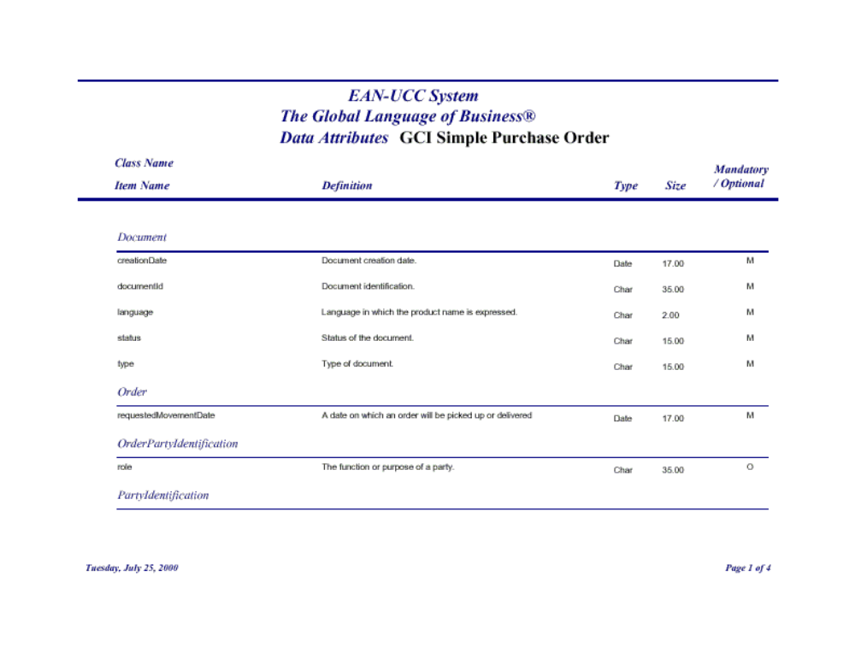
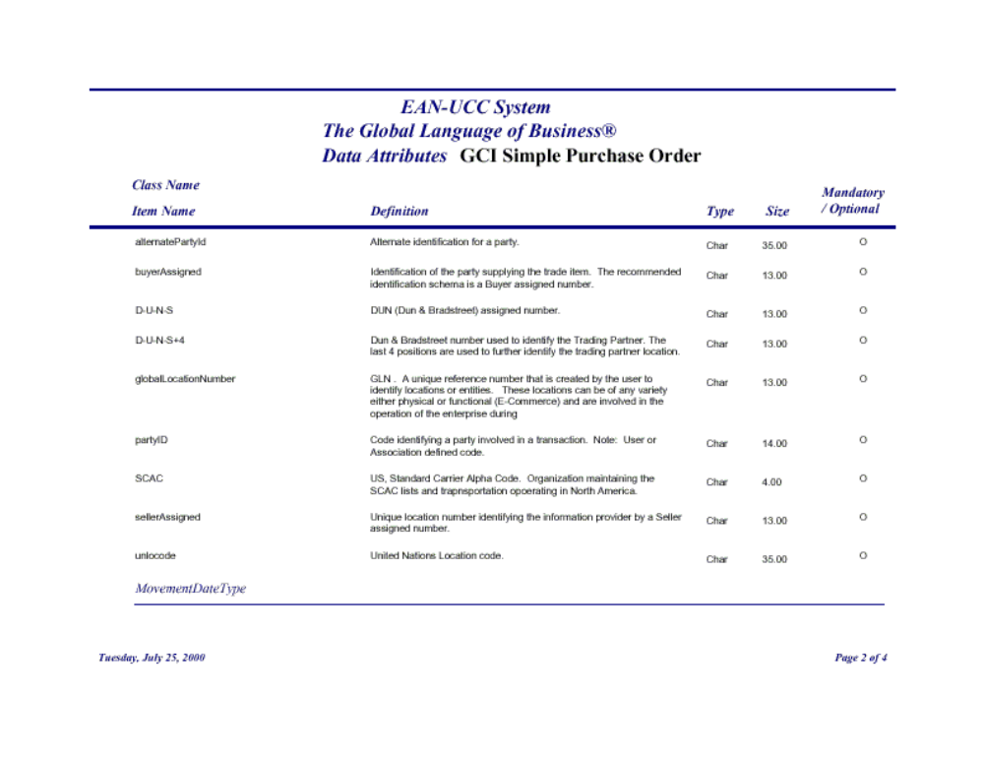
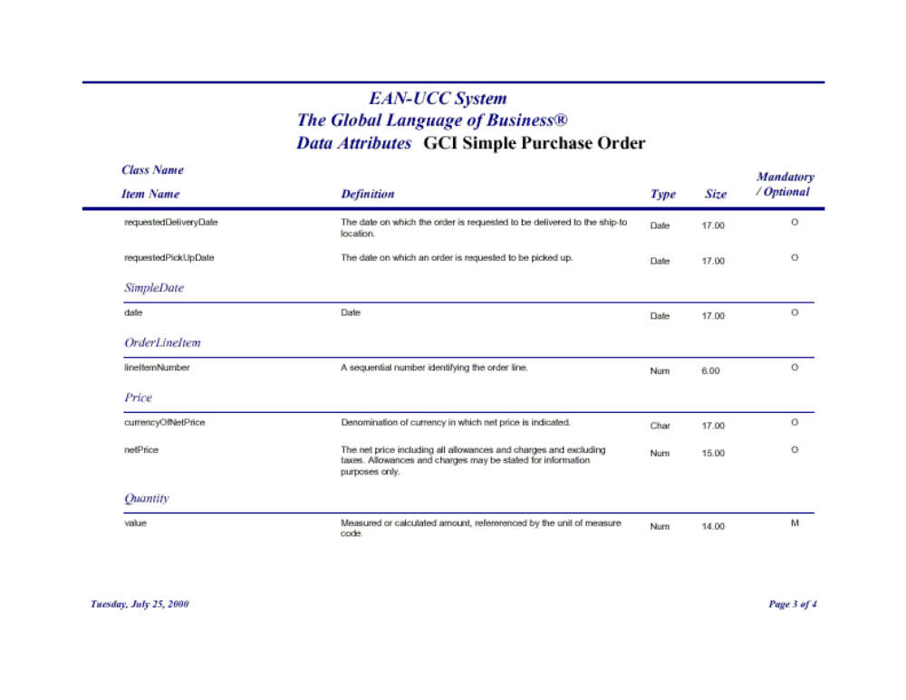
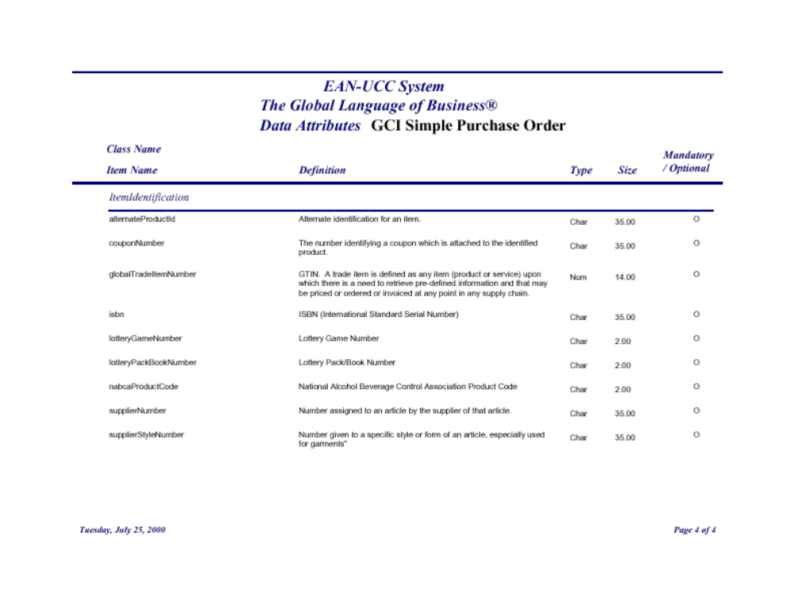

Appendix Z : Caveats and Issues

- Reliable messaging use case ?

