Message Service Specification
ebXML Transport, Routing & Packaging
Version
0.91
2 January 2001

Status of this Document
This document specifies an ebXML DRAFT for the eBusiness community Distribution of this document is unlimited.
The document formatting is based on the Internet Society’s Standard RFC format converted to Microsoft Word 2000 format,
This version
http://www.ebxml.org/working/project_teams
Latest version
http://www.ebxml.org
Previous version
http://www.ebxml.org/…

ebXML Participants
The authors wish to acknowledge the support of the members of the Transport, Routing and Packaging Project Team who contributed ideas to this specification by the group’s discussion email list, on conference calls and during face-to-face meeting.
Ralph Berwanger – bTrade.com
Jonathan Borden – Author of XMTP
Jon Bosak – Sun Microsystems
Marc Breissinger – webMethods
Dick Brooks – Group 8760
Doug Bunting – Ariba
David Burdett – Commerce One
Len Callaway – Drummond Group, Inc.
David Craft – VerticalNet
Philippe De Smedt – Viquity
Lawrence Ding – WorldSpan
Rik Drummond – Drummond Group, Inc. (Representing XML Solutions)

Christopher Ferris – Sun Microsystems
Maryann Hondo – IBM
Jim Hughes – Fujitsu
John Ibbotson – IBM
Ian Jones – British Telecommunications
Ravi Kacker – Kraft Foods
Nick Kassem – Sun Microsystems
Henry Lowe – OMG
Jim McCarthy – webXI
Bob Miller – GSX
Andrew Eisenberg – Progress Software
Dale Moberg – Sterling Commerce
Joel Munter – Intel
Farrukh Najmi – Sun Microsystems
Akira Ochi – Fujitsu
Martin Sachs, IBM
Masayoshi Shimamura – Fujitsu
Kathy Spector – Extricity
Nikola Stojanovic – Columbine JDS Systems
Gordon Van Huizen – Process Software
Martha Warfelt – Daimler Chrysler
Prasad Yendluri – Web Methods

Table of Contents
1 Status of this Document 2
2 ebXML Participants 3
3 Table of Contents 4
4 Introduction 9
4.1 Summary of Contents of Document 9
4.2 Document Conventions 10
4.3 Audience 10
4.4 Caveats and Assumptions 10
4.5 Related Documents 10
5 Design Objectives 11
6 System Overview 12
6.1 What the Message Service does 12
6.2 Message Service Overview 12
7 Packaging Specification 14
7.1 Introduction 14
7.1.1 ebXML Header Envelope and ebXML Payload Envelope 16
7.1.2 MIME usage Conventions 16
7.2 ebXML Message Envelope 17
7.2.1 Content-Type 17
7.2.1.1 type Attribute 17
7.2.1.2 boundary Attribute 17
7.2.1.3 version Attribute 17
7.2.2 ebXML Message Envelope Example 17
7.3 ebXML Header Container 17
7.3.1 Content-ID 18
7.3.2 Content-Type 18
7.3.2.1 version Attribute 18
7.3.2.2 charset Attribute 18
7.3.3 ebXML Header Envelope Example 18
7.4 ebXML Payload Container 19
7.4.1 Content-ID 19
7.4.2 Content-Type 19
7.4.3 Example of an ebXML MIME Payload Container 19
7.5 Additional MIME Parameters 20
7.6 Reporting MIME Errors 20
8 ebXML Header Document 21
8.1 XML Prolog 21
8.1.1 XML Declaration 21
8.1.2 Encoding Declaration 21
8.1.3 Standalone Document Declaration 21
8.1.4 Document Type Declaration 22
8.2 ebXMLHeader Element 22
8.2.1 ebXMLHeader attributes 22
8.2.1.1 Namespace attribute 22
8.2.1.2 version attribute 22
8.2.2 ebXMLHeader elements 22
8.2.3 Combining Principal Header Elements 23
8.2.3.1 Manifest element 23
8.2.3.2 Header element 23
8.2.3.3 RoutingHeaderList element 23
8.2.3.4 ApplicationHeaders element 23
8.2.3.5 StatusData element 23
8.2.3.6 ErrorList element 23
8.2.3.7 Acknowledgment element 23
8.2.3.8 Signature element 24
8.2.3.9 #wildcard element content 24
8.2.4 ebXMLHeader sample 24
8.3 Manifest element 24
8.3.1 Reference element 24
8.3.1.1 Description element 25
8.3.1.2 Schema element 25
8.3.2 Manifest sample 25
8.4 Header element 25
8.4.1 From and To elements 26
8.4.2 CPAId element 26
8.4.3 ConversationId element 26
8.4.4 Service element 26
8.4.4.1 type attribute 26
8.4.4.2 ebXML Message Service Header namespace 27
8.4.5 Action element 27
8.4.6 MessageData element 27
8.4.6.1 MessageId element 27
8.4.6.2 Timestamp element 27
8.4.6.3 RefToMessageId element 27
8.4.7 ReliableMessagingInfo element 27
8.4.7.1 deliverySemantics attribute 28
8.4.7.2 DeliveryReceiptRequested attribute 28
8.4.7.3 syncReplyMode attribute 29
8.4.7.4 TimeToLive attribute 29
8.4.8 Description element 29
8.4.9 #wildcard element 29
8.4.10 Header sample 30
8.5 RoutingHeaderList element 30
8.5.1 Routing Header Element 30
8.5.1.1 SenderURI element 30
8.5.1.2 ReceiverURI element 31
8.5.1.3 ErrorURI element 31
8.5.1.4 Timestamp element 31
8.5.1.5 SequenceNumber element 31
8.5.1.6 #wildcard 31
8.5.2 Single Hop Routing Header Sample 31
8.5.3 Multi-hop Routing Header Sample 32
8.6 ApplicationHeaders Element 33
8.6.1 ApplicationHeaders sample 33
8.7 StatusData Element 34
8.8 ErrorList Element 34
8.8.1 id attribute 34
8.8.2 highestSeverity attribute 34
8.8.3 Error element 34
8.8.3.1 codeContext attribute 35
8.8.3.2 errorCode attribute 35
8.8.3.3 severity attribute 35
8.8.3.4 location attribute 35
8.8.3.5 errorMessage attribute 35
8.8.3.6 softwareDetails attribute 36
8.8.4 Examples 36
8.8.5 errorCode values 36
8.8.6 Reporting Errors in the ebXML Header Document 36
8.8.7 Non-XML Document Errors 37
8.9 Acknowledgment Element 38
8.9.1 Timestamp element 38
8.9.2 From element 38
8.9.3 type attribute 38
8.9.4 signed attribute 38
8.10 Signature Element 39
9 Message Service Handler Services 40
9.1 Message Status Request Service 40
9.1.1 Message Status Request Message 40
9.1.2 Message Status Response Message 40
9.1.3 Security Considerations 41
9.2 Message Service Handler Ping Service 41
9.2.1 Message Service Handler Ping Message 41
9.2.2 Message Service Handler Pong Message 41
9.2.3 Security Considerations 42
10 Reliable Messaging 43
10.1.1 Persistent Storage and System Failure 43
10.1.2 Methods of Implementing Reliable Messaging 43
10.2 ebXML Reliable Messaging Protocol 43
10.2.1 Single-hop Reliable Messaging 44
10.2.1.1 Sending Message Behavior 44
10.2.1.2 Receiving Message Behavior 45
10.2.1.3 Resending Lost Messages 51
10.2.2 Multi-hop Reliable Messaging 52
10.2.2.1 Multi-hop Reliable Messaging without Intermediate Acknowledgments 53
10.2.2.2 Multi-hop Reliable Messaging with Intermediate Acknowledgments 54
10.3 ebXML Reliable Messaging using Queuing Transports 59
10.4 Service and Action Element Values 60
10.5 Failed Message Delivery 60
10.6 Reliable Messaging Parameters 61
10.6.1 Who sets Message Service Parameters 61
10.6.2 From Party Parameters 62
10.6.2.1 Delivery Semantics 62
10.6.2.2 Delivery Receipt Requested 63
10.6.2.3 Sync Reply Mode 63
10.6.2.4 Time To Live 43
10.6.3 To Party Parameters 63
10.6.3.1 Delivery Receipt Provided 63
10.6.4 Sending MSH Parameters 64
10.6.4.1 Reliable Messaging Method 64
10.6.4.2 Intermediate Ack Requested 64
10.6.4.3 Timeout Parameter 64
10.6.4.4 Retries Parameter 64
10.6.4.5 RetryInterval Parameter 64
10.6.4.6 Deciding when to resend a message 65
10.6.5 Receiving MSH Parameters 65
10.6.5.1 Reliable Messaging Methods Supported 65
10.6.5.2 PersistDuration 65
10.6.5.3 MSH Time Accuracy 65
11 Error Reporting and Handling 66
11.1 Definitions 66
11.2 Types of Errors 66
11.3 When to generate Error Messages 66
11.3.1 Security Considerations 66
11.4 Identifying the Error Reporting Location 67
11.5 Service and Action Element Values 67
12 Security 68
12.1 Security and Management 68
12.2 Collaboration Party Profiles 68
12.3 Risks 68
12.3.1 Unauthorized Access 68
12.3.2 Data Integrity and Confidentiality 69
12.3.3 Denial-of Service 69
12.4 Countermeasure Technologies 69
12.4.1 ebXML Message Countermeasures for Unauthorized Access and Data Integrity 69
12.4.2 Digital Certificates 69
12.4.3 ebXML Message Countermeasures for Denial of Service 69
12.4.4 ebXML Management Countermeasures for Denial of Service 70
12.5 Profiles 70
12.5.1 XML Digital Signature (XMLDSIG) 70
12.5.2 Profile - XML Signature signing of header and/or payload 70
12.5.2.1 Risks 70
12.5.2.2 Benefits 70
12.5.3 S/MIME 70
12.5.4 Profile - S/MIME signing of message payload 71
12.5.4.1 Sample S/MIME signed payload 71
12.5.4.2 Risks 72
12.5.4.3 Benefits 72
12.5.5 Profile - S/MIME encryption of message payload 72
12.5.5.1 Risks 72
12.5.5.2 Benefits 72
12.5.6 PGP/MIME 72
12.5.7 Profile - PGP/MIME signing of message payload 72
12.5.7.1 Risks 72
12.5.7.2 Benefits 73
12.5.8 Profile - PGP/MIME encryption of message payload 73
12.5.8.1 Risks 73
12.5.8.2 Benefits 73
13 Synchronous and Asynchronous Responses 74
14 References 75
14.1 Normative References 75
14.2 Non-Normative References 75
15 Disclaimer 76
16 Contact Information 93
Appendix A ebXMLHeader Schema and Data Type Definitions 95
A.1 Schema Definition 95
A.2 Data Type Definition 99
Appendix B Examples 100
Appendix C Communication Protocol Interfaces 101
C.1 HTTP 101
C.1.1 Asynchronous HTTP 101
C.1.2 Synchronous HTTP 102
C.2 SMTP 103
C.3 FTP 104
C.4 Communication Protocol Errors 104
C.4.1 Use of Error Codes 104
C.4.2 Communication Errors during Reliable Messaging 104
Appendix D Reliable Messaging Processing Logic 105
Copyright Statement 106

Introduction
This is a draft standard for trial implementation. The specification is the one of a series of specifications. The main specification that is yet to be developed is the ebXML Service Interface specification that describes, in a language independent way, how an application or other process can interact with software that complies with this ebXML Message Service specification. The ebXML Service Interface specification is being developed as separate document. It will be included in a later version of this specification or as an additional specification.

Summary of Contents of Document
This specification defines the ebXML Message Service protocol that enables the secure and reliable exchange of messages between two parties. It includes descriptions of:
- the ebXML Message structure used to package payload data for transport between parties
- the behavior of the Message Service Handler that sends and receives those messages over a data communication protocol.
This specification is independent of both the payload and the communication protocol used, although Appendices to this specification describe how to use this specification with [HTTP] and [SMTP].
This specification is organized around the following topics:
- Packaging Specification – A description of how to package an ebXML Message and its associated parts into a form that can be placed into the body of a communications protocol such as HTTP or SMTP (section 7)
- Message Headers – A specification of the structure and composition of the information necessary for an ebXML Message Service to successfully generate or process an ebXML compliant message. This is represented as an XML document called the ebXML Header document (section 8)
- Message Service Handler Services – A description of two services that enable one service to discover the status of another Message Service Handler or an individual message (section 9)
- Reliable Messaging – The Reliable Messaging function defines an interoperable protocol such that any two Message Service implementations can “reliably” exchange messages that are sent using “reliable messaging” semantics (section 10)
- Error Handling – This section describes how one ebXML Message Service reports errors it detects to another ebXML Message Service Handler (section )
- Security – This provides a complete specification of the security requirements for ebXML Messages (section ).
Appendices to this specification cover the following:
- Appendix A Schemas and DTD Definitions – This contains [XML Schema] and [XML] Data Type Definitions for the ebXML Header document
- Appendix B Examples – This contains sample message content
- Appendix C Communication Protocol Envelope Mappings – This describes how to transport ebXML Message Service compliant messages over [HTTP] and [SMTP]
- Appendix D Reliable Messaging Protocol Logic – this non-normative appendix provides processing logic that describes the behavior of a Message Service Handler when sending or receiving messages with reliable delivery

Document Conventions
Terms in Italics are defined in the ebXML Glossary of Terms [Glossary]. Terms listed in Bold Italics represent the element and/or attribute content of the XML ebXMLHeader. Terms listed in Courier font relate to MIME components.
The keywords MUST, MUST NOT, REQUIRED, SHALL, SHALL NOT, SHOULD, SHOULD NOT, RECOMMENDED, MAY, and OPTIONAL, when they appear in this document, are to be interpreted as described in RFC 2119 [Bra97].
Note that the force of these words is modified by the requirement level of the document in which they are used.
- MUST: This word, or the terms “REQUIRED” or “SHALL”, means that the definition is an absolute requirement of the specification.
- MUST NOT: This phrase, or the phrase “SHALL NOT”, means that the definition is an absolute prohibition of the specification.
- SHOULD: This word, or the adjective “RECOMMENDED”, means that there may exist valid reasons in particular circumstances to ignore a particular item, but the full implications must be understood and carefully weighed before choosing a different course.
- SHOULD NOT: This phrase, or the phrase “NOT RECOMMENDED”, means that there may exist valid reasons in particular circumstances when the particular behavior is acceptable or even useful, but the full implications should be understood and the case carefully weighed before implementing any behavior described with this label.

Audience
The target audience for this specification is the community of software developers who will implement the ebXML Message Service.

Caveats and Assumptions
It is assumed that the reader has an understanding of transport protocols, MIME and XML.

Related Documents
The following set of related specifications will be delivered in phases:
- ebXML Collaboration Protocol Profile and Agreement Specification [ebXMLTP] (under development) - defines how one party can discover and/or agree upon the information that party needs to know about another party prior to sending them a message that complies with this specification
- ebXML Message Service Interface Specification (to be developed) - defines an interface that may be used by software to interact with an ebXML Message Service
- ebXML Message Services Security Specification (under development) – defines the security mechanisms necessary to negate anticipated, selected threats
- ebXML Message Services Requirements Specification [ebXMLMSREQ] – defines the requirements of the Message Services

Design Objectives
The design objectives of this specification are to define a Message Service (MS) to support XML based electronic business between small, medium and large enterprises. This specification is intended to enable a low cost solution, while preserving a vendor's ability to add unique value through added robustness and superior performance. It is the intention of the Transport, Routing and Packaging Project Team to keep this specification as straightforward and succinct as possible.
Every item in this specification will be prototyped by the ebXML Proof of Concept Team in order to ensure the clarity and accuracy of this specification.

System Overview
This document defines the ebXML Message Service (MS) component of the ebXML infrastructure. The ebXML Message Service defines the message enveloping and header document schema used to transfer ebXML Messages over a communication protocol such as HTTP, SMTP, etc. This document provides sufficient detail to develop software for the packaging, exchange and processing of ebXML Messages.

What the Message Service does
The ebXML Message Service defines robust, yet basic, functionality to transfer messages using various existing communication protocols. The ebXML Message Service will perform in a manner that will allow for reliability, persistence, security and extensibility.
The ebXML Message Service is provided for environments requiring a robust, yet low cost solution to enable electronic business. It is one of the three "infrastructure" components of ebXML that includes: Registry/Repository [ebXMLRegRep], Collaboration Protocol Profile/Agreement [ebXMLTP] and the ebXML Message Service.

Message Service Overview
The ebXML Messaging Service may be conceptually broken down into following three parts: (1) an abstract Service Interface, (2) functions provided by the Messaging Service Layer, and (3) the mapping to underlying transport service(s).
The following diagram depicts a logical arrangement of the functional modules that exist within the ebXML Messaging Services architecture. These modules are arranged in a manner to indicate their inter-relationships and dependencies.
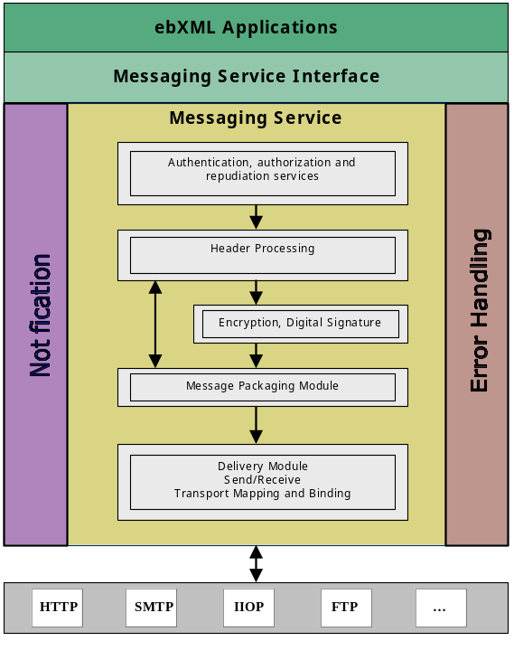
Figure 6-1 Typical Relationship between ebXML MSH Components
<DB>An explanation of these components is needed</DB>

Packaging Specification

Introduction
An ebXML Message consists of:
- an outer Communication Protocol Envelope, such as HTTP or SMTP,
- an inner communication “protocol independent” ebXML Message Envelope, specified using MIME multipart/related, that contains the two main parts of the Message:
- an ebXML Header Container that is used to envelope one ebXML Header Document,
- an optional, single ebXML Payload Container that MUST be used to envelope the actual payload (transferred data) of the Message Communication Protocol Envelope (SMTP, HTTP, etc)

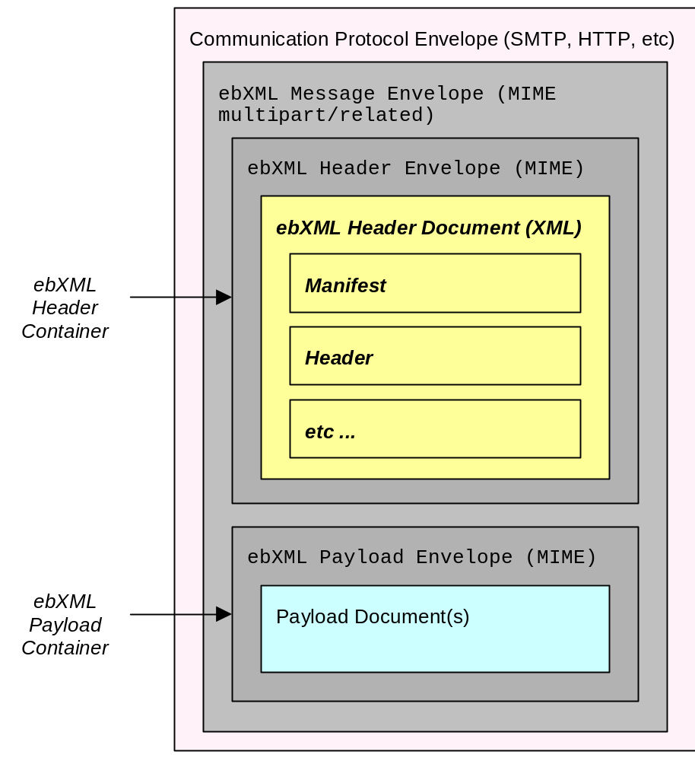Figure 7-1 ebXML Message Structure

ebXML Header Envelope and ebXML Payload Envelope
An ebXML Header Envelope and an ebXML Payload Envelope are constructed of standard, MIME components.

The ebXML Header Envelope contains a single ebXMLHeader document (see section 8). The ebXML Payload Envelope can contain any electronic data that can be transported within MIME.
Any special considerations for the usage of the ebXML Message Envelope in HTTP and SMTP transports are described in Appendix G.

MIME usage Conventions
Values associated with MIME header attributes are valid in both quoted and unquoted form. For example, the forms type="ebxml" and type=ebxml are both valid.

ebXML Message Envelope
The MIME structured ebXML Message Envelope is used to identify the message as an ebXML compliant structure and encapsulates the header and payload in MIME body parts. It MUST conform to [RFC2045] and MUST contain a Content-Type MIME header.

Content-Type
The MIME Content-Type MUST be set to multipart/related for all ebXML Message Envelopes. For example:
Content-Type: multipart/related;
The MIME Content-Type header contains three attributes:
- type
- boundary
- version

type Attribute
The MIME type attribute is used to identify the ebXML Message Envelope as an ebXML compliant structure. It conforms to a MIME XML Media Type [XMLMedia] and MUST be set to "application/vnd.eb+xml". This media type is derived from the application/xml type and shares many semantics with that type. To that type, application/vnd.eb+xml adds a specific application context, the ebXML Message Service. For example:
type="application/vnd.eb+xml"

boundary Attribute
The MIME boundary attribute is used to identify the body part separator used to identify the start and end points of each body part contained in the message. The MIME boundary SHOULD be chosen carefully in order to ensure that it does not occur within the content area of a body part see [RFC 2045] for guidance on how to do this. For example:
boundary:="-------8760"

version Attribute
The MIME version attribute is used to identify the particular version of ebXML Message Envelope being used. All message headers SHOULD USE "0.91". For example:
version="0.91"

ebXML Message Envelope Example
An example of a compliant ebXML Message Envelope header appears as follows:
Content-Type: multipart/related; type="application/vnd.eb+xml";"boundary:="-------8760";

ebXML Header Container
The ebXML Header Container is a MIME body part that MUST consist of:
- one ebXML Header Envelope, that contains
- one XML ebXML Header document (see section 8).
The following rules apply:
- the ebXML Header Container MUST be the first MIME body part in the ebXML Message.
- there MUST be one and only one ebXML Header Document in each ebXML Message.
Note that, an ebXML Payload Container may be a completely encapsulated ebXML Message.
The MIME based ebXML Header Envelope conforms to [RFC 2045] and MUST consist of the following MIME headers:
- Content-ID
- Content-Type

Content-ID
The Content-ID MIME header identifies this instance of an ebXML Message header body part. The value for Content-ID SHOULD be a unique identifier, in accordance with RFC 2045. For example:
Content-ID: <2000-0722-161201-123456789@ebxmlhost.realm>

Content-Type
The MIME Content-Type for an ebXML header is identified with the value “application/vnd.eb+xml". Content-Type contains two attributes:
- version
- charset

version Attribute
The MIME version attribute indicates the version of the ebXML Message Service Specification to which the ebXML Header Document conforms. For example:
version="0.91";

charset Attribute
The MIME charset attribute identifies the character set used to create the ebXML Header Document. The semantics of this attribute are described in the “charset parameter / encoding considerations” of application/xml as specified in [XML/Media]. The list of valid values can be found at http://www.iana.org/.
If both are present, the MIME charset attribute SHALL be equivalent to the encoding declaration of the ebXML Header Document (see section 8). If provided, the MIME charset attribute MUST NOT contain a value conflicting with the encoding used when creating the ebXML Header Document. For maximum interoperability it is RECOMMENDED that [UTF-8] be used when encoding this document. Due to the processing rules defined for media types derived from application/xml [XMLMedia], this MIME attribute has no default. For example:
charset="UTF-8"

ebXML Header Envelope Example
The following represents an example of an ebXML Header Envelope and ebXML Header
Document:
Content-ID: ebxmlheader-123@ebxmlhost.realm --| MIME ebXML |
Content-Type: application/vnd.eb+xml; | Header Envelope |
version=”0.91”; charset=”UTF-8” --| | ebXML
| Header
<ebXMLHeader> -------------| | Container
<Manifest>........ | XML ebXML Header |
</Manifest> | Document |
<Header>........ | |
</Header> | |
<Routing Header>........ | |
</Routing Header> | |
</ebXMLHeader> -------------| |
A complete example of an ebXML Header Container is presented in Appendix B. That example includes the charset attribute and portions of an XML Prolog (see sect 8.1), none of which is required to appear in an ebXML Header Container or ebXML Header Document. Appendix B also includes the outer ebXML Message Envelope and a complete (valid) ebXMLHeader element rather than the outline shown above.

ebXML Payload Container
If the ebXML Message contains a payload, then a single ebXML Payload Container MUST be used to envelop it.
If there is no payload within the ebXML Message then the ebXML Payload Container MUST not be present.
The contents of the ebXML Payload Container MUST be identified by the Message Manifest element within the ebXML Header Document (see section 8.3).
If the Message Manifest is an empty XML element, the ebXML Payload Container MUST NOT be present in the ebXML Message.
If an ebXML Payload Container is present, it MUST conform to MIME [RFC2045] and MUST consist of:
- a MIME header portion - the ebXML Payload Envelope, and
- a content portion - the payload itself that may be of any valid MIME type.
The ebXML MIME Payload Envelope, MUST consist of the following MIME headers:
- Content-ID
- Content-Type
The ebXML Message Service Specification makes no provision, nor limits in any way the structure or content of payloads. Payloads MAY be a simple-plain-text-object or complex nested multipart objects. This is the implementer’s decision.

Content-ID
The Content-ID MIME Header is used to uniquely identify an instance of an ebXML Message payload body part. The value for Content-ID SHOULD be a unique identifier, in accordance with MIME [RFC 2045]. For example:
Content-ID: <2000-0722-161201-123456789@ebxmlhost.realm>

Content-Type
The MIME Content-Type for an ebXML payload is determined by the implementer and is used to identify the type of data contained in the content portion of the ebXML Payload Container. The MIME Content-Type MUST conform to [RFC2045]. For example:
Content-Type: application/xml

Example of an ebXML MIME Payload Container
The following represents an example of an ebXML MIME Payload Envelope and a payload:
Content-ID: ebxmlpayload-123@ebxmlhost.realm --| ebXML MIME |
Content-Type: application/xml -------------| Payload Envelope | ebXML
| Payload
<Invoice> -------------| | Container
<Invoicedata>........ | Payload |
</Invoicedata> | |
</Invoice> -------------| |
A complete example of the ebXML Payload Container is presented in Appendix XX.

Additional MIME Parameters
The MIME parts may contain additional MIME parameters in conformance with the [MIME] specification. If these are present then they MUST be ignored.

Reporting MIME Errors
If a MIME error is detected in the ebXML Header Envelope or the ebXML Payload Envelope then it MUST be reported by sending an ebXML message containing an ebXMLHeader element with an ErrorList element (see section 8.8) where errorCode is set to MimeProblem and a severity set to Error. See section for more details on how to indicate an error.

ebXML Header Document
The ebXML Header Document is a single [XML] document with a number of principal header-elements. In general, separate principal-header elements are used where:
- different software components are likely to be used to generate that header-element,
- the element is not always present,
- the structure of the header element might vary independently of the other header-elements, or
- the data contained in the header-element MAY need to be digitally signed separately from the other header-elements.

XML Prolog
The ebXML Header Document’s XML Prolog MAY contain an XML declaration or a document type declaration. This specification has defined no additional comments or processing instructions that may appear in the XML prolog. For example:
<?xml version="1.0" encoding="UTF-8"?>
<!DOCTYPE ebXMLHeader SYSTEM "level1-10122000.dtd">
<ebXMLHeader>...</ebXMLHeader>

XML Declaration
The XML declaration MAY be present in an ebXML Header Document. If present, it MUST contain the version specification required by the XML Recommendation [XML]: version=’1.0’ and MAY contain an encoding declaration and standalone document declaration. The semantics described below MUST be implemented by a compliant ebXML Message Service.

Encoding Declaration
<DB>This section isn’t clear to me. I really could not work out what is or is not valid and what do you do if you get an inconsistency between the XML prolog and the MIME header. e.g. do you ignore it, assume a value or report an error.</DB>
If both <DB>the encoding declaration and the MIME charset?</DB> are present, the XML prolog for the ebXML Header Document SHALL contain the encoding declaration that SHALL be equivalent to the charset attribute of the MIME Content-Type of the
ebXML Message Header Container (see section 7.3).
If provided, the encoding declaration MUST NOT contain a value conflicting with the encoding used when creating the ebXML Header Document. It is RECOMMENDED that UTF-8 be used when encoding the ebXML Header Document.
If the character encoding cannot be determined by an XML processor using the rules specified in section 4.3.3 of [XML], the XML declaration and its contained encoding declaration SHALL be provided in the ebXML Header Document.
NOTE: The encoding declaration is not required in an XML document according to the XML version 1.0 specification [XML].
For example:
<?xml version="1.0" encoding="UTF-8"?>

Standalone Document Declaration
The standalone document declaration, if present, MAY appear as standalone=’yes’ if and only if all of the validity requirements specified in section 2.9 of the XML Recommendation [XML] are met. It is RECOMMENDED that ebXML Header Documents omit this declaration.
<DB>What do you do if the XML Recommendation is not met?</DB>

Document Type Declaration
When the ebXML Header Document will or may be processed by an XML processor not complaint with the XML Schema Recommendation [XMLSchema], a document type declaration containing a SYSTEM identifier of "level1-10122000.dtd" MUST be included. For example:
<!DOCTYPE ebXMLHeader SYSTEM "level1-10122000.dtd">
<DB>Looks to me like we should mandate its use and then maybe remove it in a later version of the spec when everyone is using XML Schema.</DB>

ebXMLHeader Element
The root element of the ebXML Header Document is named the ebXMLHeader. Its structure is described below.

ebXMLHeader attributes
There are two attributes associated with the ebXMLHeader, they are as follows:
- Namespace (xmlns)
- version

Namespace attribute
The namespace declaration (xmlns) (see [XML Namespace]) has a REQUIRED value of "http://www.ebxml.org/namespaces/messageHeader".

version attribute
The version attribute is required. Its purpose is to provide for future versioning capabilities. It has a default value of '0.91'.

ebXMLHeader elements
An ebXML Header Document consists of the following principal header elements:
- Manifest – an element that points to any data present either in the ebXML Payload Container or elsewhere, e.g. on the web
- Header – a REQUIRED element that contains routing information for the message (To/From, etc.) as well as other context information about the message
- RoutingHeaderList – an element that contains entries that identify the Message Service Handler (MSH) that sent and should receive the message. This element can be omitted.
- ApplicationHeaders – an element that can be used by a process or service to include additional information that needs to be associated with the data in the ebXML Payload but is not contained within it

- StatusData – an element that is used by a MSH when responding to a request on the status of a message that was previously received
- ErrorList – an element that contains a list of the errors that have been found in a message
- Acknowledgment – an element that is used by a MSH to indicate that a message has been received
- Signature – an element that contains a digital signature that conforms to [XMLDSIG] that signs data associated with the message
- #wildcard - any namespace-qualified element content belonging to a foreign namespace

Combining Principal Header Elements
This section describes how the various principal header elements may be used in combination.

Manifest element
The Manifest element MUST be present if there is any data associated with the message that is not present in the ebXML Header Document. This applies specifically to data in the ebXML Payload Container or elsewhere, e.g. on the web.

Header element
The Header element MUST be present in every message.

RoutingHeaderList element
The RoutingHeaderList element MAY be present in any message. It MUST be present if the message is being sent reliably (see section Error! Reference source not found.).

ApplicationHeaders element
The ApplicationHeaders element MAY be present on any message except a message that contains one or more of the following:
- an ErrorList element with a highestSeverity attribute set to Error
- a

- StatusData element

StatusData element
This element MUST NOT be present with the following elements:
- a Manifest element
- an ApplicationHeaders element,

- an ErrorList element with a highestSeverity attribute set to Error

ErrorList element
If the highestSeverity attribute on the ErrorList is set to Warning, then this element MAY be present with any other element.
If the highestSeverity attribute on the ErrorList is set to Error, then this element MUST NOT be present with the following:
- a Manifest element
- an ApplicationHeaders element
- a StatusData element

Acknowledgment element
An Acknowledgment element MAY be present on any message.

Signature element
A Signature element MAY be present on any message.

#wildcard element content
Any namespace-qualified element content MAY be added to provide for the extensibility of the ebXMLHeader. Extension element content MUST be namespace-qualified in accordance with [XMLNamespaces] and MUST belong to a foreign namespace. A foreign namespace is one that is NOT http://www.ebxml.org/namespaces/messageHeader.

ebXMLHeader sample
The following is a sample ebXMLHeader document fragment demonstrating the overall structure:
<?xml version="1.0" encoding="UTF-8"?>
<ebXMLHeader xmlns=”http://www.ebxml.org/namespaces/messageHeader” Version="0.91" >
<Manifest>...</Manifest>
<Header>...</Header>
<RoutingHeaderList>…</RoutingHeaderList>
</ebXMLHeader>

Manifest element
The Manifest element is a composite element consisting of one or more Reference elements. Each Reference element identifies data associated with the message, whether included as part of the message, or remote resources accessible via a URL. The Manifest element, if present, SHALL be the first child element of the ebXMLHeader. It identifies the payload document(s) contained in the ebXML Message Container. The purpose of the Manifest is to make it easier to directly extract a particular document associated with the Message.
The Manifest element MAY have a single attribute: id that is an XML ID.

Reference element
The Reference element is a composite element consisting of the following subordinate elements:
- Description - a textual description of the payload object referenced by the parent Reference element
- Schema - information about the schema that defines the instance document identified in the parent Reference element
- #wildcard - any namespace-qualified element content belonging to a foreign namespace
The Reference element itself is an [XLINK] simple link. XLINK is presently a Candidate Recommendation (CR) of the W3C. It should be noted that the use of XLINK in this context is chosen solely for the purpose of providing a concise vocabulary for describing an association. Use of an XLINK processor or engine is NOT REQUIRED, but MAY prove useful in certain implementations.
The Reference element has the following attribute content in addition to the element content described above:
- id - an optional XML ID for the Reference element
- xlink:type - this REQUIRED attribute defines the element as being an XLINK simple link. It has a fixed value of 'simple'
- xlink:href - this REQUIRED attribute has a value that is the URI of the payload object referenced. It SHALL conform to the [XLINK] specification criteria for a simple link.
- xlink:role - this REQUIRED attribute identifies the role that the payload object referenced serves. It MUST have a value that is a valid URI in accordance with the [XLINK] specification.
- xlink:label - this attribute MAY be present and SHALL be used in accordance with the [XLINK] specification.
- Any other namespace-qualified attribute MAY be present. A receiving MSH MAY choose to ignore any foreign namespace attributes other than those defined above.

Description element
The Description is an OPTIONAL textual description of the payload object referenced by the parent Reference element. The language of the description is defined by a required xml:lang attribute. The xml:lang attribute MUST comply with the rules for identifying languages specified in [XML]. This element is provided solely for the purpose of providing a human readable description of the payload object identified by the parent Reference element.

Schema element
The Schema element MAY be present as a child of the Reference element. It provides a means of identifying the schema, and its version, that defines the payload object identified by the parent Reference element. It has no element or text content. The Schema element contains the following attributes:
- version - a version identifier of the schema
- location - the URI of the schema

Manifest sample
The following fragment demonstrates a typical Manifest for a message with a single payload MIME body part:
<Manifest id="Manifest">
<Reference id="pay01"
xlink:href="cid:payload-1" xlink:label="PO"
xlink:role="http://regrep.org/gci/purchaseOrder">
<Schema location="http://regrep.org/gci/purchaseOrder/po.xsd"
version="1.0"/>
</Reference>
</Manifest>

Header element
The Header element immediately follows the Manifest element. It is REQUIRED in all ebXMLHeader documents. The Header element is a composite element comprised of the following subordinate elements:
- From
- To
- CPAId
- ConversationId
- Service
- Action
- MessageData
- ReliableMessagingInfo

- #wildcard
The Header attribute MAY have an attribute: id that is of type XML ID.

From and To elements
The From element identifies the Party that originated the message. The From element consists of a PartyId element.
The To element identifies the intended recipient of the message. As with From, it is a logical identifier that is comprised of a PartyId element.
The PartyId element has a single attribute: type and a string value.
If the type attribute is present, then it indicates that the parties that are sending and receiving the message know, by some other means, how to interpret the content of the PartyId element. The two parties MAY use the value of the type attribute to assist in the interpretation.
If the type attribute is not present, the content of the PartyId element MUST be a URI [RFC 2396] otherwise report an error (see section ) with errorCode set to Inconsistent and severity set to error.
The following fragment demonstrates usage of the From and To elements. The first illustrates a user-defined numbering scheme, and the second a URN.
<From>
<PartyId type="MyNumberingScheme">1234567890123</PartyId>
</From>
<To>
<PartyId">urn:dnb.com:duns:3210987654321</PartyId>
</To>

CPAId element
The CPAId is a string that identifies the Collaboration Protocol Agreement that governs the processing of the message. The CPAId MAY be a URI, possibly established by registering a CPA with an ebXML compliant Registry, that identifies the CPA uniquely.

ConversationId element
The ConversationId is a string that identifies the set of related messages that make up a conversation between two Parties. The Party that initiates a conversation determines the value of the ConversationId element that shall be reflected in all messages pertaining to that conversation.
Note that implementations are free to choose how they will identify and store conversational state related to a specific ConversationId. Implementations SHOULD provide a facility for mapping between their identification schema and a ConversationId generated by another implementation.

Service element
The Service element identifies the service that SHOULD act on the payload in the message. It is specified by the designer of the service. The designer of the service may be:
- a standards organization, or
- an individual or enterprise

The Service element has a single type attribute.

type attribute
If the type attribute is present, then it indicates that the parties that are sending and receiving the message know, by some other means, how to interpret the content of the Service element. The two parties MAY use the value of the type attribute to assist in the interpretation.
If the type attribute is not present, the content of the Service element MUST be a URI [RFC 2396] otherwise there is an error.

ebXML Message Service Header namespace
URIs in the Service element that start with the namespace: http://www.ebxml.org/namespaces/messageService are reserved for use by this specification.

Action element
The Action element identifies a process within a Service, that processes the Message. Action SHALL be unique within the Service in which it is defined.

MessageData element
The REQUIRED MessageData element provides a means of uniquely identifying an ebXML Message. It is contains the following three elements:
- MessageId
- Timestamp
- RefToMessageId

MessageId element
The REQUIRED element MessageId is a unique identifier for the message conforming to [RFC2392]. The "local part" of the identifier as defined in [RFC2392] is implementation dependent.

Timestamp element
The Timestamp is a value representing the time that the message header was created conforming to [ISO-8601]. The format of CCYYMMDDTHHMMSS.SSSZ is REQUIRED to be used. This time format is Coordinated Universal Time (UTC).
<DB>Should we make this compliant with an XML Schema timeInstant instead? </DB>

RefToMessageId element
The RefToMessageId element has a cardinality of zero or one. When present, it MUST contain the MessageId value of an earlier ebXML Message to which this message relates. If there is no earlier related message, the element MUST NOT be present.
For Error messages, the RefToMessageId element is REQUIRED and its value MUST be the MessageId value of the message in error (as defined in section 8.8).
For Acknowledgment Messages, the RefToMessageId element is REQUIRED, and its value MUST be the MessageId value of the ebXML Message being acknowledged. See also sections 8.2.3.7 and 10.

ReliableMessagingInfo element
The ReliableMessagingInfo element identifies the quality of service with which the message MUST be delivered. This element has a four attributes:
- deliverySemantics
- deliveryReceiptRequested
- syncReplyMode, and
- timeToLive.

deliverySemantics attribute
The deliverySemantics element, if present, over-rides the value of the same parameter in the CPA. If it is not present, the value in the CPA MUST be used.
The deliverySemantics parameter/element MUST used by the From Party MSH to indicate whether the Message must be sent reliably. Valid Values are:
- OnceAndOnlyOnce. The message must be sent using a reliableMessagingMethod that will result in the application or other process at the To Party receiving the message once and only once
- BestEffort The reliable delivery semantics are not specified. In this case the value of reliableMessagingMethod is ignored.
The default value for deliverySemantics is specified in the CPA. If no value is specified in the CPA then the default value is BestEffort.
If deliverySemantics is set to OnceAndOnlyOnce then the From Party MSH and the To Party MSH must adopt the Reliable Messaging behavior (see section 10) that describes how messages are resent in the case of failure and duplicates are ignored.
If deliverySemantics is set to BestEffort then a MSH that received a message that it is unable to deliver MUST NOT take any action to recover or otherwise notify anyone of the problem, and the MSH that sent the message must not attempt to recover from any failure.
This means that duplicate messages might be delivered to an application and persistent storage of messages is not required.
If the To Party is unable to support the type of Delivery Semantics requested, then the To Party SHOULD report the error to the From Party using an ErrorCode of NotSupported and a Severity of Error.
<ReliableMessagingInfo deliverySemantics=”OnceAndOnlyOnce”/>

DeliveryReceiptRequested attribute
The deliveryReceiptRequested element, if present, over-rides the value of the same parameter in the CPA. If not present then the value in the CPA MUST be used.
The deliveryReceiptRequested parameter/element MUST be used by a From Party MSH to indicate whether a message received by the To Party MSH should result in the To Party MSH returning an acknowledgment message containing an Acknowledgment element with a type of deliveryReceipt.
The deliveryReceiptRequested parameter/element is frequently used to help implement Reliable Messaging (see section 10) although it can be used independently.
Before setting the value of deliveryReceiptRequested, the From Party SHOULD check the deliveryReceiptSupported parameter for the To Party in the CPA to make sure that its value is compatible.
Valid values for deliveryReceiptRequested are:
- Unsigned - requests that an unsigned Delivery Receipt is requested
- Signed - requests that a signed Delivery Receipt is requested, or
- None - indicates that no Delivery Receipt is requested.
When a To Party MSH receives a message with deliveryReceiptRequested not set to None then it should check if it is able to support the type of Delivery Receipt requested.
If the To Party MSH can produce the Delivery Receipt of the type requested, then it MUST return to the From Party on the message just received, a message containing an Acknowledgement element with the value of the type attribute set to DeliveryReceipt.
If the To Party cannot return a Delivery Receipt of the type requested then it MUST report the error to the From Party using an ErrorCode of NotSupported and a Severity of Error.

syncReplyMode attribute
The syncReplyMode is an optional attribute that indicates whether a response to a message must be returned at the same time as any acknowledgements. It has two values:
- True which indicates that the MSH that receives the message MUST get the message processed by the application or other process that needs to process it before the MSH sends any response to the original message, or
- False which indicates that an acknowledgement to the message MAY be sent separately before processing of the message by the application or other process.
The default value is False.

TimeToLive attribute
The TimeToLive is an optional attribute in the header that conforms to [ISO8601] and indicates the time by which a message should be delivered to the To Party Message Service Handler.
When setting a value for TimeToLive it is RECOMMENDED that the From Party takes into account the accuracy of its own internal clocks as well as the mshTimeAccuracy parameter for the Receiver MSH (see section 10.6.5.3) that indicates the accuracy to which a MSH will keep its internal clocks.
How a MSH ensures that its internal clocks are kept sufficiently accurate is an implementation decision.
If a MSH receives a Message where TimeToLive has expired the MSH MUST:
- send a Message to the From Party MSH, reporting that the TimeToLive of the message has passed
- NOT forward the message to another MSH or application/other system that should receive the message.
The message reporting the error MUST contain an ErrorCode set to TimeToLiveExpired, and a severity attribute set to Error
In this context the TimeToLive has expired if the time of the internal clock of the MSH that receives a message is greater than the value of TimeToLive for the Message.
If TimeToLive is not present then it MUST be assumed that TimeToLive is infinite and therefore checks for message expiry are unnecessary.

Description element
The Description element MAY be present as a child element of the Header. The language of the description is defined by a required xml:lang attribute. The xml:lang attribute MUST comply with the rules for identifying languages specified in [XML]. This element is provided solely for the purposes of providing a human readable description of the purpose or intent of the message.

#wildcard element
In support of allowing an ebXML Message to be extended to include element content from a foreign namespace, a #wildcard element has been provided. Additional element content MAY be added to the Header element immediately following the MessageData element. Such additional element content MUST be namespace-qualified in accordance with [XMLNamespaces].

Header sample
The following fragment demonstrates the structure of the Header element of the ebXMLHeader document:
<Header id="N01">
<From>
<PartyId type="uri">…</PartyId>
</From>
<To>
<PartyId type="userType">...</PartyId>
</To>
<CPAId>http://www.ebxml.org/cpa/123456</CPAId>
<ConversationId>987654321</ConversationId>
<Service type="myservicetypes">QuoteToCollect</Service>
<Action>NewPurchaseOrder</Action>
<MessageData>
<MessageId>UUID-2</MessageId>
<Timestamp>20000725T121905.000Z</Timestamp>
<RefToMessageId>UUID-1</RefToMessageId>
</MessageData>
<ReliableMessagingInfo deliverySemantics="BestEffort"/>
</Header>

RoutingHeaderList element
A RoutingHeaderList consists of one or more RoutingHeader elements. Exactly one RoutingHeader is appended to the RoutingHeaderList, following any pre-existing RoutingHeader before transmission of a message over a data communication protocol.
The RoutingHeaderList element MAY be omitted from the header if:
- the message is being sent over a single hop (see section 8.5.2), and
- the message is not being sent reliably (see section 10)

Routing Header Element
The RoutingHeader element contains information about a single transmission of a message between two Parties. If a message traverses multiple hops by passing through some type of intermediate system between the From Party and the To Party, then each transmission over each hop results in the addition of a new Routing Header element.
The RoutingHeader element is a composite element comprised of the following subordinate elements:
- SenderURI
- ReceiverURI
- ErrorURI
- Timestamp
- SequenceNumber
- #wildcard

SenderURI element
This element contains the URI of the message's Sender Messaging Service Handler. The recipient of the message, unless there is another URI more specifically identified within the CPA, uses the URI to send a message, when required that:
- responds to an earlier message
- acknowledges an earlier message
- reports an error in an earlier message.

ReceiverURI element
This element contains the URI of the Receiver’s Messaging Service Handler URI. It is the URI to which the Sender sends the message.

ErrorURI element
This URI, if present, identifies the URI that is used for reporting errors. If it is not present then errors are reported by sending a message to the SenderURI.

Timestamp element
The Timestamp element is the time the individual RoutingHeader was created. It is in the same format as in the Timestamp element in the MessageData element.

SequenceNumber element
The SequenceNumber is an optional element that indicates the sequence in which messages must be processed by a receiving MSH. The SequenceNumber is unique within the ConversationId and Sender MSH. It is set to one on the first message from that MSH for a Conversation and then incremented by one for each subsequent message sent.
A MSH that receives a message with a SequenceNumber set MUST NOT pass the message to an application as long as the storage required to save out-of-sequence messages is within the implementation defined limits and until all the messages with lower SequenceNumbers have been received and passed to the application.
If the implementation defined limit for saved out-of-sequence messages is reached, then the Receiving MSH MUST indicate a delivery failure to the Sending MSH with errorCode set to DeliveryFailure and severity set to Error (see section 10.5).

#wildcard
This MAY contain any namespace-qualified element content belonging to a foreign namespace.

Single Hop Routing Header Sample
A single hop message and its return is illustrated by the diagram below.
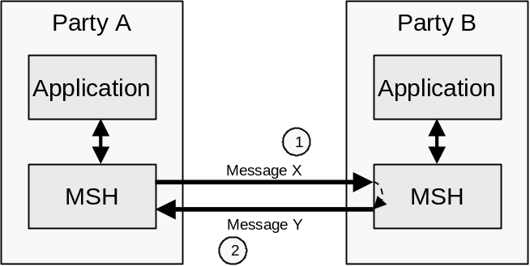
Figure 8-2 Single Hop Message
The content of the corresponding messages could include:
- Transmission 1 - Message X From Party A To Party B
<Header id=”...”>
<From>urn:myscheme.com:id:PartyA-id</From>
<To>urn:myscheme.com:id:PartyB-id</To>
<ConversationId>219cdj89dj2398djfjn</ConversationId>
...
<MessageData>
<MessageId>29dmridj103kvna</MessageId>
...
</MessageData>
...
</Header>
<RoutingHeaderList id=”...”>
<RoutingHeader>
<SenderURI>url:PartyA.com/PartyAMsh</SenderURI>
<ReceiverURI>url:PartyB.com/PartyBMsh</ReceiverURI>
<Timestamp>20001216T21:19:35.145Z-8</Timestamp>
</RoutingHeader>
</RoutingHeaderList>
- Transmission 2 - Message Y From Party B To Party A
<Header id=”...”>
<From>urn:myscheme.com:id:PartyB-id</From>
<To>urn:myscheme.com:id:PartyA-id</To>
<ConversationId>219cdj89dj2398djfjn</ConversationId>
...
<MessageData>
<MessageId>eis99dk4mvzlghasi</MessageId>
<RefToMessageId>29dmridj103kvna</RefToMessageId>
...
</MessageData>
...
</Header>
<RoutingHeaderList id=”...”>
<RoutingHeader>
<SenderURI>url:PartyA.com/PartyAMsh</SenderURI>
<ReceiverURI>url:PartyB.com/PartyBMsh</ReceiverURI>
<Timestamp>20001216T21:20:05.274Z-6</Timestamp>
</RoutingHeader>
</RoutingHeaderList>

Multi-hop Routing Header Sample
Multi-hop messages are not sent directly from one party to another, instead they are sent via an intermediate party. This is illustrated by the diagram below.
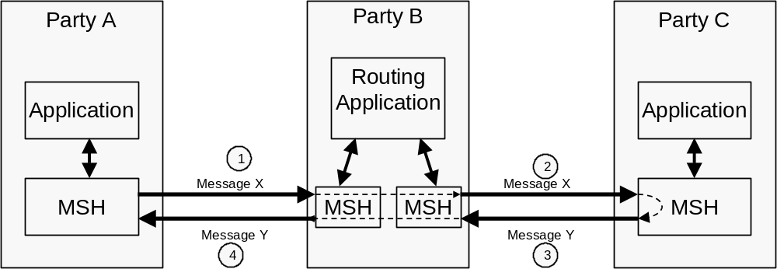
Figure 8-3 Multi-hop Message
The content of the corresponding messages could include:
- Transmission 1 - Message X From Party A To Party B
<Header id=”...”>
<From>urn:myscheme.com:id:PartyA-id</From>
<To>urn:myscheme.com:id:PartyC-id</From>
<ConversationId>219cdj89dj2398djfjn</ConversationId>
...
<MessageData>
<MessageId>29dmridj103kvna</MessageId>
...
</MessageData>
...
</Header>
<RoutingHeaderList id=”...”>
<RoutingHeader>
<SenderURI>url:PartyA.com/PartyAMsh</SenderURI>
<ReceiverURI>url:PartyB.com/PartyBMsh</ReceiverURI>
<Timestamp>20001216T21:19:35.145Z-8</Timestamp>
</RoutingHeader>
</RoutingHeaderList>
- Transmission 2 - Message X From Party B To Party C
<Header id=”...”>
<From>urn:myscheme.com:id:PartyA-id</From>
<To>urn:myscheme.com:id:PartyC-id</From>
<ConversationId>219cdj89dj2398djfjn</ConversationId>
...
<MessageData>
<MessageId>29dmridj103kvna</MessageId>
...
</MessageData>
...
</Header>
<RoutingHeaderList id=”...”>
<RoutingHeader>
<SenderURI>url:PartyA.com/PartyAMsh</SenderURI>
<ReceiverURI>url:PartyB.com/PartyBMsh</ReceiverURI>
<Timestamp>20001216T21:19:35.145Z-8</Timestamp>
</RoutingHeader>
<RoutingHeader>
<SenderURI>url:PartyB.com/PartyAMsh</SenderURI>
<ReceiverURI>url:PartyC.com/PartyBMsh</ReceiverURI>
<Timestamp>20001216T21:19:45.483Z-6</Timestamp>
</RoutingHeader>
</RoutingHeaderList>
Message Y would be similar to Message X except that the direction of transmission is reversed.

ApplicationHeaders Element
The ApplicationHeaders element supports the extension of an ebXML Message through the inclusion of additional XML elements that belong to a foreign namespace, as child elements of the ApplicationHeaders element.
Any additional element content MUST be namespace-qualified in accordance with [XMLNamespaces].
An MSH implementation MUST make the information content of the ApplicationHeaders element available to the application or application services layer of software. How this is done is an implementation decision but conformance to the ebXML Service Interface specification (to be defined) is recommended.
The ApplicationHeaders element has a single attribute called mustUnderstand. This attribute has two possible values true and false. The default value for the mustUnderstand attribute is false.
An ApplicationHeaders element that has a mustUnderstand set to a value of true means that a receiving MSH MUST be capable of understanding the meaning of the namespace-qualified element content. If the content is not understood, the receiving MSH MUST respond with a message that includes an errorCode of NotSupported in an Error element as defined in section 8.8.

ApplicationHeaders sample
<ApplicationHeaders mustUnderstand="true">
<foo:ProprietaryStuff
xmlns:foo="http://www.example.com/ebxml-msh-extensions">…
</foo:ProprietaryStuff>
</ApplicationHeaders>

StatusData Element
The StatusData element is used by one MSH to respond to a request on the status of the processing of a message that was previously sent (see also section 9.1).
The StatusData element consists of the following elements and attributes:
- a RefToMessageId element that contains the MessageId of the message whose status is being reported
- a Timestamp element. This contains the time that the message, whose status is being reported, was received. This MUST be omitted if the message whose status is being reported is NotRecognized or the request was UnAuthorized
- a ForwardURI element. This MUST only be present if messageStatus is set to Forwarded. If present it indicates the URI of the ReceiverURI to which the message was forwarded
- a messageStatus attribute that is set to one of the following values:
- UnAuthorized – the Message Status Request is not authorized or accepted
- NotRecognized – the message identified by the RefToMessageId element in the StatusData element is not recognized
- Received – the message identified by the RefToMessageId element in the StatusData element has been received by the MSH, but has not been processed by an application or forwarded to another MSH
- Processed – the message identified by the RefToMessageId element in the StatusData element has been received by the MSH for the To Party on the original message, and has been passed to the application or other process that is to handle it
- Forwarded – the message identified by the RefToMessageId element in the StatusData element has been received by the MSH, and has been forwarded to another MSH

ErrorList Element
The existence of an ErrorList element indicates that the message that is identified by the RefToMessageId in the header has an error.
The ErrorList element consists of one or more Error elements and the following two attributes:
- id attribute
- highestSeverity attribute
If there are no errors to be reported then the ErrorList element MUST NOT be present.

id attribute
The id attribute uniquely identifies the ErrorList element within the document.

highestSeverity attribute
The highestSeverity attribute contains the highest severity of any of the Error elements. Specifically, if any of the Error elements has a severity of Error then highestSeverity must be set to Error otherwise set highestSeverity to Warning.

Error element
An Error element consists of the following:
- codeContext attribute
- errorCode attribute
- severity attribute
- location attribute
- xml:lang attribute
- errorMessage attribute
- softwareDetails attribute

codeContext attribute
The codeContext attribute identifies the namespace or scheme for the errorCodes. It MUST be a URI. Its default value is http://www.ebxml.org/messageServiceErrors. If it is does not have the default value then it indicates that an implementation of this specification has used its own errorCodes.
Use of non ebXML values for errorCodes is NOT RECOMMENDED. In addition, an implementation of this specification MUST NOT use its own errorCodes if an existing errorCode as defined in section 8.8.5 has the same or very similar meaning.

errorCode attribute
The required errorCode attribute indicates the nature of the error in the message in error. Valid values for the errorCode and a description of the code’s meaning are given in section 8.8.5.

severity attribute
The required severity attribute indicates the severity of the error. Valid values are:
- Warning - This indicates that although there is an error, other messages in the conversation will still be generated in the normal way.
- Error - This indicates that there is an unrecoverable error in the message and no further messages will be generated as part of the conversation.

location attribute
The location attribute points to the part of the message that is in error.
If an error exists in the ebXML Header document and the document is “well formed” (see [XML]), then the content of the location attribute MUST be an [XPointer].
If the ebXML Header document is not “well formed” then the location attribute MUST be omitted.
If the error is associated with the MIME envelope that wraps the ebXML Header Document and the ebXML Payload, then location id contains the content-id of the MIME part that is in error, in the format cid:23912480wsr, where the text after the”:” is the value of the MIME part’s content-id.
The location attribute MUST NOT be used to point to errors inside the ebXML Payload Container as the method of reporting errors in the ebXML Payload Container is application dependent.

errorMessage attribute
The errorMessage attribute provides a narrative description of the error in the language defined by the xml:lang attribute. Typically, it will be the message generated by the XML parser or other software that is validating the message. This means that the value of the attribute is defined by the vendor/developer of the software, that generated the Error element.
The xml:lang must comply with the rules for identifying languages specified in [XML].
The errorMessage attribute MAY be omitted.
<DB>Do we want to allow multiple errorMessage elements in different languages, e.g. so that if you send a message to Switzerland you could send it in French, German and Italian?</DB>

softwareDetails attribute
The softwareDetails attribute contains a value that is set by the vendor/developer of the software that generated the Error element. It SHOULD contain data that enables the vendor/developer as well as the recipient of the message to identify the precise location in their software and the set of circumstances that caused the software to generate a message reporting the error. It is RECOMMENDED that this element include plain text separated by punctuation to identify:
- the name of the software vendor;
- the name, version and release number of the software that generated the ebXML Error Document
- the part of the software that caused the error to be generated that can be used by the Software Vendor to identify the circumstances that caused the error
If any part of the softwareDetails attribute contains text that is readable by a human, then it SHOULD be in the language identified by xml:lang.

Examples
An example of an ErrorList element is given below.
<ErrorList id=’3490sdo9’, highestSeverity=”error”>
<Error errorCode=’UnableToParse’, severity=”Error”, location=cid:21398adhiwqe, xml:lang=”us-en”, errorMessage=’XSD parser error – document not parsable”, softwareDetails=’Software Development Corp.; ebXML Connector!!; v2.7, build 2.7313; Ref HA’/>
<Error .... />
</ErrorList>

errorCode values
This section describes the ErrorCodes (see section 8.8.3.2) that are used in a message reporting an error. They are described in a table with three headings:
- the first column contains the value to be used as an errorCode, e.g. UnableToParse
- the second column contains a "Short Description" of the errorCode. Note that this narrative MUST NOT be used in the errorMessage attribute.
- the third columns contains a "Long Description" that provides an explanation of the meaning of the error and provides guidance on when the particular ErrorCode should be used.
It is RECOMMENDED that implementers of software that conforms to this specification make available to a user that is being informed of the error: the value of the errorCode, the “Short Description” and optionally the “Long Description”.
It is also RECOMMENDED that the “Short Description” and the “Long Description” are translated into the preferred language of the user if this is known.

Reporting Errors in the ebXML Header Document
The following list contains error codes that can be associated with the ebXML Header Document:
Error Code | Short Description | Long Description
UnableToParse | XML not well formed or invalid. | The XML document is not well formed or not valid and cannot be successfully parsed. See [XML] for the meaning of "well formed" and "not valid".
ValueNotRecognized | Element content or attribute value not recognized. | Although the document is well formed and valid, the element/attribute contains a value that could not recognized and therefore could not be used by the ebXML Message Service
NotSupported | Element or attribute not supported | Although the document is well formed and valid, an element or attribute is present that:  - is consistent with the rules and constraints contained in this specification, but  - is not supported by the ebXML Message Service that is processing the message.
Inconsistent | Element content or attribute value inconsistent with other elements or attributes. | Although the document is well formed and valid, according to the rules and constraints contained in this specification the content of an element or attribute is inconsistent with the content of other elements or their attributes.
OtherXml | Other error in an element content or attribute value. | Although the document is well formed and valid, the element content or attribute value contains values that do not conform to the rules and constraints contained in this specification and is not covered by other error codes. The errorMessage attribute should be used to indicate the nature of the problem.

Non-XML Document Errors
The following are error codes that identify errors that are not associated with the ebXML Header Document:
Error Code | Short Description | Long Description
MessageTooLarge | Message too large | The message is too large to be processed by the ebXML Message Service.
MimeProblem | A MIME error has occurred | An error has been detected in the structure or format of a MIME part of the message. For example:  - Missing MIME Part. Although the MIME message is correctly structured, a MIME part is missing that should have been present if the rules and constraints contained in this specification are followed  - Unexpected MIME Part. Unexpected MIME part. Although the MIME message is correctly structured, a MIME part is present that is not expected in the particular context according to the rules and constraints contained in this specification
DeliveryFailure | Message Delivery Failure | A message has been received that either probably or definitely could not be sent to its next destination. Note that if severity is set to Warning then there is a small probability that the message was delivered.
TimeToLiveExpired | Message Time To Live Expired | A message has been received that arrived after the time specified in the TimeToLive element of the Header element
SecurityFailure | Message Security Checks Failed | Validation of signatures or checks on the authenticity or authority of the sender of the message have failed.
Unknown | Unknown Error | Indicates that an error has occurred that is not covered explicitly by any of the other errors. The errorMessage attribute should be used to indicate the nature of the problem.

Acknowledgment Element
The Acknowledgment element is an optional element that is used by one Message Service Handler to indicate that another Message Service Handler has received a message.
For clarity two terms are defined:
- message being acknowledged. This is the Message that is has been received by a MSH that is now being acknowledged
- acknowledgment message. This is the message that acknowledges that the message being acknowledged has been received.
The message being acknowledged is identified by the RefToMessageId contained in the MessageData element contained within the Header Element of the acknowledgment message containing the value of the MessageId of the message being acknowledged.
The Acknowledgment element consists of the following:
- a Timestamp element
- a From element
- a type attribute
- a signed attribute

Timestamp element
The Timestamp element is a value representing the time that the message being acknowledged was received by the Party generating the acknowledgment message. It must conform to [ISO-8601]. <DB>Do we make this conform to XML Schema timeInstant</DB>

From element
This is the same element as the From element within Header element (see section 8.4.1). However, when used in the context of an Acknowledgment Element, it contains the identifier of the Party that is generating the acknowledgment message.
If the From element is omitted then the Party that is sending the element is identified by the From element in the Header element.

type attribute
The type attribute indicates who sent the acknowledgment message. It MUST contain either:
- DeliveryReceipt - indicates that the acknowledgment message was generated by the To Party identified by the To element of the message being acknowledged, or
- IntermediateAck - indicates that the acknowledgment message was generated by a Party that is not the To Party identified by the To element of the message being acknowledged. Typically this will be a Party that has received the message and is forwarding it to either the To Party or another Party with the intention that the message is sent to the To Party.
The default value for type is DeliveryReceipt.

signed attribute
The signed attribute indicates whether the acknowledgment message is digitally signed. It MUST contain either:
- True - indicates that the acknowledgment message is digitally signed, or
- False - indicates that the acknowledgment message is not digitally signed
The default value for signed is False.
See section for details on what should be signed and how a signature that signs an acknowledgment message should be checked.

Signature Element
TBD

Message Service Handler Services
The Message Service Handler MUST support two services that are designed to help provide smooth operation of a Message Handling Service implementation:
- Message Status Request
- Message Service Handler Ping
Each service is described below:

Message Status Request Service
The Message Status Request Service consists of the following:
- sending a Message Status Request message to a Message Service Handler (MSH) about a message previously sent
- the Message Service Handler that receives the request sending a Message Status Response message in return.

Message Status Request Message
A Message Status Request message consists of no ebXML Payload and the following elements in the ebXML Header:
- A Header element
- A RoutingHeaderList element
- A Signature element
The RoutingHeaderList and the Signature elements MAY be omitted (see sections 8.5 and 8.10).
The Header element MUST contain the following:
- a From element that identifies the party that created the message status request message
- a To element that identifies a Party that should receive the message. If a RoutingHeader was present on the message whose status is being checked then this MUST be the ReceiverURI from that message.
- a Service element that contains: http://www.ebxml.org/namespaces/messageService/MessageStatus
- an Action element that contains Request
The message is then sent to the To Party.

Message Status Response Message
Once the To Party on the Message Status Request message receives the message, they MAY generate a Message Status Response message that consists of no ebXML Payload and the following elements in the ebXML Header.
- a Header element
- a RoutingHeaderList element
- an Acknowledgement element
- a StatusData element
- a Signature element
The RoutingHeaderList, Acknowledgement and Signature elements MAY be omitted (see sections 8.5, 8.9 and 8.10).
The Header element MUST contain the following:
- a From element that identifies the creator of the Message Status Response message
- a To element that is set to the value of the From element in the Message Status Request message
- a Service element that contains: http://www.ebxml.org/namespaces/messageService/MessageStatus
- an Action element that contains Response
- a RefToMessageId that identifies the Message Status Request message.
The message is then sent to the To Party.

Security Considerations
Party’s that receive a Message Status Request message SHOULD always respond to the message. However they MAY ignore the message instead of responding with messageStatus set to UnAuthorized if they consider that the sender of the message received is unauthorized. The decision process that results in this course of action is implementation dependent.
<DB> Do we want to allow the Message Status Response to include the original response to the message in the Payload?</DB><CF> quite possibly.</CF>

Message Service Handler Ping Service
The Message Service Handler Ping Service enables one Message Service Handler to determine if another MSH is operating. It consists of:
- sending a Message Service Handler Ping message to a MSH, and
- the MSH that receives the Ping responding with a Message Service Handler Pong message.

Message Service Handler Ping Message
A Message Service Handler Ping (MSH Ping) message consists of no ebXML Payload and the following elements in the ebXML Header:
- A Header element
- A RoutingHeaderList element
- A Signature element
The RoutingHeaderList and the Signature elements MAY be omitted (see sections 8.5 and 8.10).
The Header element MUST contain the following:
- a From element that identifies the creator of the MSH Ping message
- a To element that identifies the operator of the MSH that is being sent the MSH Ping message
- a Service element that contains: http://www.ebxml.org/namespaces/messageService/MSHStatus
- an Action element that contains Ping
The message is then sent to the To Party.

Message Service Handler Pong Message
Once the To Party on the MSH Ping message receives the message, they MAY generate a Message Service Handler Pong (MSH Pong) message that consists of no ebXML Payload and the following elements in the ebXML Header.
- a Header element
- a RoutingHeaderList element
- an Acknowledgement element
- a Signature element
The RoutingHeaderList, Acknowledgement and Signature elements MAY be omitted (see sections 8.5, 8.9 and 8.10).
The Header element MUST contain the following:
- a From element that identifies the creator of the MSH Pong message
- a To element that identifies a Party that generated the MSH Ping message
- a Service element that contains: http://www.ebxml.org/namespaces/messageService/MessageStatus
- an Action element that contains Pong
- a RefToMessageId that identifies the MSH Ping message.
The message is then sent to the To Party.

Security Considerations
Party’s that receive a MSH Ping message SHOULD always respond to the message. However there is a risk that some Parties might use the MSH Ping message to determine the existence of a Message Service Handler as part of a security attack on that MSH. Therefore recipients of a MSH Ping MAY ignore the message if they consider that the sender of the message received is unauthorized or part of some attack. The decision process that results in this course of action is implementation dependent.

Reliable Messaging
Reliable Messaging defines an interoperable protocol such that the two Messaging Service Handlers (MSH) operated by a From Party and a To Party can “reliably” exchange messages that are sent using “reliable messaging” semantics.
“Reliably” means that the From Party can be highly certain that the message sent will be delivered to the To Party. If there is a problem in sending a message then the sender resends the message until either the message is delivered, or the sender gives up. If the message cannot be delivered, for example because there has been a catastrophic failure of the To Party’s system, then the From Party is informed.

Persistent Storage and System Failure
A MSH that supports Reliable Messaging MUST keep messages that are sent or received reliably in persistent storage. In this context persistent storage is a method of storing data that does not lose information after a system failure or interruption.
This specification recognizes that different degrees of resilience may be realized depending on the technology that is used to persist the data. However, as a minimum, persistent storage that has the resilience characteristics of a hard disk (or equivalent) SHOULD be used. It is strongly RECOMMENDED though that implementers of this specification use technology that is resilient to the failure of any single hardware or software component.
Even after a system interruption or failure, a MSH MUST ensure that messages in persistent storage are processed in the same way as if the system failure or interruption had not occurred. How this is done is an implementation decision.

Methods of Implementing Reliable Messaging
ebXML support for Reliable Messaging can be implemented in one of the following two ways:
- using the ebXML Reliable Messaging protocol, or
- using commercial queuing transport protocol software products that are designed to provide reliable delivery of messages using proprietary protocols.
Each of these are described below.

ebXML Reliable Messaging Protocol
The ebXML Reliable Messaging Protocol is used to implement Reliable Messaging when either:
- no queuing transport protocol products are available, or
- an implementation decision has been made to use the ebXML Reliable Messaging Protocol on top of a queuing transport protocol.
Use of the ebXML Reliable Messaging Protocol described in this section MUST be followed if the deliverySemantics parameter/element is set to OnceAndOnlyOnce and the ReliableMessagingMethod parameter/element is set to ebXML (the default).
The remainder of this section describes the ebXML Reliable Messaging Protocol. In outline it involves:
- a From Party sending a message to the To Party
- the To Party returning another message that references the first
This is illustrated by the figure below.
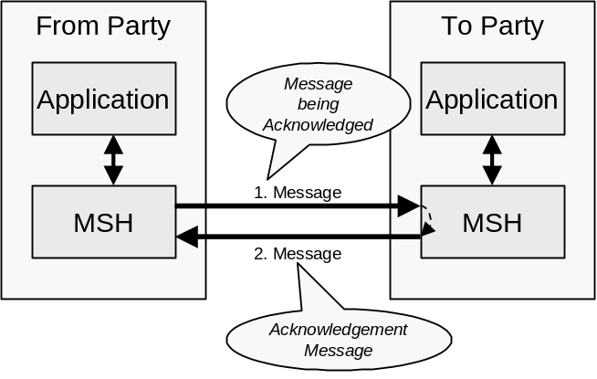
Figure 10-4 Indicating that a message has been received
The diagram above illustrates two terms that are used in the remainder of this section:
- message being acknowledged. This is the Message that needs to be sent reliably and therefore needs to be acknowledged
- acknowledgment message. This is the message that acknowledges that the message being acknowledged has been received.
The receipt of the acknowledgment message indicates that the message being acknowledged has been sent reliably.
An acknowledgement message MUST contain a MessageData element with a RefToMessageId that contains the same value as the MessageId element in the message being acknowledged.
Note that an acknowledgment message can also contain a payload.
A Message can be sent reliably either over:
- a Single-hop i.e. the sending of a message directly from the From Party’s MSH to the To Party’s MSH without passing through any intermediate MSHs.
- Multi-hops i.e. the sending of a message indirectly from the From Party’s MSH to the To Party’s MSH via one or more intermediate MSHs that are not owned by or operated by on behalf of either the From Party or the To Party.
Multi-hop Reliable Messaging can work either with, or without, Intermediate Acknowledgments. See also section 8.5 on Routing Headers
Single-hop Reliable Messaging is described first followed by Multi-hop Reliable Messaging. Note that Multi-hop Reliable Messaging is an extension of Single-hop reliable Messaging.

Single-hop Reliable Messaging
This section describes the REQUIRED behavior of a Message Service Handler (MSH) that is sending and/or receiving messages that support the ebXML Reliable Messaging .Protocol.

Sending Message Behavior
If a MSH is given data by an application that needs to be sent reliably then the MSH MUST do the following:
- Create a message from components received from the application that includes:
deliverySemantics set to OnceAndOnlyOnce, and
a RoutingHeader element that identifies the sender and the receiver URIs
- Save the message in persistent storage (see section 10.1.1)
- Send the message (the message being acknowledged) to the Receiver MSH
- Wait for the Receiver MSH to return an acknowledgement message and, if it does not, then resend the identical message as described in section 10.2.1.4
It is RECOMMENDED that messages that are sent reliably include deliveryReceiptRequested set to Signed or UnSigned.
If the message does not need to be sent reliably, then deliverySemantics MUST be set to BestEfforts. Other values for the elements/attributes in the Header are as defined in the CPA.

Receiving Message Behavior
If deliverySemantics on the received message is set to OnceAndOnlyOnce then do the following:
- Check to see if the message is a duplicate (i.e. there is a message in persistent storage that was received earlier that contains the same value for the MessageId)
- If the message is not a duplicate then do the following:
  - Save the MessageId of the received message in persistent storage. As an implementation decision, the whole message MAY be stored if there are other reasons for doing so.
  - If the received message contains a RefToMessageId element then do the following:
    - Look for a message in persistent storage that has a MessageId that is the same as the value of RefToMessageId on the received Message
    - If a message is found in persistent storage then mark the persisted message as delivered
  - If deliveryReceiptRequested is set to Signed or UnSigned then create an Acknowledgment element with type set to DeliveryReceipt that identifies the received message
  - If syncReplyMode is set to True then pass the data in the received message to the application or other process that needs to process it and wait for the application to produce a response.
  - If deliveryReceiptRequested is set to Signed or UnSigned, or syncReplyMode is set to True then do the following:
    - Create a RoutingHeader element that identifies the sender and the receiver URIs
    - Set the RefToMessageId to the value of the MessageId in the received message

Create a message from the response generated by the application (if any), the Acknowledgement element (if any) and the RoutingHeader that includes deliverySemantics set to OnceAndOnlyOnce
    - Save the message in persistent storage for later resending
    - Send the message back to the Sending MSH
  - If syncReplyMode is set to False then pass the data in the received message to the application or other process that needs to process it. Note that, depending on the application, this can result in the application generating another message to be sent (see previous section).
- If the message is a duplicate, then do the following:
  - Look in persistent storage for a response to the received message (i.e. it contains a RefToMessageId that matches the MessageId of the received message) that was most recently sent to the MSH that sent the received message (i.e. it has a RoutingHeader element with the greatest value of the Timestamp)
  - If no message was found in persistent storage then ignore the received message as either no message was generated in response to the message, or the processing of the earlier message is not yet complete
  - If a message was found in persistent storage then resend the persisted message back to the MSH that sent the received message.

Resending Lost Messages
This section describes the behavior that occurs when messages are lost. A message is "lost" when a sending MSH does not receive a response to a message. For example, it is possible that a message being acknowledged was lost, for example:
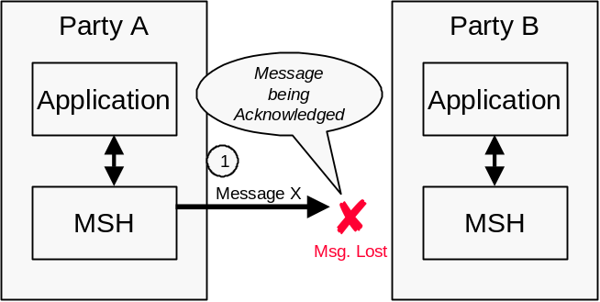
Figure 10-13 Lost “Message Being Acknowledged”
It is also possible that the Acknowledgment Message was lost, for example ...
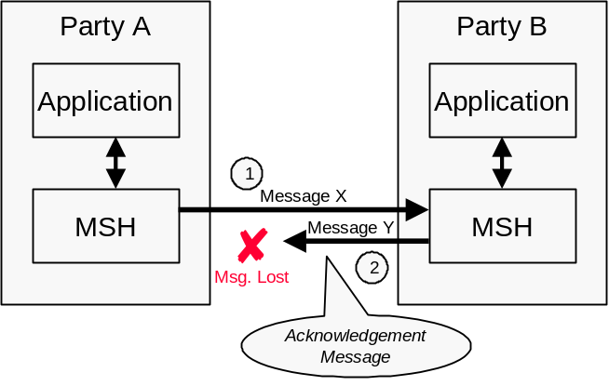
Figure 10-14 Lost Acknowledgment Message
The rules that apply are as follows:
- The Sending MSH MUST resend the original message if an Acknowledgment Message has not been received from the Receiving MSH and either of the following are true:
  - The message has not yet been resent and at least the time specified in the timeout parameter has passed since the first message was sent, or
  - The message has been resent, and the following are both true:
    - At least the time specified in the retryInterval has passed since the last time the message was resent, and
    - The message has been resent less than the number of times specified in the retries Parameter
- If the Sending MSH does not receive an Acknowledgment Message after the maximum number of retries, the Sending MSH SHOULD notify one of the following:
  - The application and/or system administrator function if the Sending MSH is the From Party MSH, or
  - The Sending MSH of the From Party, if the Sending MSH is operated by an Intermediate Party (see section 10.5)
- If the Sending MSH detects a communications protocol error that is unrecoverable at the transport protocol level, the Sending MSH SHOULD first attempt to resend the message using a different communications protocol if the CPA allows this, then if this is not successful, notify the From Party of the failure to deliver as described in section 10.5.
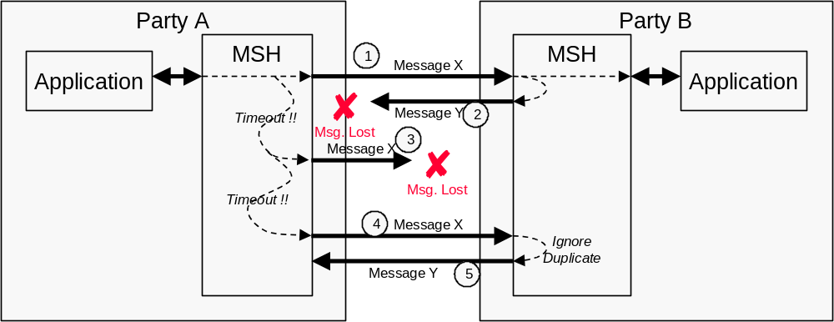
Figure 10-15 Resending Lost Messages
The diagram above shows the behavior that MUST be followed by the sender of the message being acknowledged (e.g. Message X) and the acknowledgment message (e.g. Message Y). Specifically:
- The sender of the message being acknowledged (e.g. Party A) MUST re-send the identical message to the To Party MSH (e.g. Party B) if no Acknowledgment Message is received
- The recipient of the message being acknowledged (e.g. Party B), when it receives a duplicate message, MUST re-send to the sender of the message being acknowledged (e.g. Party A), a message identical to the most recent message that was sent to the recipient (i.e. Party A)
- The recipient of the message being acknowledged (e.g. Party A) MUST ignore duplicate messages and not forward them a second time to the application, the next MSH or other process that ultimately needs to receive them.
In this context:
- an identical message is a message that contains, apart from perhaps an additional RoutingHeader element, the same ebXML Header and ebXML Payload as the earlier message that was sent.
- a duplicate message is a message that contains the same MessageId as an earlier message that was received.
- the most recent message is the message with the latest Timestamp in the MessageData element that has the same RefToMessageId as the duplicate message that has just been received.
Note that the Communication Protocol Envelope MAY be different. This means that the same message MAY be sent using different communication protocols and the reliable messaging behavior described in this section will still apply. The ability to use alternative communication protocols is specified in the CPA.

Multi-hop Reliable Messaging
Multi-hop reliable Messaging can occur either:
- without Intermediate Acknowledgment, or
- with Intermediate Acknowledgments
Each of these is described below.

Multi-hop Reliable Messaging without Intermediate Acknowledgments
Multi-hop Reliable Messaging without Intermediate Acknowledgment is identified by the IntermediateAckRequested of the Routing Header for the hop being set to False.
The overall message flow is illustrated by the diagram below.
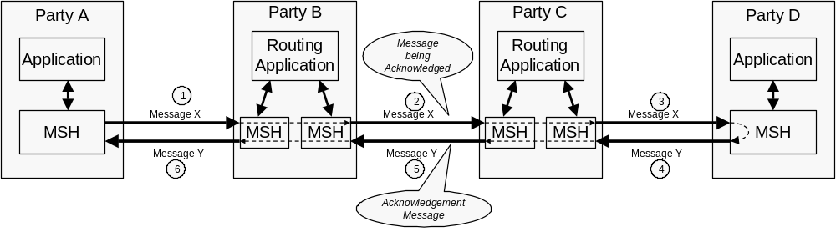
Figure 10-16 Multi-hop Reliable Messaging without Intermediate Acknowledgments
This is essentially the same as Single-hop Reliable Messaging except that the Message passes through multiple intermediate parties. This means that:
- the From Party (e.g. Party A) and the To Party (e.g. Party D) are the only parties that adopt the Reliable Messaging behavior described in this section
- the intermediate parties (e.g. Parties B and C), just forward the messages they receive, they do not undertake any Reliable Messaging behavior.
It is RECOMMENDED that Multi-hop Reliable Messaging without Intermediate Acknowledgments is used when the From Party that is sending a message is confident that the total time taken for ...
- the message being acknowledged to be sent to the To Party, and
- the acknowledgment message to be returned
... is sufficiently short so that the From Party will not resend the message being acknowledged.
This is described in more detail below:
- The From Party and the To Party adopt the sending message and receiving message behavior described in sections 10.2.1.1 and 10.2.1.2 except that the From Party MSH (e.g. Party A) sends to an Intermediate Party (e.g. Party B) a message (the message being acknowledged) e.g. Message X in transmission 1, that contains
a ReliableMessagingInfo element with deliverySemantics set to OnceAndOnlyOnce
a RoutingHeader element that contains the SenderURI of the sender (e.g. the URL for Party A’s MSH) and the ReceiverURI of the next recipient of the message (e.g. the URL of Party B’s MSH)
- Once the Intermediate Party (e.g. Party B or Party C) receives the message, they determine its next destination (in the example above this could be done by the Routing Application) and forward the message (e.g. Transmission 2 of Message X) to the next Party (e.g. either Party C or Party D). Before sending the message they do the following:
transfer elements in the ebXML Header and Payload unchanged from the inbound message to the outbound message except that, they
add a RoutingHeader element to the RoutingHeaderList that contains the SenderURI of the next party to receive the message (e.g. the URL for Party C’s or Party D’s MSH) and the ReceiverURI (e.g. the URL for Party B’s or Party C’s MSH)
- The previous step then repeats until eventually the message (e.g. Message X) reaches its final destination at the To Party (e.g. Party D)
- Once the To Party receives the message (i.e. the message being acknowledged) they return an acknowledgment message to the From Party through the Intermediate Parties.)
- Steps 2 and 3 above then repeat until the acknowledgment message reaches the To Party (e.g. Party A)

Multi-hop Reliable Messaging with Intermediate Acknowledgments
Multi-hop Reliable Messaging with Intermediate Acknowledgments is similar to Multi-hop Reliable Messaging without Intermediate Acknowledgment except that any of the Parties that are transmitting a Message can request that the recipient return an Intermediate Acknowledgment.
This is illustrated by the diagram below.
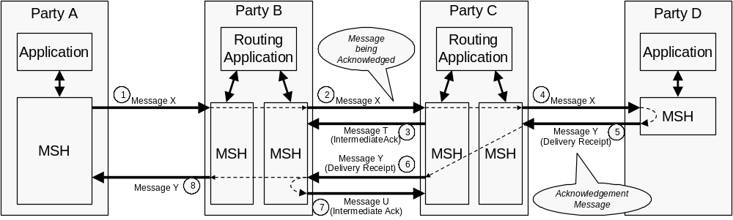
Figure 10-17 Multi-hop Reliable Messaging with Intermediate Acknowledgments
The main difference between Multi-Hop Reliable Messaging with Intermediate Acknowledgments and the without is:
- any party may request an intermediate acknowledgment
- any party that either sends or receives a message that requests an intermediate acknowledgment must adopt the reliable messaging behavior even if the ReliableMessagingInfo element indicates otherwise.
It is RECOMMENDED that Multi-hop Reliable Messaging with Intermediate Acknowledgments is used when the From Party that is sending a message is considers that the total time taken for ...
- the message being acknowledged to be sent to the To Party, and
- the acknowledgment message to be returned
... is so long that the From Party will resend the message being acknowledged.
The rules that apply to Multi-hop Reliable Messaging with Intermediate Acknowledgment are as follows:
- Any Party that is sending a message can request that the recipient send an Acknowledgment Message that is an Intermediate Acknowledgment by setting the IntermediateAckRequested of the RoutingHeader for the hop to True. (e.g. Transmission 2 of Message X, or Transmission 6 of Message Y)
- If a MSH that is not the To Party

- receives a message that requires an Intermediate Acknowledgment (e.g. Transmission 2 of Message X, or Transmission 6 of Message Y) then:
  - If the MSH can identify itself as the ReceiverURI in the RoutingHeader for the hop, and an Intermediate Acknowledgment is requested, then the MSH must return an Acknowledgment Message (e.g. Transmission 3 of Message T, or Transmission 7 of Message U) with:
The Service and Action elements set as in defined in section 10.4
The From element contains the ReceiverURI from the last RoutingHeader in the message that has just been received
The To element contains the SenderURI from the last RoutingHeader in the message that has just been received
a RefToMessageId element that contains the MessageId of the message being acknowledged
a ReliableMessagingInfo element with deliverySemantics set to OnceAndOnlyOnce
an Acknowledgment element with type set to IntermediateAck
a RoutingHeader element that contains the SenderURI of the sender (e.g. the URL for Party C’s or Party B’s MSH) and the ReceiverURI of the next recipient of the message (e.g. the URL of Party B’s or Party C’s MSH)
- If a MSH that is the To Party receives a message and it requires an Intermediate Acknowledgment (see step 2) then, unless the To Party is returning an Acknowledgment Message that is a Delivery Receipt, return an Acknowledgment Message as described in step 2c above.

ebXML Reliable Messaging using Queuing Transports
This section describes the differences that apply if a Queuing Transport is used to implement Reliable Messaging.
Use of the ebXML Reliable Messaging Protocol is identified by the ReliableMessagingMethod parameter being set to Transport for transmission (either a Single-hop or a Multi-hop)
If Reliable Messaging using a Queuing Transport is being used then the following rules apply:
- An Intermediate Ack SHOULD not be requested. If an Intermediate Ack is requested, then it is ignored.
- No message acknowledgments with an Acknowledgment element with a type of IntermediateAck should be sent, even if requested
- Implementations should use the facilities of the Queuing Transport to determine if the message was delivered
- If an intermediate MSH cannot forward a message to the next Party then the From Party should be notified using the procedure described in section 10.5.
- An acknowledgment message with an Acknowledgment element with a type attribute set to deliveryReceipt can be sent if requested to inform the sender of the message being acknowledged that the message was delivered.

Service and Action Element Values
An Acknowledgement element can be included in an ebXMLHeader that is part of a message that is being sent as a result of processing of an earlier message. In this case the values for the Service and Action elements are set by the designer of the Service (see section 8.4.4).
An Acknowledgement element also can be included in an ebXMLHeader that does not include any results from the processing of an earlier message. In this case, the values of the Service and Action elements MUST be set as follows:
- The Service element MUST be set to: http://www.ebxml.org/namespaces/messageService/MessageAcknowledgement
- The Action element MUST be set to the value of the type attribute in the Acknowledgment element.
Note that deliveryReceiptRequested must be set to None on a message that is only an acknowledgement.

Failed Message Delivery
It is possible, that a Message cannot be delivered to its ultimate destination. This can be either:
- when the To Party MSH cannot deliver the message to the Application or other process that needs it, or
- when using Intermediate Acknowledgments and an Intermediate system determines that a message may have been lost. This is illustrated by the diagram below.
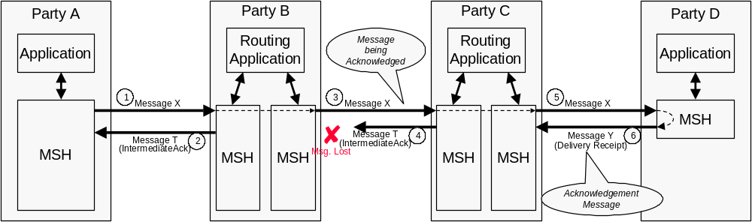
Figure 10-22 Failed Message Delivery using Intermediate Acknowledgments
In this example, Party B does not know if Party C (or Party D) has received the message since, even after resending, it has not received the acknowledgment message (Message T).
In both these circumstances the MSH that detects the problem MUST send a message to the From Party that sent the message being acknowledged (via the Intermediate Party if required). The message contains:
- a From Party that identifies the Party that detected the problem
- a To Party that identifies the From Party that created the message that could not be delivered
- a Service element and Action element set as described in 11.5
- a ReliableMessagingInfo element with deliverySemantics set to the same value as the deliverySemantics on the message that could not be delivered
- an Error element with a severity of:
- Error if the Party that detected the problem could not even transmit the message (e.g. Transmission 3 was impossible)
- Warning if the message (e.g. Message X in Transmission 3) was transmitted, but no acknowledgment was received. This means that the message probably was not delivered although there is a small probability that it was
- an ErrorCode of DeliveryFailure
This is illustrated by the diagram below by the text and arrows in red.
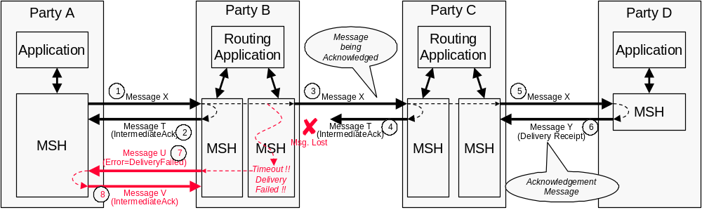
Figure 10-23 Reporting Failed Message Delivery
Note that the message that contains an Error element with an ErrorCode of DeliveryFailure (e.g. Message U in Transmission 7) might be sent reliably. It is possible the acknowledgment message for this message (e.g. Message V in Transmission 8) is not received. In this case, the Party that detects the failed delivery (e.g. Party B) SHOULD inform the Party (e.g. Party A) that sent the message being acknowledged (e.g. Message X in Transmission 1) of the failure. How this is done is outside the scope of this specification.

Reliable Messaging Parameters
This section describes the parameters required to control reliable messaging. This parameter information may be contained:
- in the ebXML Message header, or
- in the CPA associated with the message.
If the information is in both the ebXML message header and the CPA, the information in the header over-rides the CPA.

Who sets Message Service Parameters
The values to be used in parameters can be specified by the following parties:
- the From Party
- the To Party
- the sending Message Service Handler (MSH)
- the receiving Message Service Handler
Parameters set by the From Party or the To Party, apply to the delivery of a message as a whole. Parameters set by the sending or receiving MSH apply to a single-hop.
Note that the From Party is the sending MSH and the To Party is the receiving MSH for the first/last MSH that handles the message.
The table below indicates where these parameters may be set.
Specified By | Parameter | CPA/  CPP | Message  Header | Routing  Header
From Party | deliverySemantics | Yes | Yes | N/A
From Party | deliveryReceiptRequested | Yes | Yes | N/A
From Party | syncReplyMode | Yes | Yes | N/A
From Party | timeToLive | Yes | Yes | N/A
To Party | deliveryReceiptProvided | Yes | No | No
Sending MSH | reliableMessagingMethod | No | N/A | Yes
Sending MSH | intermediateAckRequested | No | N/A | Yes
Sending MSH | timeout | Yes | No | No
Sending MSH | retries | Yes | No | No
Sending MSH | retryInterval | Yes | No | No
Receiving MSH | reliableMessagingSupported | Yes | No | No
Receiving MSH | intermediateAckSupported | Yes | No | No
Receiving MSH | persistDuration | Yes | No | No
Receiving MSH | mshTimeAccuracy | Yes | No | No
In this table, the following interpretation of the columns should be used:
- the Specified By columns indicates the Party that sets the value in the Collaboration Party Protocol, Message Header, or Routing Header
- if the CPA/CPP column contains a Yes then it indicates that the party in the Specified By column specifies the value that is present in the CPP
- if the CPA/CPP column contains a No then it indicates that the parameter value is never specified in the CPP
- if the Message Header or Routing Header columns contain a Yes then it indicates that the parameter value may be specified in the Header element or Routing Header and over-rides any value in the CPA. It the value is not specified in the Header element or Routing Header then the value in the CPA must be used.
- if the Message Header/Routing Header columns contain a No then it indicates that the value in the CPA is always used
- if the Message Header/Routing Header columns contain a N/A then it indicates that the value may be specified in another header
These parameters are described below.

From Party Parameters
This section describes the parameters that are set by the From Party

Delivery Semantics
The deliverySemantics parameter may be present as either an element within the ebXMLHeader element or as a parameter within the CPA. See section 8.4.8.1 for more information.

Delivery Receipt Requested
The deliveryReceiptRequested parameter may be present as either an element within the ebXMLHeader element or as a parameter within the CPA. See section 8.4.8.2 for more information.

Sync Reply Mode
The syncReplyMode parameter may be present as either an element within the ebXMLHeader element or as a parameter within the CPA. See section 8.4.8.3 for more information.

Time To Live

The TimeToLive element may be presented within the ebXMLHeader element see section 8.4.8.2 for more information.

To Party Parameters
This section describes the parameters that are set by the To Party

Delivery Receipt Provided
The DeliveryReceiptProvided parameter indicates whether a To Party can provide an acknowledgment message with a type attribute of deliveryReceipt in response to a message. Valid values are:
- Signed - indicates that only a signed Delivery Receipt can be provided
- Unsigned - indicates only an unsigned Delivery Receipt can be provided,
- Both - indicates that either a signed or an unsigned Delivery Receipt can be provided, or
- None - indicates that the To Party does not create Delivery Receipts
If a MSH receives a Message where deliveryReceiptRequested is in not compatible with the value of DeliveryReceiptProvided then the MSH MUST return an Error Message to the From Party MSH, reporting that the DeliveryReceiptProvided is not supported. This must

contain an errorCode set to NotSupported and a severity of Error.

Sending MSH Parameters
This section describes the parameters that are set by the Party that operates the Sending MSH.

Reliable Messaging Method
The ReliableMessagingMethod parameter indicates the requested method for Reliable Messaging that will be used when sending a Message. Valid values are:
- ebXML in this case the ebXML Reliable Messaging Protocol as defined in section 10 is followed, or
- Transport, in this case a Queuing Transport Protocol is used for reliable delivery of the message, see section 10.3.

Intermediate Ack Requested
The IntermediateAckRequested parameter is used by the Sending MSH to request that the Receiving MSH that receives the Message returns an acknowledgment message with an Acknowledgment element with a type of IntemediateAcknowledgment..
Valid values for IntermediateAckRequested are:
- Unsigned - requests that an unsigned Delivery Receipt is requested
- Signed - requests that a signed Delivery Receipt is requested, or
- None - indicates that no Delivery Receipt is requested.
The default value is None.

Timeout Parameter
The timeout parameter is an integer value that specifies the time in seconds that the Sending MSH MUST wait for an Acknowledgment Message before first resending a message to the Receiving MSH.

Retries Parameter
The retries Parameter is an integer value that specifies the maximum number of times the message being acknowledged must be resent to the Receiving MSH using the same Communications Protocol by the Sending MSH.

RetryInterval Parameter
The retryInterval parameter is an integer value specifying, in seconds, the time the Sending MSH MUST wait between retries, if an Acknowledgment Message is not received.

Deciding when to resend a message
The Sending MSH MUST resend the original message if an Acknowledgment Message has not been received from the Receiving MSH and either:
- the message has not yet been resent and at least the time specified in the timeout parameter has passed since the first message was sent, or
- the message has been resent, and
- at least the time specified in the retryInterval has passed since the last time the message was resent, and
- the message has been resent less than the number of times specified in the retries Parameter, and
If the Sending MSH does not receive an Acknowledgment Message after the maximum number of retries, the Sending MSH SHOULD notify either:
- the application and/or system administrator function if the Sending MSH is the From Party MSH, or
- send an message reporting the delivery failure, if the Sending MSH is operating by an Intermediate Party (see section 10.5)

Receiving MSH Parameters
This section describes the parameters that are set by the Party that operates the Receiving MSH.

Reliable Messaging Methods Supported
The reliableMessagingMethodsSupported parameter is a list of the methods that a MSH uses to support Reliable Messaging. It must be a URI. The URI for the ebXML Reliable Messaging Protocol described in section 10 is http://www.ebxml.org/namespaces/reliableMessaging

PersistDuration
PersistDuration is the minimum length of time in days that a Message that is sent reliably is kept in Persistent Storage by a MSH. The value used for PersistDuration is an implementation decision although it MUST be greater than the value of the TimeToLive parameter for any message that is sent.
If a duplicate message (i.e. with the same MessageId) is received before the PersistDuration has passed, then the MSH that receives it MUST process it as a duplicate message as described in sections 10.2.1.4 and .
If a duplicate message is received after the PersistDuration has passed, then although it may be treated as a duplicate, the sender must realize that it will probably be treated by the MSH as if the message were a new message that had not been received before.

MSH Time Accuracy
The mshTimeAccuracy parameter in the CPA indicates the minimum accuracy that a Receiving MSH keeps the clocks it uses when checking, for example, TimeToLive. It’s value is in the format “mm:ss” which indicates the accuracy in minutes and seconds.

Error Reporting and Handling
This section describes how one ebXML Message Service Handler (MSH) reports errors it detects in an ebXML Message to another MSH.

Definitions
For clarity two phrases are defined that are used in this section:
- message in error. A message that contains or causes an error of some kind
- message reporting the error. A message that contains an ebXML ErrorList element that describes the error(s) found in a message in error.

Types of Errors
One MSH needs to report to another MSH errors in a message in error that are associated with:
- the structure or content of the Message Envelope (e.g. MIME) (see section 7),
- the ebXML Message Header document (see section 8),

- reliable messaging failures (see section 10), or
- security (see section 12).
Unless specified to the contrary, all references to "an error" in the remainder of this specification imply any or all of the types of errors listed above.
Errors associated with Data Communication protocols are detected and reported using the standard mechanisms supported by that data communication protocol and are do not use the error reporting mechanism described here.

When to generate Error Messages
When an MSH detects an error in a message in error, a message reporting the error MUST be generated and delivered to the MSH that sent the message in error if:
- the Error Reporting Location (see section11.4) to which the message reporting the error should be sent can be determined, and
- the message in error does not have an ErrorList element with highestSeverity set to Error.
If the Error Reporting Location cannot be found or the message in error has an ErrorList element with highestSeverity set to Error, it is RECOMMENDED that:
- the error is logged,
- the problem is resolved by other means, and
- no further action is taken.

Security Considerations
Party’s that receive a Message that contains an error in the header SHOULD always respond to the message. However they MAY ignore the message and not respond if they consider that the message received is unauthorized or is part of some security attack. The decision process that results in this course of action is implementation dependent.

Identifying the Error Reporting Location
The Error Reporting Location is a URI that is specified by the sender of the message in error that indicates where to send a message reporting the error. This may be specified:
- by reference, for example by using the CPAId to identify the Party Agreement that contains the Error Reporting Location, or
- by value, for example by using the ErrorURI contained within the RoutingHeader element.
If a message contains an ErrorURI then the ErrorURI MUST be used.
If an ErrorURI is not used then the ErrorURI implied by the CPA identified by the CpaID on the message SHOULD be used. If no ErrorURI is implied by the CPA, then the SenderURI MUST be used.
Even if the message in error cannot be successfully analyzed or parsed, MSH implementers SHOULD try to determine the Error Reporting Location by other means. How this is done is an implementation decision.

Service and Action Element Values
An ErrorList element can be included in an ebXMLHeader that is part of a message that is being sent as a result of processing of an earlier message. In this case the values for the Service and Action elements are set by the designer of the Service (see section 8.4.4).
An ErrorList element can also be included in an ebXMLHeader that is not being sent as a result of the processing of an earlier message. In this case, the values of the Service and Action elements MUST be set as follows:
- The Service element MUST be set to: http://www.ebxml.org/namespaces/messageService/MessageStatus
- The Action element MUST be set to MessageError.

Security
The ebXML Message Service, by its very nature, presents certain security risks. A Message Service may be at risk by means of:
- Unauthorized access
- Data integrity and/or confidentiality attacks (e.g. through man-in-the-middle attacks)
- Denial-of-Service, spoofing, bombing attacks
Each of these security risks MAY be addressed in whole, or in part, by the application of one, or a combination, of the countermeasures described in this section. This specification describes a set of profiles, or combinations of selected countermeasures, that have been selected to address key risks based upon commonly available technologies. Each of the specified profiles includes a description of the risks that are not addressed.
Application of countermeasures SHOULD be balanced against an assessment of the inherent risks and the value of the asset(s) that might be placed at risk. <CF> need some reference to risk assessment sites/docs here.</CF>

Security and Management
No technology, regardless of how advanced it might be, is an adequate substitute to the effective application of security management policies and practices.
It is STRONGLY RECOMMENDED that the site manager of an ebXML Message Service apply due diligence to the support and maintenance of its; security mechanism, site (or physical) security procedures, cryptographic protocols, update implementations and apply fixes as appropriate. (See http://www.cert.org/ ,http://ciac.llnl.gov/)

Collaboration Party Profiles
The configuration of Security for MSHs is specified in the CPP. There are three areas of the CPP that have security definitions as follows:
- The Document Exchange section addresses security to be applied to the payload of the message. The MSH is not responsible for any security specified at this level but may offer these services to the message sender.
- The Message section addresses security applied to the entire ebXML Document, which includes the header and the payload.
- The Transport section addresses the Transport level. The MSH is not responsible for any security specified at this level.

Risks

Unauthorized Access
One of the risks for Message Service Handlers is sending messages to or receiving messages from another message service handler that is not known or one that is being impersonated by a rogue MSH. Receiving a flood of requests from a known or unknown MSH can be considered a denial of service attack. Message Service Handlers need to be identified and need to be able to authenticate requests from other MSHs.
A message MAY carry information that authenticates the sending MSH in the message header. If authentication data is in the header, it MUST be protected from modification and inappropriate access.
Messages that are digitally signed MAY also be asserted as authenticated requests.
Authentication MAY also be provided by the underlying transport, such as through the use of [TLS].

Data Integrity and Confidentiality
Integrity protection is the term used to express a requirement that data MUST be protected from unauthorized modification while it is stored or passed over the network. The common technology for integrity protection is to generate a hash of the data and storing both the information and the hash securely. In a network protocol the hash is sent through a protected means and MAY be used to validate that the data received is the same data that was sent.
Privacy, or confidentiality, is the term used to express a requirement that data MUST be encrypted while it is stored or passed over the network. The common method for privacy protection is encryption via symmetric key algorithm like DES or triple-DES.

Denial-of Service
It is assumed that ebXML data and operations flow over the existing web infrastructure. All message services will implement their own web security infrastructure and practices. There are threats at all levels of the stack that need to be addressed through other means outside ebXML.

Countermeasure Technologies

ebXML Message Countermeasures for Unauthorized Access and Data Integrity

Digital Certificates
The X.509 v3 standard describes an extensible framework within which basic certificate information MAY be extended. It also describes how such extensions MAY be used to control the process of issuing and validating certificates. Presently, there is no single view as to which certificate extensions must be present in an X.509 v3 digital certificate. The Collaboration Protocol Agreement identifies the particular X.509 v.3 certificate extensions that the parties to an agreement have agreed to use. An implementation of the ebXML Message Service MAY handle the subset of the certificate extensions listed in [S/MIME], but this capability is NOT REQUIRED. A Message Service that receives a message that contains critical extensions in an X509 v3 certificate that it is unable to handle MUST abandon processing of the message and return an Error (see section with errorCode set to SecurityFailure and severity set to Error.
An implementation of the ebXML Message Service MAY implement a certificate-revocation list (CRL) retrieval mechanism. The purpose of a CRL is to gain access to certificate revocation information when validating certificate chains. It is RECOMMENDED that the Message Service retrieve and utilize CRL information each time a certificate is verified. The ultimate decision regarding use of the CRL information is left to the security policy of a party deploying an ebXML Message Service.
The use of a digital signature on an ebXML message satisfies the requirements for message integrity verification as well as authentication of the sender’s identity. The digital signature also helps to establish the ebXML message non-repudiation property.

ebXML Message Countermeasures for Denial of Service
Message Service implementations SHOULD be able to immediately detect messages that MAY be a denial of service attack and take appropriate measures to reject these messages. Message Service implementations SHOULD be able to authenticate the claimed identity of a message sender when authentication is
required by the business. <MH> need to tie this in to requirements in the CPP for authenticating at the MSH or transport level.</MH>

ebXML Management Countermeasures for Denial of Service
It is STRONGLY RECOMMENDED that the site manager of an ebXML Message Service take appropriate measures to monitor announcements and descriptions of new attacks (See http://www.cert.org/) and apply updates and patches as appropriate.

Profiles

XML Digital Signature (XMLDSIG)
The joint W3C/IETF XMLDSIG Working Group has released the [XMLDSIG] specification as a Candidate Recommendation effective November, 2000. This means that the specification is made public for the purposes of encouraging implementations of the specification to validate that it can be successfully implemented. To date, there are at least three implementations of the specification in circulation, with others under development. It is anticipated that this specification, along with the recently initiated XML Encryption Working Group (also a joint W3C/IETF initiative) will be key technologies that MAY be employed by the ebXML Message Service.
The [XMLDSIG] specification defines how an XML document(s) MAY be signed, either in whole or as selective element content by means of a transformation such as [XPATH] or [XSLT].

Profile - XML Signature signing of header and/or payload
An ebXML Message MAY be signed using technology that implements the [XMLDSIG] specification.
To be completed.

Risks
This profile does not provide persistent privacy/confidentiality. It is STRONGLY RECOMMENDED that this profile be used in conjunction with a secure transport that provides for authentication as well as encryption over the network such as is provided by [TLS]. HTTP over SSL (HTTP/S) would be such a transport mechanism.

Benefits
This profile provides the only means of signing both the header and payload objects. This profile also allows the message to be modified as it traverses through intermediary Message Service Handlers that MUST append RoutingHeader elements as the message is (re) sent on its path from the From Party to the To Party.

S/MIME
[S/MIME] names the message digest algorithms (md5, sha1), the public key encryption algorithm (RSA), and the bulk data encryption algorithms (RC2/40 and, optionally, Triple DES) that MUST be implemented in order to comply with the standard. An implementation of the ebXML Message Service that claims support for S/MIME SHALL conform to that standard.
The [S/MIME] specification REQUIRES that each MIME entity to be signed and/or encrypted MUST be converted to a canonical form that may be uniquely and unambiguously represented in both the environment where the signature is to be created and the environment where the signature is to be verified. MIME entities MUST be presented in a canonical format for enveloping as well as for signing.
The S/MIME specification RECOMMENDS transmitting entities such as 8-bit text and binary data to be encoded with quoted-printable or base-64 transfer encoding. This provision applies to formatting of the ebXML messages due to the transport independence property of the protocol.
Digital certificates are delivered as a part of the application/pkcs7-signature part of the multipart/signed message. [S/MIMECH] provides the guidelines for use of the digital certificates in S/MIME messages. The exact implementation of the certificate handling procedures and authentication semantics of the information in the digital certificate received with an ebXML message is left to the Trading Partner Agreement. <CF> this needs work!</CF>

Profile - S/MIME signing of message payload
The multipart/signed form defined by the [S/MIME] specification MAY be used to sign ebXML message payloads. This specification makes no claims as to how the signing and packaging of the payload object(s) is to be achieved. An implementation of the ebXML Message Service MAY choose to offer these services to the application or application service layers of software as described in the section on the Message Service Interface. However, this is not a REQUIRED feature of an ebXML Message Service.
This profile SHALL be uniquely identified by the following URI:
- http://www.ebxml.org/namespaces/security-profiles/smime-pkcs7-signed-payload
The [S/MIME] specification REQUIRES two parameters of the multipart/signed content type:
- protocol
- micalg
An ebXML message payload that is signed using this profile SHALL use the following values for these MIME parameters:
- protocol="application/pkcs7-signature
- micalg="rsa-sha1"

Sample S/MIME signed payload
The following is a sample S/MIME signed payload
Content-Type: multipart/related; type="application/vnd.eb+xml; version="0.91"; boundary=ebxmlenvelopeuniquestring;
Content-Id: localpart@domain

--ebxmlenvelopeuniquestring
Content-Type: application/vnd.eb+xml; version="0.91"; charset="UTF-8";
Content-Id: localpart@domain

<?xml version="1.0" encoding="UTF-8"?>
<ebXMLHeader version="0.91" xmlns=http://www.ebxml.org/namespaces/messageHeader>
…
</ebXMLHeader>

--ebxmlenvelopeuniquestring

Content-Type: multipart/signed; boundary="someuniquestring"; protocol="application/pkcs7-signature"; micalg="rsa-sha1";
Content-Id: localpart@domain

--someuniquestring
Content-Type: text/plain
Content-Id: localpart@domain

<Payload in the clear>

--someuniquestring
Content-Type: application/pkcs7-signed; name="smime.p7s";
Content-Id: localpart@domain
Content-Transfer-Encoding: base64

%^)*&TLYGSRKWHF

--someuniquestring--
--ebxmlenvelopeuniquestring--

Risks
This profile does not provide persistent privacy/confidentiality. It is STRONGLY RECOMMENDED that this profile be used in conjunction with a secure transport that provides for authentication as well as encryption over the network such as is provided by [TLS]. HTTP over SSL (HTTP/S) would be such a transport mechanism.
The header document is unsigned and there is no binding of the header and payload.

Benefits
This is the simplest form of integrity, with application signing and authentication of the payload only.

Profile - S/MIME encryption of message payload
This profile SHALL be uniquely identified by the following URI:
- http://www.ebxml.org/namespaces/security-profiles/smime-pkcs7-encrypted-payload
The [S/MIME] specification REQUIRES two parameters of the multipart/signed content type:
- protocol
- micalg
An ebXML message payload that is signed using this profile SHALL use the following values for these MIME parameters:
- protocol="application/pkcs7-signature
- micalg="rsa-sha1"

Risks
The header document is unsigned and there is no binding of the header and payload.

Benefits
This is the simplest form of integrity, with application signing and authentication of the payload only.

PGP/MIME
[PGP/MIME] MAY be used to sign and/or encrypt an ebXML message payload object(s). An implementation of the ebXML Message Service that claims support for PGP/MIME SHALL conform to that standard.

Profile - PGP/MIME signing of message payload
TBD - Dick

Risks
This profile does not provide persistent privacy/confidentiality. It is STRONGLY RECOMMENDED that this profile be used in conjunction with a secure transport that provides for authentication as well as encryption over the network such as is provided by [TLS]. HTTP over SSL (HTTP/S) would be such a transport mechanism.
The header document is unsigned and there is no binding of the header and payload.

Benefits

Profile - PGP/MIME encryption of message payload
TBD - Dick

Risks

Benefits

Synchronous and Asynchronous Responses
This section may not be needed.

References
<DB>What’s the difference between normative and non-normative</DB>

Normative References
[HTTP] RFC 2068 - Hypertext Transfer Protocol -- HTTP/1.1, R. Fielding, J. Gettys, J. Mogul, H. Frystyk, T. Berners-Lee, January 1997
[ISO 8601] International Standards Organization Ref. ISO 8601 Second Edition, Published 1997
[RFC 2392] IETF Request For Comments 2392. Content-ID and Message-ID Uniform Resource Locators. E. Levinson, Published August 1998
[RFC 2396]
[RFC2045] IETF RFC 2045. Multipurpose Internet Mail Extensions (MIME) Part One: Format of Internet Message Bodies, N Freed & N Borenstein, Published November 1996
[SMTP] RFC 821, Simple Mail Transfer Protocol, J Postel, August 1982
[TLS] RFC2246, T. Dierks, C. Allen. January 1999.
[UTF-8] UTF-8 is an encoding that conforms to ISO/IEC 10646. See [XML] for usage conventions.

[XML] W3C XML 1.0 Recommendation,
http://www.w3.org/TR/2000/REC-xml-20001006

[XML Namespace] Recommendation for Namespaces in XML, World Wide Web Consortium, 14 January 1999, http://www.w3.org/TR/REC-xml-names

Non-Normative References
[Glossary] ebXML Glossary, see ebXML Project Team Home Page
[PGP/MIME] RFC2015, "MIME Security with Pretty Good Privacy (PGP)", M. Elkins. October 1996.
[S/MIME] RFC2311, “S/MIME Version 2 Message Specification”, S. Dusse, P. Hoffman, B. Ramsdell, L. Lundblade, L. Repka. March 1998.
[S/MIMECH] RFC 2312, “S/MIME Version 2 Certificate Handling”, S. Dusse, P. Hoffman, B. Ramsdell, J. Weinstein. March 1998.
[TRPREQ] ebXML Transport, Routing and Packaging: Overview and Requirements, Version 0.96, Published 25 May 2000
[XLINK] W3C Xlink Candidate Recommendation, http://www.w3.org/TR/xlink/
[XMLDSIG] Joint W3C/IETF XML Digital Signature specification,
http://www.w3.org/TR/2000/CR-xmldsig-core-20001031/
[XMLMedia] IETF Internet Draft on XML Media Types. See http://www.imc.org/draft-murata-xml-08. Note. It is anticipated that this Internet Draft will soon become a RFC. Final versions of this specification will refer to the equivalent RFC.
[XMLSchema] W3C XML Schema Candidate Recommendation,
http://www.w3.org/TR/xmlschema-0/
http://www.w3.org/TR/xmlschema-1/
http://www.w3.org/TR/xmlschema-2/

[XMTP] XMTP - Extensible Mail Transport Protocol http://www.openhealth.org/documents/xmtp.htm

Disclaimer
The views and specification expressed in this document are those of the authors and are not necessarily those of their employers. The authors and their employers specifically disclaim responsibility for any problems arising from correct or incorrect implementation or use of this design.

Contact Information
Team Leader
Name Rik Drummond
Company Drummond Group, Inc.
Street 5008 Bentwood Crt.
City, State, Postal Code Fort Worth, Texas 76132
Country USA
Phone +1 (817) 294-7339
EMail: rik@drummondgroup.com

Vice Team Leader
Name Chris Ferris
Company Sun Microsystems
Street One Network Drive
City, State, Postal Code Burlington, MA 01803-0903
Country USA
Phone: +1 (781) 442-3063
EMail: chris.ferris@sun.com

Team Editor
Name David Burdett
Company Commerce One
Street 4400 Rosewood Drive
City, State, Postal Code Pleasanton, CA 94588
Country USA
Phone: +1 (925) 520-4422
EMail: david.burdett@commerceone.com

Authors
Name Dick Brooks
Company Group 8760
Street 110 12th Street North, Suite F103
City, State, Postal Code Birmingham, Alabama 35203
Phone: +1 (205) 250-8053
E-mail: dick@8760.com

Name David Burdett
Company Commerce One
Street 4400 Rosewood Drive
City, State, Postal Code Pleasanton, CA 94588
Country USA
Phone: +1 (925) 520-4422
EMail: david.burdett@commerceone.com

Name Chris Ferris
Company Sun Microsystems
Street One Network Drive
City, State, Postal Code Burlington, MA 01803-0903
Country USA
Phone: +1 (781) 442-3063
EMail: chris.ferris@east.sun.com

Name John Ibbotson
Company IBM UK Ltd
Street Hursley Park
City, State, Postal Code Winchester SO21 2JN
Country United Kingdom
Phone: +44 (1962) 815188
Email: john_ibbotson@uk.ibm.com

Name Nicholas Kassem
Company Java Software, Sun Microsystems
Street 901 San Antonio Road, MS CUP02-201
City, State, Postal Code Palo Alto, CA 94303-4900
Phone: +1 (408) 863-3535
E-mail: Nick.Kassem@eng.sun.com

Name Masayoshi Shimamura
Company Fujitsu Limited
Street Shinyokohama Nikko Bldg., 15-16, Shinyokohama 2-chome
City, State, Postal Code Kohoku-ku, Yokohama 222-0033, Japan
Phone: +81-45-476-4590
E-mail: shima@rp.open.cs.fujitsu.co.jp

Document Editing Team
Name Ralph Berwanger
Company bTrade.com
Street 2324 Gateway Drive
City, State, Postal Code Irving, TX 75063
Country USA
Phone: +1 (972) 580-2900
EMail: rberwanger@btrade.com

Name Ian Jones
Company British Telecommunications
Street Enterprise House, 84-85 Adam Street
City, State, Postal Code Cardiff, CF24 2XF
Country United Kingdom
Phone: +44 29 2072 4063
EMail: ian.c.jones@bt.com

Name Martha Warfelt
Company Daimler Chrysler Corporation
Street 800 Chrysler Drive
City, State, Postal Code Auburn Hills, MI
Country USA
Phone: +1 (248) 944-5481 1210
EMail: maw2@daimlerchrysler.com 1211
- ebXMLHeader Schema and Data Type Definitions
  - Schema Definition
The following is the definition of the ebXMLHeader element as a schema that conforms to [XMLSchema]. <DB>The few changes from version 0.9 are highlighted.</DB>
<?xml version = "1.0" encoding = "UTF-8"?>
<xsd:schema xmlns="http://www.ebxml.org/namespaces/messageHeader" targetNamespace="http://www.ebxml.org/namespaces/messageHeader" xmlns:ds="http://www.w3.org/2000/10/xmldsig#" xmlns:xlink="http://www.w3.org/1999/xlink" xmlns:xsd="http://www.w3.org/2000/10/XMLSchema">
<xsd:import namespace="http://www.w3.org/2000/10/xmldsig#" schemaLocation="http://www.w3.org/TR/2000/10/xmldsig-core-schema/xmldsig-core-schema.xsd"/>

<!-- EBXML HEADER -->
<xsd:element name="ebXMLHeader">
<xsd:complexType>
<xsd:sequence>
<xsd:element ref="Manifest" minOccurs="0" maxOccurs="1"/>
<xsd:element ref="Header"/>
<xsd:element ref="RoutingHeaderList" minOccurs="0" maxOccurs="1"/>
<xsd:element ref="Acknowledgment" minOccurs="0" maxOccurs="1"/>
<xsd:element ref="StatusData" minOccurs="0" maxOccurs="1"/>
<xsd:element ref="ApplicationHeaders" minOccurs="0" maxOccurs="1"/>
<xsd:element ref="ErrorList" minOccurs="0" maxOccurs="1"/>
<xsd:element ref="ds:Signature" minOccurs="0" maxOccurs="unbounded"/>
</xsd:sequence>
<xsd:attribute name="version" use="fixed" value="0.9" type="xsd:string"/>
<xsd:anyAttribute namespace="##any" processContents="lax"/>
</xsd:complexType>
</xsd:element>

<!-- MANIFEST -->
<xsd:element name="Manifest">
<xsd:complexType>
<xsd:sequence>
<xsd:element ref="Reference" maxOccurs="unbounded"/>
<xsd:any namespace="##other" processContents="lax"/>
</xsd:sequence>
<xsd:attribute name="id" use="required" type="xsd:ID"/>
</xsd:complexType>
</xsd:element>

<xsd:element name="Reference">
<xsd:complexType>
<xsd:sequence>
<xsd:element ref="Schema" minOccurs="0" maxOccurs="1"/>
<xsd:element ref="Description" minOccurs="0" maxOccurs="1"/>
<xsd:any namespace="##other" processContents="lax"/>
</xsd:sequence>
<xsd:attribute name="id" type="xsd:ID"/>
<xsd:attribute name="xlink:type" use="required" type="xsd:string" value="simple"/>
<xsd:attribute name="xlink:href" use="required" type="xsd:uriReference"/>
<xsd:attribute name="xlink:label" type="xsd:string"/>
<xsd:attribute name="xlink:role" use="required" type="xsd:uriReference"/>
<xsd:attribute name="xlink:title" type="xsd:string"/>
</xsd:complexType>
</xsd:element>

<xsd:element name="Schema">
<xsd:complexType>
<xsd:simpleContent>
<xsd:attribute name="location" use="required" type="xsd:string"/>
<xsd:attribute name="version" use="required" type="xsd:string"/>
</xsd:simpleContent>
</xsd:complexType>
</xsd:element>

<!-- HEADER -->
<xsd:element name="Header">
<xsd:complexType>
<xsd:sequence>
<xsd:element ref="From"/>
<xsd:element ref="To"/>
<xsd:element ref="CPAId"/>
<xsd:element ref="ConversationId"/>
<xsd:element ref="Service"/>
<xsd:element ref="Action"/>
<xsd:element ref="MessageData"/>
<!-- Removed DeliveryReceiptRequested and TimeToLive and made them optional attributes of Reliable Messaging Info -->
<xsd:element ref="ReliableMessagingInfo" minOccurs="0" maxOccurs="1"/>
<xsd:element ref="Description" minOccurs="0" maxOccurs="1"/>
<xsd:any namespace="##other" processContents="lax" minOccurs="0" maxOccurs="unbounded"/>
</xsd:sequence>
<xsd:attribute name="id" type="xsd:ID"/>
</xsd:complexType>
</xsd:element>

<xsd:element name="To">
<xsd:complexType>
<xsd:simpleContent>
<xsd:extension base="xsd:string">
<xsd:attribute name="type" type="xsd:string"/>
</xsd:extension>
</xsd:simpleContent>
</xsd:complexType>
</xsd:element>

<xsd:element name="CPAId" type="xsd:string"/>

<xsd:element name="ConversationId" type="xsd:string"/>

<xsd:element name="Service" type="xsd:string"/>

<xsd:element name="Action" type="xsd:string"/>

<xsd:element name="MessageData">
<xsd:complexType>
<xsd:sequence>
<xsd:element ref="MessageId"/>
<xsd:element ref="Timestamp"/>
<xsd:element ref="RefToMessageId" minOccurs="0" maxOccurs="1"/>
</xsd:sequence>
</xsd:complexType>
</xsd:element>

<xsd:element name="MessageId" type="xsd:string"/>

<xsd:element name="ReliableMessagingInfo">
<xsd:complexType>
<xsd:simpleContent>
<xsd:attribute name="deliverySemantics" use="default" value="BestEffort"/>
<xsd:simpleType>
<xsd:restriction base="xsd:NMTOKEN">
<xsd:enumeration value="OnceAndOnlyOnce"/>
<xsd:enumeration value="BestEffort"/>
</xsd:restriction>
</xsd:simpleType>
<!-- Added in deliveryReceiptRequested attribute -->
<xsd:attribute name="deliveryReceiptRequested" use="default" value="None"/>
<xsd:simpleType>
<xsd:restriction base="xsd:NMTOKEN">
<xsd:enumeration value="Signed"/>
<xsd:enumeration value="UnSigned"/>
<xsd:enumeration value="None"/>
</xsd:restriction>
</xsd:simpleType>
<!-- Added in timeToLive attribute -->
<xsd:attribute name="timeToLive" type="xsd:timeInstant"/>
</xsd:simpleContent>
</xsd:complexType>
</xsd:element>

<!-- ROUTING HEADER LIST -->
<xsd:element name="RoutingHeaderList">
<xsd:complexType>
<xsd:sequence>
<xsd:element ref="RoutingHeader" maxOccurs="unbounded"/>
</xsd:sequence>
<xsd:attribute name="id" type="xsd:ID"/>
</xsd:complexType>
</xsd:element>

<xsd:element name="RoutingHeader">
<xsd:complexType>
<xsd:sequence>
<xsd:element ref="SenderURI"/>
<xsd:element ref="ReceiverURI"/>
<xsd:element ref="ErrorURI" minOccurs="0" maxOccurs="1"/>
<xsd:element ref="Timestamp"/>
<xsd:element ref="SequenceNumber" minOccurs="0" maxOccurs="1"/>
<xsd:any namespace="##other" processContents="lax" minOccurs="0" maxOccurs="unbounded"/>
</xsd:sequence>
<xsd:attribute name="reliableMessagingMethod"/>
<xsd:simpleType>
<xsd:restriction base="xsd:NMTOKEN">
<xsd:enumeration value="ebXML"/>
<xsd:enumeration value="Transport"/>
</xsd:restriction>
</xsd:simpleType>
<xsd:attribute name="intermediateAckRequested"/>
<xsd:simpleType>
<xsd:restriction base="xsd:NMTOKEN">
<xsd:enumeration value="Signed"/>
<xsd:enumeration value="UnSigned"/>
<xsd:enumeration value="None"/>
</xsd:restriction>
</xsd:simpleType>
</xsd:complexType>
</xsd:element>

<xsd:element name="SenderURI" type="xsd:uriReference"/>

<xsd:element name="ReceiverURI" type="xsd:uriReference"/>

<xsd:element name="SequenceNumber" type="xsd:positiveInteger" minOccurs="0" maxOccurs="1"/>

<xsd:element name="ErrorURI" type="xsd:uriReference" minOccurs="0" maxOccurs="1"/>

<!-- APPLICATION HEADERS -->
<xsd:element name="ApplicationHeaders" type="ApplicationHeaders"/>
<xsd:complexType name="ApplicationHeaders">
<xsd:sequence>
<xsd:any namespace="##other" processContents="lax"/>
</xsd:sequence>
<xsd:attribute name="id" type="xsd:ID"/>
</xsd:complexType>

<!-- ACKNOWLEDGEMENT -->
<xsd:element name="Acknowledgment">
<xsd:complexType>
<xsd:sequence>
<xsd:element ref="Timestamp"/>
<xsd:element ref="From" minOccurs="0" maxOccurs="1"/>
</xsd:sequence>
<xsd:attribute name="id" type="xsd:ID"/>
<xsd:attribute name="type" use="default" value="DeliveryReceipt"/>
<xsd:simpleType>
<xsd:restriction base="xsd:NMTOKEN">
<xsd:enumeration value="DeliveryReceipt"/>
<xsd:enumeration value="IntermediateAck"/>
</xsd:restriction>
</xsd:simpleType>
<xsd:attribute name="signed" type="xsd:boolean"/>
</xsd:complexType>
</xsd:element>

<!-- ERROR LIST -->
<xsd:element name="ErrorList">
<xsd:complexType>
<xsd:sequence>
<xsd:element ref="Error" maxOccurs="unbounded"/>
</xsd:sequence>
<xsd:attribute name="id" type="xsd:ID"/>
<xsd:attribute name="highestSeverity" use="default" value="Warning"/>
<xsd:simpleType>
<xsd:restriction base="xsd:string">
<xsd:enumeration value="Warning"/>
<xsd:enumeration value="Error"/>
</xsd:restriction>
</xsd:simpleType>
</xsd:complexType>
</xsd:element>

<xsd:element name="Error">
<xsd:complexType>
<xsd:attribute name="codeContext" use="required" type="xsd:uriReference"/>
<xsd:attribute name="errorCode" use="required" type="xsd:string"/>
<xsd:attribute name="severity" use="default" value="Warning"/>
<xsd:simpleType>
<xsd:restriction base="xsd:NMTOKEN">
<xsd:enumeration value="Warning"/>
<xsd:enumeration value="Error"/>
</xsd:restriction>
</xsd:simpleType>
<xsd:attribute name="location" type="xsd:string"/>
<xsd:attribute name="xml:lang" type="xsd:language"/>
<xsd:attribute name="errorMessage" type="xsd:string"/>
<xsd:attribute name="softwareDetails" type="xsd:string"/>
</xsd:complexType>
</xsd:element>

<!-- STATUS DATA -->
<xsd:element name="StatusData">
<xsd:sequence>
<xsd:element ref="RefToMessageId"/>
<xsd:element ref="Timestamp" minOccurs="0" maxOccurs="1"/>
<xsd:element name="ForwardURI" type="xsd:uriReference" minOccurs="0" maxOccurs="1"/>
</xsd:sequence>
<xsd:attribute name="messageStatus"/>
<xsd:simpleType>
<xsd:restriction base="xsd:NMTOKEN">
<xsd:enumeration value="UnAuthorized"/>
<xsd:enumeration value="NotRecognized"/>
<xsd:enumeration value="Received"/>
<xsd:enumeration value="Processed"/>
<xsd:enumeration value="Forwarded"/>
</xsd:restriction>
</xsd:simpleType>
</xsd:element>

<!-- COMMON ELEMENTS -->
<xsd:element name="From">
<xsd:complexType>
<xsd:simpleContent>
<xsd:extension base="xsd:string">
<xsd:attribute name="type" type="xsd:string"/>
</xsd:extension>
</xsd:simpleContent>
</xsd:complexType>
</xsd:element>

<xsd:element name="Description">
<xsd:complexType>
<xsd:simpleContent>
<xsd:extension base="xsd:string">
<xsd:attribute name="xml:lang" type="xsd:NMTOKEN"/>
</xsd:extension>
</xsd:simpleContent>
</xsd:complexType>
</xsd:element>

<xsd:element name="RefToMessageId" type="xsd:string"/>

<xsd:element name="Timestamp" type="xsd:timeInstant"/>
<!-- Does timeInstant conform to ISO 2601? -->

</xsd:schema>
  - Data Type Definition
This section will contain a [XML] DTD that is equivalent to the schema defined in section E.1.
- Examples
To be completed.
- Communication Protocol Interfaces
This Appendix describes how the ebXML Message Service messages are carried by Communication Protocols. Two protocols are supported:
- Hypertext Transfer Protocol – HTTP/1.1, in both asynchronous and synchronous forms, and
- SMTP – Simple Mail Transfer Protocol
  - HTTP
This section describes how to transport ebXML compliant messages of [HTTP]. This can work in one of the following two ways:
- asynchronously, where the response to a message is sent using a separate HTTP POST, and
- synchronously, where the response to a message is sent on the HTTP RESPONSE returned from an HTTP POST
These are described below.
    - Asynchronous HTTP
In Asynchronous HTTP, all ebXML Message Service messages are carried by an HTTP Request Message (POST method). The HTTP Response Message to an HTTP Request Message has no entity body. This is illustrated by the figure below.
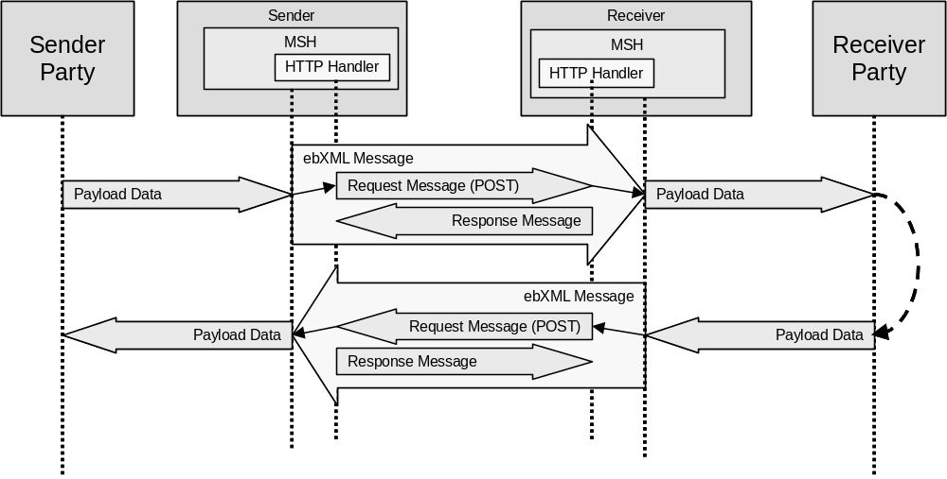
Figure C.1 Asynchronous HTTP Message Flow
A message that is being sent asynchronously MAY be identified by the following HTTP header:
ebxmlresponse=asynchronous
If the ebXMLresponse HTTP parameter is omitted then it MUST be assumed that the response is sent asynchronously.
    - Synchronous HTTP
In Synchronous HTTP, one ebXML Message Service message is carried by an HTTP Request Message (POST method) with the ebXML Message that is a response to the first message sent in the HTTP Response Message to the HTTP Request Message. This is illustrated by the figure below.
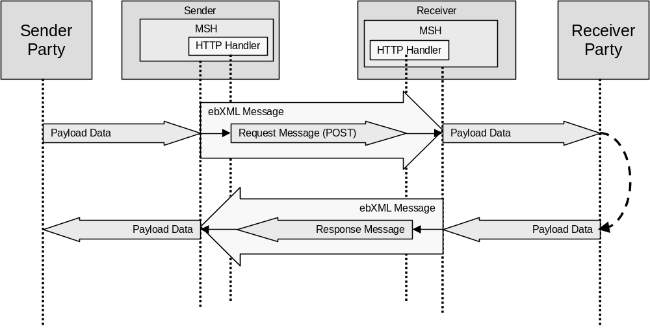
Figure C.2 Synchronous HTTP Message Flow
If a response is being sent synchronously, the following HTTP header MUST be included in the HTTP envelope:
ebxmlresponse=synchronous
  - SMTP
All ebXML Message Service messages are carried as mail in an [SMTP] Mail Transaction as shown in the figure below.
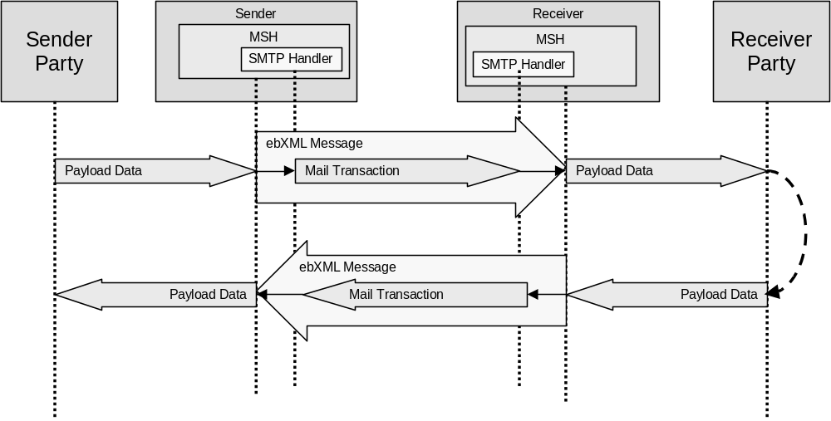
Figure C.3 SMTP Message Flow
The Mail Transaction follows RFC 821, “SIMPLE MAIL TRANSFER PROTOCOL”, as shown in the following Figure:
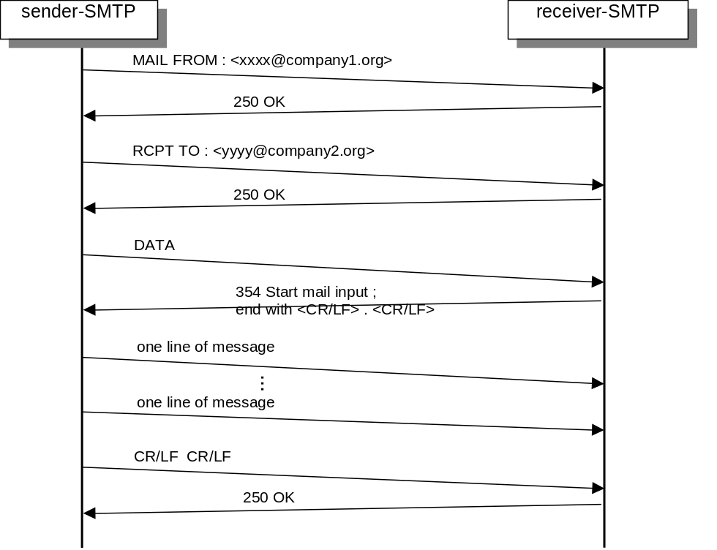
Figure C.4 SMTP Sequence
  - FTP
This section will describe how ebXML Messages may be sent using the File Transfer protocol as defined in RFC 959
This section is to be completed.
  - Communication Protocol Errors
    - Use of Error Codes
Communication Protocol Error Codes are used only to report errors in the communication protocol envelope (see section 7.1). A normal OK Response (e.g. an HTTP code 200) is used even if there are errors in the MIME envelope, the ebXML Header document or the payload.
    - Communication Errors during Reliable Messaging
When the Sender or the Receiver detects a transport protocol level error (such as an HTTP, SMTP or FTP error) and Reliable Messaging is being used then the appropriate transport recovery handler will execute a recovery sequence. Only if the error is unrecoverable, does Reliable Messaging recovery take place (see section 10).
- Reliable Messaging Processing Logic
This section will contain non-normative reference processing logic to describe the behavior of a MSH that is taking part in reliable messaging. It’s purpose is to assist implementers in developing consistent interoperable solutions.

Copyright Statement
This document and translations of it may be copied and furnished to others, and derivative works that comment on or otherwise explain it or assist in its implementation may be prepared, copied, published and distributed, in whole or in part, without restriction of any kind, provided that the above copyright notice and this paragraph are included on all such copies and derivative works. However, this document itself may not be modified in any way, such as by removing the copyright notice or references to the Internet Society or other Internet organizations, except as needed for the purpose of developing Internet standards in which case the procedures for copyrights defined in the Internet Standards process must be followed, or as required to translate it into languages other than English.
The limited permissions granted above are perpetual and will not be revoked by ebXML or its successors or assigns.
This document and the information contained herein is provided on an "AS IS" basis and ebXML DISCLAIMS ALL WARRANTIES, EXPRESS OR IMPLIED, INCLUDING BUT NOT LIMITED TO ANY WARRANTY THAT THE USE OF THE INFORMATION HEREIN WILL NOT INFRINGE ANY RIGHTS OR ANY IMPLIED WARRANTIES OF MERCHANTABILITY OR FITNESS FOR A PARTICULAR PURPOSE.

