Reliable Messaging

Reliable Messaging defines an interoperable protocol such that any two Messaging Service Handlers (MSH) can “reliably” exchange messages that are sent using “reliable messaging” delivery semantics.
“Reliably” means that the From Party can be highly certain that the message sent will be delivered to the To Party. If there is a problem in sending a message then the sender resends the message until either the message is delivered, or the sender gives up. If the message cannot be delivered, for example because there has been a catastrophic failure of the To Party’s system, then the From Party is informed.

Persistent Storage and System Failure
A MSH that supports Reliable Messaging MUST keep messages, and/or selected data from these messages, in persistent storage. In this context persistent storage is a method of storing data that does not lose information after a system failure or interruption.
This specification recognizes that different degrees of resilience may be realized depending on the technology that is used to persist the data. However, as a minimum, persistent storage that has the resilience characteristics of a hard disk (or equivalent) SHOULD be used. It is strongly RECOMMENDED though that implementers of this specification use technology that is resilient to the failure of any single hardware or software component.
Even after a system interruption or failure, a MSH MUST ensure that messages in persistent storage are processed as if the system failure or interruption had not occurred. How this is done is an implementation decision.
In order to support the filtering of duplicate messages, a Receiving MSH SHOULD, save the MessageId in persistent storage. It is also RECOMMENDED that the following be kept in Persistent Storage:
the complete message, at least until the information in the message has been passed to the application or other process that needs to process it
the time the message was received, so that the information can be used to generate the response to a Message Status Request (see section Error: Reference source not found)

Reliable Messaging Parameters
This section describes the parameters required to control reliable messaging. This parameter information is contained in the following:
- the ebXML Message Header, or
- the CPA that governs the processing of a message.

The table below indicates where these parameters may be set.
Parameter | CPA | Header
deliverySemantics | Yes | Yes
syncReplyMode | Yes | Yes
timeToLive | Yes | Yes
reliableMessagingMethod | No | Yes
intermediateAckRequested | No | Yes
timeout | Yes | No
retries | Yes | No
retryInterval | Yes | No
reliableMessagingSupported | Yes | No
persistDuration | Yes | No

In this table, the following interpretation of the columns should be used:
- if the CPA column contains a Yes then it indicates that the value that is present in the CPA determines the processing semantics
- if the CPA column contains a No then it indicates that the parameter value is never specified in the CPA
- if the Header column contains a Yes then it indicates that the parameter value MAY be specified in the ebXML Header document.

These parameters are described below.

Delivery Semantics
The deliverySemantics parameter may be present as either an attribute within the QualityOfService element of the ebXMLHeader document. The deliverySemantics attribute takes its value from the CPA that governs the processing of a given message. See section Error: Reference source not found for more information.

Sync Reply Mode
The syncReplyMode parameter may be present as either an element within the ebXMLHeader element or as a parameter within the CPA. See section Error: Reference source not found for more information.

Time To Live
The TimeToLive element may be presented within the ebXMLHeader document see section Error: Reference source not found for more information.

Reliable Messaging Method
The ReliableMessagingMethod parameter indicates the requested method for Reliable Messaging that will be used when sending a Message. Valid values are:
- ebXML in this case the ebXML Reliable Messaging Protocol as defined in section 1.3.1 is followed, or
- Transport, in this case a reliable transport protocol is used for reliable delivery of the message, see section .

Intermediate Ack Requested
The IntermediateAckRequested parameter is used by the Sending MSH to request that the Receiving MSH that receives the Message returns an acknowledgment message with an Acknowledgment element with a type of IntemediateAcknowledgment..
Valid values for IntermediateAckRequested are:
- Unsigned - requests that an unsigned Delivery Receipt is requested
- Signed - requests that a signed Delivery Receipt is requested, or
- None - indicates that no Delivery Receipt is requested.
The default value is None.

Timeout Parameter
The timeout parameter is an integer value that specifies the time in seconds that the Sending MSH MUST wait for an Acknowledgment Message before first resending a message to the Receiving MSH.

Retries Parameter
The retries Parameter is an integer value that specifies the maximum number of times a Sending MSH SHOULD attempt to redeliver an unacknowledged or undelivered message.

RetryInterval Parameter
The retryInterval parameter is an integer value specifying, in seconds, the time the Sending MSH SHOULD wait between retries, if an Acknowledgment Message is not received.

Reliable Messaging Methods Supported
The reliableMessagingMethodsSupported parameter is a list of the methods that a MSH uses to support Reliable Messaging. It must be a URI. The URI for the ebXML Reliable Messaging Protocol described in section 1.3.1 is http://www.ebxml.org/namespaces/reliableMessaging

PersistDuration
The persistDuration parameter is specified in the CPA. It represents the minimum length of time, expressed as a [XMLSchema] timeDuration, that data from a Message that is sent reliably, is kept in Persistent Storage by a MSH that receives that Message. Note that implementations may determine that a message is persisted for longer than the time specified in persistDuration, for example in order to meet legal requirements or the needs of a business process. This information is recorded separately within the CPA.

Methods of Implementing Reliable Messaging
Support for Reliable Messaging can be implemented in one of the following two ways:
- using the ebXML Reliable Messaging protocol, or
- using ebXML Header and Message structures together with commercial software products that are designed to provide reliable delivery of messages using alternative protocols
.<DB>Change elsewhere</DB>

Use of alternative protocols to effect reliable delivery of messages is outside the scope of this specification.

ebXML Reliable Messaging Protocol
The ebXML Reliable Messaging Protocol described in this section MUST be followed if the deliverySemantics parameter/element is set to OnceAndOnlyOnce and the ReliableMessagingMethod parameter/element is set to ebXML (the default).
The ebXML Reliable Messaging Protocol is illustrated by the figure below.
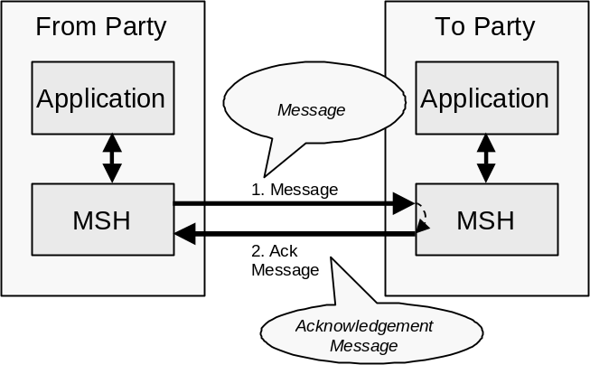
Figure 1-1 Indicating that a message has been received

The receipt of the acknowledgment message indicates that a message has been successfully received, and either processed or persisted by the receiving MSH to which the message was sent.
An acknowledgment message MUST contain a MessageData element with a RefToMessageId that contains the same value as the MessageId element in the message being acknowledged.

Sending Message Behavior
If a MSH is given data by an application that needs to be sent reliably then the MSH MUST do the following:
- Create a message from components received from the application that includes:
deliverySemantics set to OnceAndOnlyOnce, and
a RoutingHeader element that identifies the sender and the receiver URIs
- Save the message in persistent storage (see section 1.1)
- Send the message to the Receiver MSH
- Wait for the Receiver MSH to return an acknowledgment message and, if it does not, then resend the identical message as described in section 1.3.1.4

Receiving Message Behavior
If deliverySemantics on the received message is set to OnceAndOnlyOnce then do the following:
- Check to see if the message is a duplicate (e.g. there is a message in persistent storage that was received earlier that contains the same value for the MessageId)
- If the message is not a duplicate then do the following:
  - Save the MessageId of the received message in persistent storage. As an implementation decision, the whole message MAY be stored if there are other reasons for doing so
  - If the received message contains a RefToMessageId element then do the following:
    - Look for a message in persistent storage that has a MessageId that is the same as the value of RefToMessageId on the received Message
    - If a message is found in persistent storage then mark the persisted message as delivered

- If the message is a duplicate, then do the following:
  - Look in persistent storage for a response to the received message (i.e. it contains a RefToMessageId that matches the MessageId of the received message)
  - If no message was found in persistent storage then ignore the received message as either no message was generated in response to the message, or the processing of the earlier message is not yet complete
  - If a message was found in persistent storage then resend the persisted message back to the MSH that sent the received message.

Service and Action Element Values
An Acknowledgment element can be included in an ebXMLHeader that is part of a message that is being sent as a result of processing of an earlier message. In this case the values for the Service and Action elements are set by the designer of the Service (see section Error: Reference source not found).
An Acknowledgment element also can be included in an ebXMLHeader that does not include any results from the processing of an earlier message. In this case, the values of the Service and Action elements MUST be set as follows:
- The Service element MUST be set to: http://www.ebxml.org/namespaces/messageService/MessageAcknowledgment
- The Action element MUST be set to the value of the type attribute in the Acknowledgment element.

Resending Lost Messages and Duplicate Filtering
This section describes the behavior that is required by the sender and receiver of a message in order to handle when messages are lost. A message is "lost" when a sending MSH does not receive a response to a message. For example, it is possible that a messagewas lost, for example:
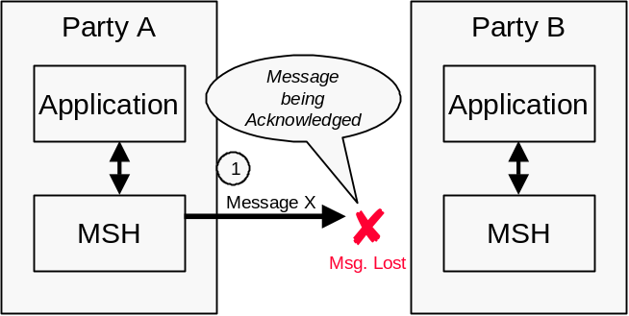
Figure 1-2 Lost Message
It is also possible that the Acknowledgment Message was lost, for example:
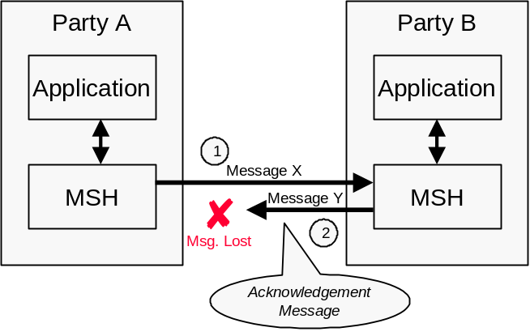
Figure 1-3 Lost Acknowledgment Message
The rules that apply are as follows:
- The Sending MSH MUST resend the original message if an Acknowledgment Message has not been received from the Receiving MSH and either of the following are true:
  - The message has not yet been resent and at least the time specified in the timeout parameter has passed since the first message was sent, or
  - The message has been resent, and the following are both true:
    - At least the time specified in the retryInterval has passed since the last time the message was resent, and
    - The message has been resent less than the number of times specified in the retries Parameter
- If the Sending MSH does not receive an Acknowledgment Message after the maximum number of retries, the Sending MSH SHOULD notify the application and/or system administrator function.
- If the Sending MSH detects a communications protocol error that is unrecoverable at the transport protocol level then the Sending MSH SHOULD first attempt to resend the message using the same transport protocol until the number of retries has been reached, and then again, using a different communications protocol, if the CPA allows this. If these are not successful, then notify the From Party of the failure to deliver as described in section 1.4.

Duplicate Message Handling

In this context:
- an identical message is a message that contains the exact same ebXML Header and ebXML Payload as the earlier message that was sent previously.
- a duplicate message is a message that contains the same MessageId as an earlier message that was received.
Note that the Communication Protocol Envelope MAY be different. This means that the same message MAY be sent using different communication protocols and the reliable messaging behavior described in this section will still apply. The ability to use alternative communication protocols is specified in the CPA and is an OPTIONAL implementation specific feature.

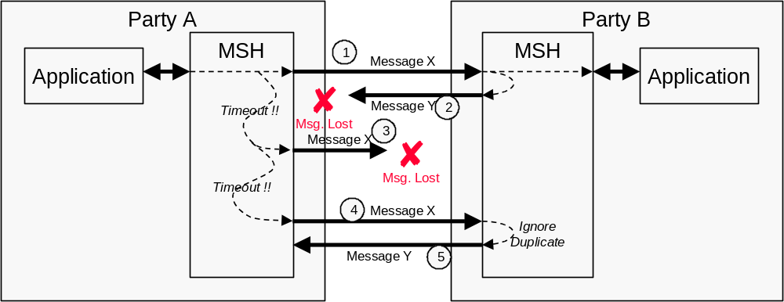
Figure 1-4 Resending Unacknowledged Messages
The diagram above shows the behavior that MUST be followed by the sending and receiving MSH for messages that require reliable delivery as regards to duplicate message receipt. Specifically:
- The sender of the message (e.g. Party A) MUST re-send the identical message if no Acknowledgment Message is received
- The recipient of the message (e.g. Party B), when it receives a duplicate message, MUST re-send to the sender of the message (e.g. Party A), a message identical to the message that was originally sent in response to the duplicate message
- The recipient of a duplicate message MUST NOT forward them a second time to the application or other process that would normally be expected to process received messages.

Multi-hop Reliable Messaging

Multi-hop Reliable Messaging with Intermediate Acknowledgments is similar to Multi-hop Reliable Messaging without Intermediate Acknowledgment except that any of the Parties that are transmitting a Message can request that the recipient return an Intermediate Acknowledgment.
This is illustrated by the diagram below.
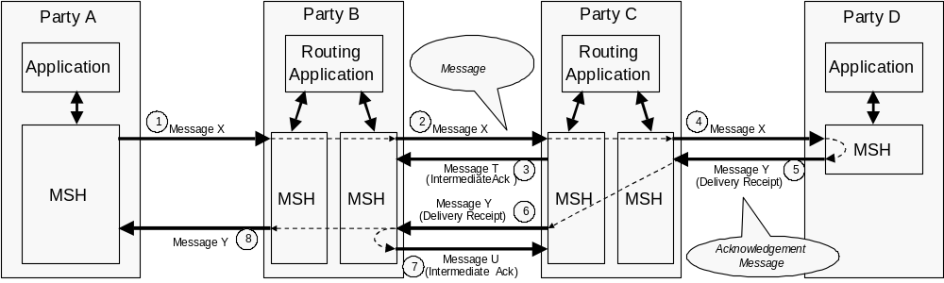
Figure 1-5 Multi-hop Reliable Messaging
<CBF>The image above needs to be fixed so that delivery receipt is not included. Intermediate acks only</CBF>

The rules that apply to Multi-hop Reliable Messaging are as follows:
- Any Party that is sending a message can request that the recipient send an Acknowledgment Message by setting the AckRequested of the RoutingHeader for the hop to Signed or Unsigned.
- a MSH that is not the To Party receives a message that requires an Intermediate Acknowledgment then: the MSH MUST return an Acknowledgment Message with: (e.g. Transmission 2 of Message X, or Transmission 6 of Message Y)

The Service and Action elements set as in defined in section 1.4
    - The From element contains the ReceiverURI from the last RoutingHeader in the message that has just been received
    - The To element contains the SenderURI from the last RoutingHeader in the message that has just been received
    - a RefToMessageId element that contains the MessageId of the message being acknowledged
    - a QualityOfServiceInfo element with deliverySemantics set to BestEffort

Failed Message Delivery
In the event that some actor, involved, in some capacity, in the delivery of a message has determined that a message cannot be delivered to
the application or other process that has been designated to process the message,

that actor SHOULD send a delivery failure notification message to the From Party that sent the message. The delivery failure notification message contains:
- a From Party that identifies the Party that detected the problem
- a To Party that identifies the From Party that created the message that could not be delivered
- a Service element and Action element set as described in Error: Reference source not found
- a QualityOfServiceInfo element with deliverySemantics set to the same value as the deliverySemantics on the message that could not be delivered
- an Error element with a severity of:
- Error if the Party that detected the problem could not even transmit the message (e.g. Transmission 3 was impossible)
- Warning if the message (e.g. Message X in Transmission 3) was transmitted, but no acknowledgment was received. This means that the message probably was not delivered although there is a small probability that it was
- an ErrorCode of DeliveryFailure

